 | 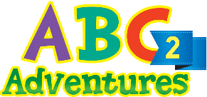 |  | Word List |  |  | 
Class |  |  |  | Name

Lesson 1

Picture | Word | Picture | Word
 | man | 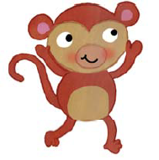 | monkey
 | map | 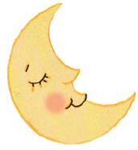 | moon

 |  |  | Word List
Class |  |  |  | Name

Lesson 2

Picture | Word | Picture | Word
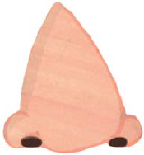 | nose |  | numbers
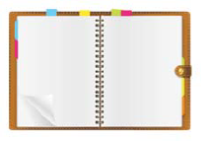 | notebook |  | nurse

 |  |  | Word List
Class |  |  |  | Name

Lesson 3

Picture | Word | Picture | Word
 | octopus | 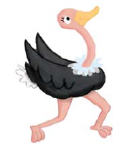 | ostrich
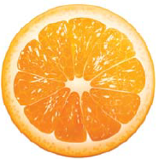 | orange | 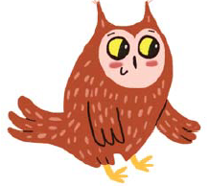 | owl

 |  |  | Word List
Class |  |  |  | Name

Lesson 4

Picture | Word | Picture | Word
 | man |  | monkey
 | map |  | moon
 | nose |  | numbers
 | notebook |  | nurse
 | octopus |  | ostrich
 | orange |  | owl

 |  |  | Word List
Class |  |  |  | Name

Lesson 5

Picture | Word | Picture | Word
 | panda | 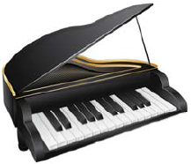 | piano
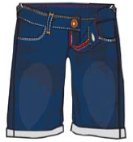 | pants | 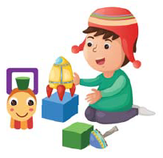 | play

 |  |  | Word List
Class |  |  |  | Name

Lesson 6

Picture | Word | Picture | Word
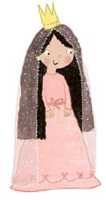 | queen | 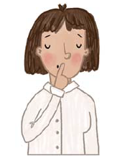 | quiet
 | question | 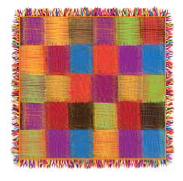 | quilt

 |  |  | Word List
Class |  |  |  | Name

Lesson 7

Picture | Word | Picture | Word
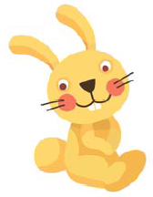 | rabbit |  | robot
 | rain | 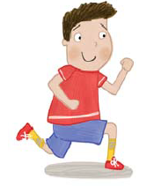 | run

 |  |  | Word List
Class |  |  |  | Name

Lesson 8

Picture | Word | Picture | Word
 | panda |  | piano
 | pants |  | play
 | queen |  | quiet
 | question |  | quilt
 | rabbit |  | robot
 | rain |  | run

 | 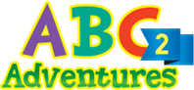 |  | Word List
Class |  |  |  | Name

Lesson 9

Picture | Word | Picture | Word
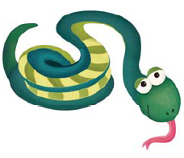 | snake | 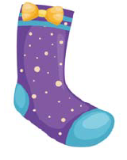 | sock
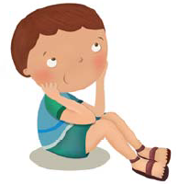 | sit |  | sun

 |  |  | Word List
Class |  |  |  | Name

Lesson 10

Picture | Word | Picture | Word
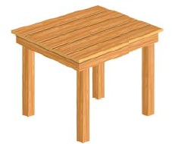 | table | 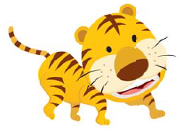 | tiger
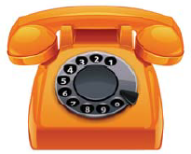 | telephone |  | two

 |  |  | Word List
Class |  |  |  | Name

Lesson 11

Picture | Word | Picture | Word
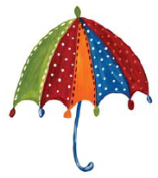 | umbrella | 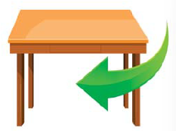 | under
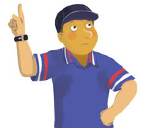 | umpire |  | up

 |  |  | Word List
Class |  |  |  | Name

Lesson 12

Picture | Word | Picture | Word
 | snake |  | sock
 | sit |  | sun
 | table |  | tiger
 | telephone |  | two
 | umbrella |  | under
 | umpire |  | up

 |  |  | Word List
Class |  |  |  | Name

Lesson 13

Picture | Word | Picture | Word
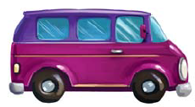 | van |  | vine
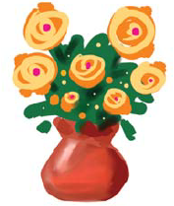 | vase | 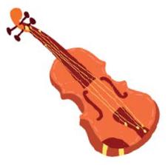 | violin

 |  |  | Word List
Class |  |  |  | Name

Lesson 14

Picture | Word | Picture | Word
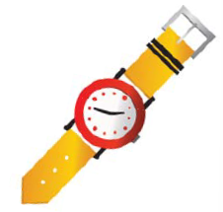 | watch |  | whale
 | water | 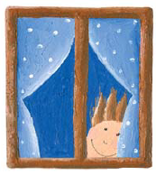 | window

 |  |  | Word List
Class |  |  |  | Name

Lesson 15

Picture | Word | Picture | Word
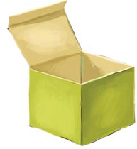 | box | 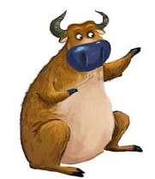 | ox
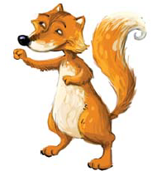 | fox | 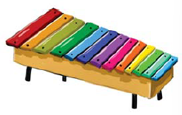 | xylophone

 |  |  | Word List
Class |  |  |  | Name

Lesson 16

Picture | Word | Picture | Word
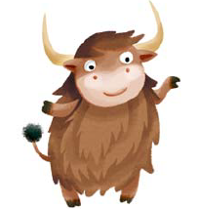 | yak | 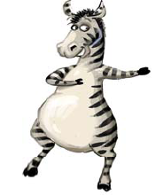 | zebra
 | yoyo | 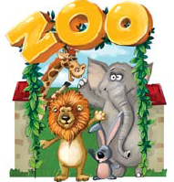 | zoo

