Unit 1 New People
Unit 1 Lesson 1 What’s your name?

1 Write the letters in the correct blanks. Then listen and check. [Track 02]

- c
- a
- b
- e
- f
- d

2 Fill in the blanks with the words from the box to complete the conversations. Remember to capitalize. Then listen and check. [Track 03]

- Hello, Yes, student, Yeah
- boy, No
- Are, am, last, isn’t, name, we’re

3 Circle the correct answers.
- are
- aren’t
- is
- aren’t
- is
- isn’t

4 Put the words in order to make yes/no questions.
- Are they friends?
- Is your first name Helena?
- Are you teachers?
- Are we classmates?
- Is your last name Stark?
- Is she a student?

Unit 1 Lesson 2 I’m the teacher
1 Put the conversation in the correct order. Listen and check. Then practice. [Track 04]

Student: Good afternoon. Is this the English class?
Teacher: Yes, it is. Good afternoon!
Student: Great. And are you the teacher?
Teacher: Yes, I’m Ms. Sousa. What’s your name?
Student: I’m Daniel, but you can call me Danny.
Teacher: Nice to meet you, Danny. Are you a new student?
Student: Yeah, I am. It’s my first day in this school.
Teacher: Well, welcome to my English class—and to the school!

2 Underline the errors and rewrite the sentences correctly.

- Your last name are Dixon.
Your last name is Dixon.
- I’m nice to meet you.
It’s nice to meet you.
- How you are?
How are you?
- I no am a student.
I’m not a student.
- What your name?
What’s your name?
- People me call Dot.
People call me Dot.

3 Put a (√) next to the correct response.

1. Are we classmates?
[√] No. I’m not a student.
[ ] Yes, we is classmates.

2. Hey, how’s it going?
[ ] Nice to meet you.
[√] Not bad.

3. My name’s Alberto, but you can call me Beto.
[ ] Good to meet you, Alberto!
[√] Nice to meet you, Beto!

4. Are you a new student here?
[√] Yes, it’s my first day.
[ ] Yes, I is.

5. What’s your name?
[√] Briana. And you?
[ ] Briana. How you?

6. I’m a new teacher.
[√ ] Welcome! Good to meet you.
[ ] Hey!

Unit 1 Lesson 3 Titles

1 Find and circle the jobs.
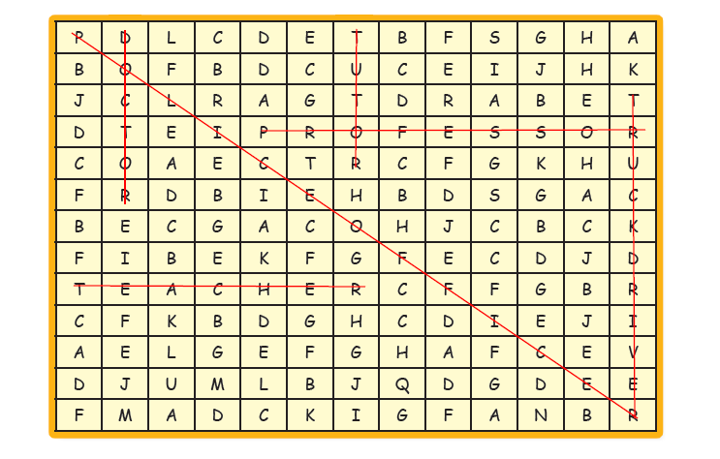
2 Listen. Are these sentences true (t) or false (f)? [Track 05]

1. a Karim is a new student. f
b Daisy’s last name is Hernandez. f
2. a The doctor’s last name is Banda. t
b Mrs. Smith is new. f
3. a The woman’s first name is Sandy. f
b The woman is married. t

3 Listen again and circle the response you hear. [Track 05]

1. B: Great! Nice to meet you.
2. B: All right, thanks.
3. B: No, I’m here for Mrs. Park

Unit 1 Lesson 4 Where are you from?

1 Complete the crossword. Write the nationalities.

- Mexican
- Korean
- American
- Thai
- Egyptian
- Canadian
- Chinese
- Japanese

2 Where’s the stress? Put the nationalities in the correct column. Then listen and check. [Track 06]

Ooo | oOo | ooO | oOoo
Mexican | Egyptian  Korean | Japanese | American  Brazilian  Canadian

3 Match each question with its response. Then listen and check. [Track 07]

- e
- c
- d
- b
- f
- a

Unit 1 Lesson 5 Bye.

1 Match the two columns to make farewell phrases.

- d
- a
- e
- f
- b
- c

2 Listen to the conversations. Put a check mark (√) next to the response you hear. [Track 08]

1. Okay, we’ll stop here for today. Have a good night!
[ ] Thanks! See you then, professor.
[√] Thanks! See you soon, professor.

2. Goodbye, Dr. Samuels.
[√] Good night, Mr. Richards.
[ ] Goodbye, Mr. Richards.

3. Okay. See you soon!
[ ] Have a good tomorrow!
[√] Have a good afternoon.

4. Bye, Mara.
[√] Have a good day, sir.
[ ] Goodbye, Mr. Wilson.

3 Read the email. Choose the correct answers.

- Mexico
- Her
- My
- Melissa’s
- United States
- her

4 Write an email to a friend or a parent. Talk about your professors or teachers and your friends.
[KEY: Answers will vary.]

Unit 1 Review
1 Vocabulary
Choose the correct answers.
- b
- d
- d
- d
- a
- a

2 Reading Comprehension
Read Jason’s description of his class. Then put a check mark (√) next to true or false.
- false
- false
- false
- false
- true

3 Grammar
Circle the correct answers.
- am, I’m
- is
- aren’t, They’re
- isn’t
- am not
- we’re
- is from
- ?
- Am I
- she

4 Listening Comprehension
Listen to the conversation and fill in the blanks with the words and phrases from the box. Some words are not used. [Track 09]
- I’m not, name
- How’s it, bad, good
- doctor, woman, I’m, Dr.
- Are, am
- Take care, Yep

Unit 2 The Classroom
Unit 2 Lesson 1 What do you have here?

1 Find and circle the school supplies.

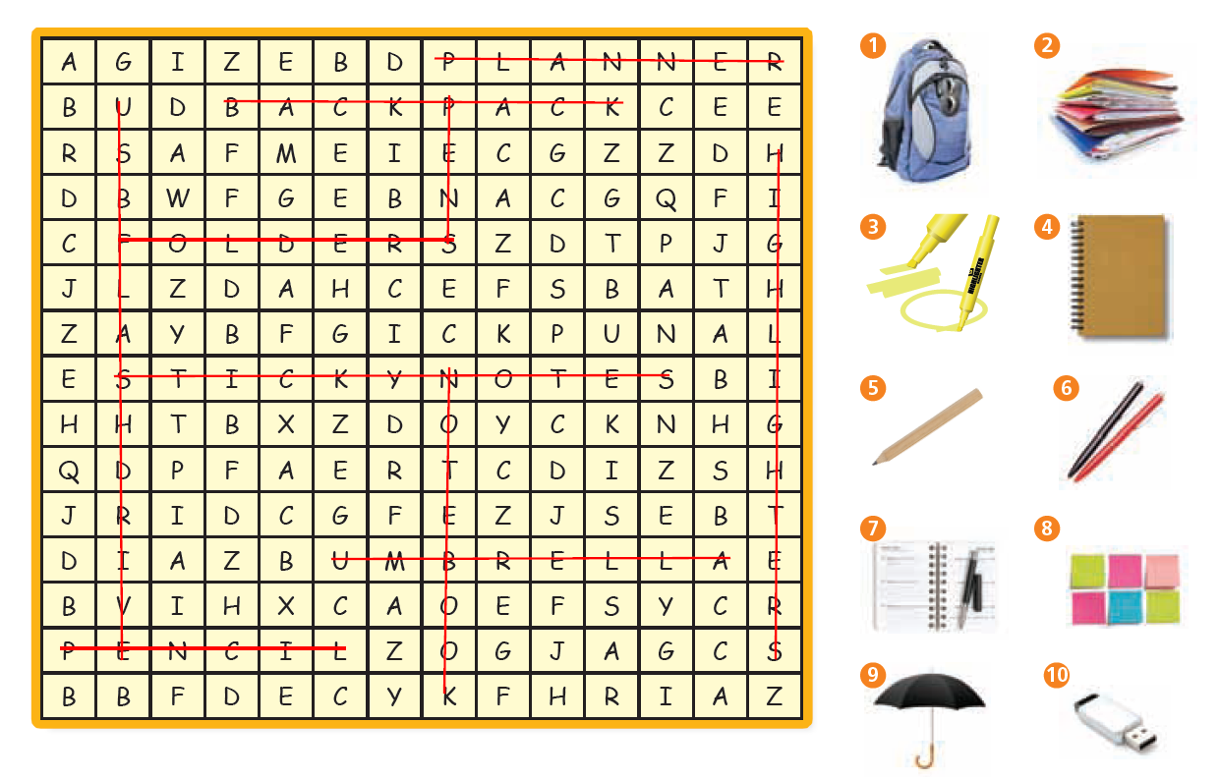
2 Listen. What school supplies do students need? Fill in the blanks using the words in exercise 1. Then listen again to check. [Track 10]
- pencil
- pens
- highlighters
- sticky notes
- folders
- notebook
- USB flash drive

3 Circle the correct answers.
- a
- an
- name
- an
- a, pens
- no article
- an
- nineteen
- a, a

Unit 2 Lesson 2 What do you have outside?

1 Listen to the conversation and choose the correct answer. [Track 11]

[KEY: b. at home ]

2 Listen again and circle true or false. [Track 11]

- Patty calls Marlo. true
- Marlo is in his car. false
- Marlo has a bicycle. true
- His dog is next to him. false
- Patty asks three questions. true

3 Fill in the blanks with the words from the box and the correct form of have to complete the questions. Add a, an, and do/does where needed.

[KEY:
- have … [answers will vary]
- have … [answers will vary]
- Do … have … [answers will vary]
- Does … have … [answers will vary]
- Do … have … [answers will vary]
- Do/Does … have … [answers will vary]

4 Answer the questions in exercise 3 with information that is true for you. Then ask a partner the questions. Write their answers.

[KEY: Answers will vary. Possible answers include:
- Yes, I do. or: No, I don’t.
- Yes, he/she does. or: No, he/she doesn’t.
- Yes, I do. or: No, I don’t.
- Yes, he/she does. or: No, he/she doesn’t.
- Yes, they do. or: No, they don’t.
- Answers will vary.]

Unit 2 Lesson 3 Whose is it?

1 Put the letters in order to make words. Then complete the crossword.
 |  |  |  |  |  | ¹ B | R | O | ⁷ W | N
 |  |  |  |  |  |  |  |  | H
 |  |  |  |  |  |  |  |  | I
 |  |  |  | ² M | A | ⁸ G | E | N | T | A
 |  |  |  |  |  | R |  |  | E
 |  |  |  |  | ³ R | E | D
 |  |  |  |  |  | E |  | ⁹ Y
 |  |  | ⁴ O | R | A | N | G | E
 |  |  |  |  |  |  |  | L
 |  |  |  | ⁵ P | U | R | P | L | E
 |  |  |  | I |  |  |  | O
 |  |  |  | N |  |  |  | W
⁶ B | L | A | C | K

2 Circle the correct sentences. Then listen and check. [Track 12]

- a. Is Nina’s smartphone red?
- b. Is it a black pen?
- a. The pencil is green. Its eraser is pink.
- a. Whose purple folder is it?
- b. It’s my blue highlighter.
- b. The table computer is theirs.

3 Do these questions have a rising or a rising-falling intonation? Put the letters in the correct columns. Then listen, check, and practice. [Track 13]

Is your backpack blue?  Is the phone yours? | Whose bag is it?  Whose notebook is it?

4 Underline the errors and rewrite the sentences correctly.

- Whose folders they are?
Whose folders are they?
- Its my pen!
It’s my pen!
- They’re mines.
They’re mine.
- Their Ella’s shoes.
They’re Ella’s shoes.

Unit 2 Lesson 4 The Things Around You

1 Match the two columns to make sentences. Then listen and check. [Track 14]

- d
- f
- e
- a
- c
- b

2 Study the picture of the lecture hall and fill in the blanks to complete the sentences. Then write three more sentences about the classroom.

[KEY: Answers may vary.
- There are announcements on the wall.
- The announcements are under the clock on the wall.
- There are two desks in front of the wall.
- The two chairs are under the clock.
- The computer is on the desk next to the podium.
- [Answers will vary; possible answers include: There are lights. There’s a teacher/professor. There are classmates/students. There’s a floor/ceiling. There are lights. There are walls. There are two aisles.]
- [Answers will vary; possible answers include: There are lights. There’s a teacher/professor. There are classmates/students. There’s a floor/ceiling. There are lights. There are walls. There are two aisles.]
- [Answers will vary; possible answers include: There are lights. There’s a teacher/professor. There are classmates/students. There’s a floor/ceiling. There are lights. There are walls. There are two aisles.]

Unit 2 Lesson 5 Where is it?

1 Circle the correct answers.

- in
- between
- in
- on, under
- on, next to

2 Listen to the conversation and choose the correct answer. [Track 15]

[KEY: c. parent and child]

3 Listen again. Put a check mark (√) next to the response you hear. [Track 15]

[KEY:
- Whose tablet is it?
[√ ] My friend’s tablet. It’s Diana’s tablet.

- Is it under your bed?
[ √] No, and it’s not on my desk.

- Is it between the wall and the bed?
[√ ] Oh, let me check.

- Is it between your books or your folders in that box?
[√ ] No. Oh, no!

4 Look at the picture and read the sentences. Are they true or false? Put a (√) next to the true sentences. Rewrite the false sentences to make them true.

[Key: Answers may vary
- [ ] There are books and notebooks on the floor.
- [√ ]
- [ ] The TV is behind a man.
- [√ ]
- [ ] There is a clock behind the women. / …clock on the wall.]

Unit 2 Review
1 Vocabulary
Circle the correct answers.
- podium
- tablet, table
- planner
- announcement board
- folder
- console
- boyfriend
2 Reading Comprehension
Read the class rules. Then choose the correct answers.
- a
- b
- c
- b
- a
3 Grammar
Choose the correct answers.
- c
- b
- d
- a
- d
- b
4 Listening Comprehension
Listen to the conversation and fill in the blanks. [Track 16]
- Amy
- planner, classroom
- 13
- back, wall
- planner, red
- under
- books

Module Review
1 Listen and answer the question. [Track 17]
[KEY: b. English B Conversation]

2 Listen again. Are these sentences true (t) or false (f). [Track 17]

- There’s an English class in the next classroom. true
- Students need school supplies for this class. true
- All of the students are from Brazil. false
- Brianna is from the United States. true

3 Listen to the end of the class. Put a check mark (√) next to the phrases you hear. [Track 18]
[ KEY:
[ ] That’s all for today. [√ ] Have a good day! [√ ] Good night! [ √] Bye, Brianna.
[√ ] We’ll stop here. [ ] See you tomorrow! [ √] Take care. [ ] Have a good afternoon.
[ √] I’ve got to get going. [ √] See you soon. [√ ] Bye. [ √] Goodbye.]

4 Read the profiles. All these people are:
[KEY: c. English students]

5 Make these sentences negative to make them true.

- Rolf’s dog isn’t named Mouse.
- Cristina’s favorite possession isn’t her phone.
- Ryo doesn’t have a best friend called Hiro.
- Wendy isn’t English.
- Tanet’s favorite possession isn’t his car.
- Afia isn’t American.

6 Put the words in order to make questions about the people on E-pals International. Do you know the answers?

- Are there three women? A: Yes, there are.
- Does Rolf have a dog and a cat? A: Yes, he does.
- Whose bicycle is it? A: It's Tanet's.
- Is Wendy Colombian? A: No, she isn't.
- Whose books are they? A: They're Wendy's.
- Does Cristina have a brother? A: Yes, she does.

7 Write your own profile for E-pals International.

[KEY: Answers will vary]

Unit 3 About Family
Unit 3 Lesson 1 In My Family

1 Write sentences about the family members in the picture.

[KEY: Answers will vary]

2 Now listen to the description of the picture. Do your sentences say what the speaker says? [Track 19]

[KEY: Answers will vary]

3. Fill in the blanks with the words from the box to complete the questions. Then listen and check. [Track 20]

- How many people are there in your family?
- How many siblings do you have?
- How many children do you have?
- How many sisters does he have?

4 Listen again. Put a check mark next to the correct responses. [Track 20]

- There are seven people.
- Five.
- I don’t have any children.
- He has one sister.

5. Underline the errors and rewrite the sentences correctly.

- How many students there are in your class?
How many students are there in your class?

- How many sibling do you have?
How many siblings do you have?

- I’m have five siblings.
I have five siblings.

- How many brothers and sisters do Jeremy have?
How many brothers and sisters does Jeremy have?

- There are eight person in my family.
There are eight people in my family.

Unit 3 Lesson 2 Technology and Media

1 Label the pictures with media and technology words. Then find and circle each word.

[KEY: phone, laptop, headphones, digital camera, photo, selfie]

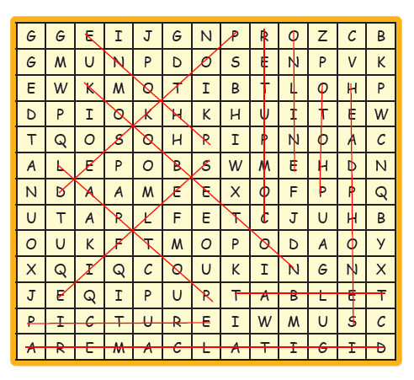

2 Circle the correct answers.

- friends
- some
- any
- doesn’t
- does

3 Put the words in order to make questions with any.

- Do you have any friends here?
- Do you have any photos of your siblings?
- Does he have any relatives nearby?
- Do you have any selfies on your phone?

Unit 3 Lesson 3 Family Photos

1 Listen to the conversation. Who are the people in the picture? Choose the correct answer. [Track 21]

[KEY: a. Zheping’s parents]

2 Listen again. Are the sentences true (t) or false (f)? [Track 21]

- true
- true
- false
- false
- true

3 Circle the correct answers. Then listen and check. [Track 22]

- These
- they
- those
- That
- this
- This
- this
- that

4 Circle the correct answers.

- these
- that
- this
- those

5 Listen to each word. Put a check mark under the correct vowel sound. [Track 23]

- i
- i:
- i:
- i
- i:
- i:
- i
- i

Unit 3 Lesson 4 They’re his ex-wives.

1 Put the letters in order to make words. Then complete the crossword.

[KEY:
Down: 1. grandfather; 2. parents; 6. aunt

Across: 1. grandmother; 3. uncle; 4. exwife; 5. cousin; 7. children]

2 Write a plural noun for each picture. Then listen and check. [Track 24]

[KEY: children – women – glasses – babies]

3 Listen. Circle the correct answers. [Track 25]

- children
- photo
- brother

4 Listen again and fill in the blanks. [Track 25]

- names
- girl
- kids

Unit 3 Lesson 5 Appearance

1 Match the people in the pictures to the descriptions. Then listen. Write the people’s names. [Track 26]

- b Anna
- c Jackson
- a Brad
- d Lauren

2 Rewrite the sentences using with.

- The man with black hair is my friend.
- The woman with long, brown hair is my teacher.
- The girl with blond hair is my daughter.
- The man with the beard is my boyfriend.

3 Read the description of the photo. There are five errors. Underline the errors and correct them.

This is my family. There are five person (people) in my family, including me. The man of (with) brown hair is my brother. His name is Rob. He’s a salesman. The woman with gray hair is my mom. Her name is Janice. The girl with black (blond) hair is my sister. She is a student. Finally, a (the) man with gray hair is my dad. He (His) name is Rick. He doesn’t work. He’s old! I see them once a year. I really miss them.

Unit 3 Review

1 Vocabulary
Fill in the blanks with the words from the box.

- aunt
- siblings
- divorced
- facial, mustache
- photo, brother
- hair, grandfather
- family

2 Grammar
Choose the correct answers.

- b
- a
- a
- c
- a
- b

3 Reading Comprehension
Read the letter. Then find the mistakes in the sentences below and write them correctly.

- Amanda has an important meeting tonight.
- Mr. Carr has short gray hair and black glasses.
- Simon Carr’s business is called Big Mind, Inc.
- Naoko and Kami are sisters.
- Jeff Short is tall and has a long, black beard.

4 Listening Comprehension
Listen to the conversation and put a check mark next to true or false. [Track 27]

- true
- false
- false
- true
- false

Unit 4 School Life
Unit 4 Lesson 1 Ages and Birthdays

1 Listen to the conversation and circle the correct answers. [Track 28]

- family members
- writing family information

2 Listen again and put a check mark next to true or false. [Track 28]

- false
- true
- true
- true
- false

3 Match the questions and answers.

- b
- e
- a
- d
- c

4 Look back at exercise 3. Choose two of the questions and answer them with information that is true for you. Write complete sentences.

[KEY: Answers will vary]

Unit 4 Lesson 2 Studying

1 Fill in the blanks with the correct words from the box.

- study
- discuss
- practice
- take
- learn
- read

2 Put the words in order to make sentences.

- You always study so hard.
- I love to discuss stories in French class.
- We read the newspaper every morning. / Every morning we read the newspaper.
- They take a test each semester. / Each semester they take a test.
- I write well in my English course.

3 Find and circle the words.

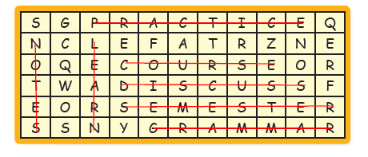

4 Complete the statements by writing phrases that match the pictures.

[KEY: Answers will vary
- Every night, I write notes.
- Nowadays, students use computers a lot in classes.
- In some cases, we discuss the homework together.]

Unit 4 Lesson 3 Do you have class on Friday?

1 Put a check mark next to the correct answers.

- Yes, I do.
- No, he doesn’t.
- No, they don’t.
- Yes, we do.

2 Read the email. Then put a check mark next to the correct answers.

- No, she doesn’t.
- Yes, they do.
- No, it doesn’t.
- No, he doesn’t

3 Read the email again and answer the following questions.

- Yes, she does.
- No, she doesn’t.
- Yes, she does.
- She plays basketball and rides her bike.

4 Imagine you are Jordy. What three questions do you want to ask Sandra?

[KEY: Answers will vary]

Unit 4 Lesson 4 Going to College

1 Listen and fill in the blanks. [Track 29]

- listens
- discuss
- teaches
- take
- practices

2 Listen again. Write the verbs you hear in the correct columns. [Track 29]

 | no extra “s” sound | extra “s”  sound | extra “es” sound
1. |  | x
2. | x
3. |  |  | x
4. | x
5. |  |  | x

3 Read the letter. Are the statements true of false? Circle.

- true
- false
- true
- false
- true

Unit 4 Lesson 5 I study at night.

1 Put a check mark under the correct preposition.

 | in | at | on
Tuesday afternoon |  |  | x
the summer | x
the weekend |  |  | x
May 15th |  |  | x
night |  | x
Mondays and Wednesdays |  |  | x
the 21st of June, 2015 |  |  | x
January | x

2 Listen to the conversation and fill in the blanks. [Track 30]

[ Key:
on April 21st; in the summer; in the afternoon; in the evenings; in May; Tuesdays and Wednesday; on the weekends]

3 Underline the errors and rewrite the sentences correctly.

- I always play soccer in Friday.
I always play soccer on Friday.

- Sheryl’s birthday is in September 15th.
Sheryl’s birthday is on September 15th.

- I start a new art history class on January.
I start a new art history class in January.

- Dave is too tired to study in night.
Dave is too tired to study at night.

- As a music major, I practice the violin at the afternoons.
As a music major, I practice the violin in the afternoons.

Unit 4 Review

1 Vocabulary
Read the descriptions. Then choose the correct answers.

- c
- d
- d
- a
- d
- b
- d
- c
- a
- a

2 Grammar
Fill in the blanks with the words from the box.

- on
- your parents
- your mom
- November 29th
- November
- in

3 Reading Comprehension
Read Natalia Fisher’s schedule for this week. Then complete the sentences below.

- on Tuesday afternoon
- will study / studies
- works
- have dinner
- Marcia; on Saturday

4 Listening Comprehension
Listen to the conversations. Fill in the blanks with the words you hear. [Track 31]

- A: do you have
B: At 1:30.
- A: how old
B: 22.
- A: fifth grade
B: in elementary school
- A: do your roommates
B: At; in the evening
- A: in the summer
B: we have; in October

Module Review
1 Listen. Where are the speakers? [Track 32]

[KEY: a. at a party]

2 Listen again and circle true or false. [Track 32]

- true
- false
- false
- true

3 Listen to a conversation at the party. Fill in the blanks. [Track 33]

Marie: So, that’s my uncle, over there. He’s my dad’s brother.
Eric: Ah. The man with the beard?
Marie: Yep. And the woman with long brown hair is his wife.
Eric: Okay. Who are those two women over there?
Marie: Those are my aunts. They’re my mom’s sisters.

4 Read Marie’s family tree. Circle the correct answers.

- two
- William
- are married

5 Larissa is writing an article about university life. She has some questions for you. Put the words in order to make yes/no questions. Then write an answer for each.

- Do you study before a test?
- Do your classmates take notes in class?
- Does your teacher explain difficult ideas?

6 Complete Larissa’s sentences. Fill in the blanks with the correct expressions from the box.

- This year
- September 5th
- Mondays and Thursdays
- the weekends
- the morning
- November

7 Write a letter to a friend describing your life as a student. Explain your schedule and lifestyle.

[KEY: Answers will vary.]

Unit 5 Doing Things at School
Unit 5 Lesson 1 Telling Time

1 Fill in the blanks with the words from the box.
- is
- midnight
- 9:30
- What
- starts
- does

2 Complete the sentences to describe the time of day.
- 12:55
- at 7:15
- at 9:00

3 Match the questions and answers.
- c
- d
- a
- b

4 Put the words in order to complete the conversation.
Juan: We have no plans tonight.
Jillian: Do you want to see a movie?
Juan: Yes, I want to watch The Voyage!
Jillian: What’s it about?
Juan: It’s an exciting space movie.
Jillian: What time does it start?
Juan: It starts at 7 and ends at 9.

Unit 5 Lesson 2 What do you do after class?

1 Fill in the blanks with before or after or a correct form of do or go.
- before
- go
- do
- goes
- before
- does

2 Listen and fill in the subject and verb that you hear in each sentence. [Track 34]
- We go
- Amanda eat
- George has
- They do
- Jin goes

3 Read Sandeep’s schedule. Are the sentences below true (t) or false (f)?
- false
- true

4 Read the schedule again and answer the questions.
- Sandeep takes Creative Writing on Tuesdays at 1:00.
- He takes history at 10:00 am
- He has dinner at 6:30 on Friday.

Unit 5 Lesson 3 Where do you go after class?

1 Complete the crossword using adverbs of frequency.
ACROSS
4. hardly ever
DOWN
1. usually
2. sometimes
3. never
5. always
2 Complete the chart with the correct adverbs of frequency from the puzzle above. Then use the student book to add more.
100% of the time | 70 – 95% of the time | 60 – 40% of the time | 30 – 5% of the time | 0% of the time
always | often | sometimes | occasionally | never
 | usually |  | hardly ever

3 Underline the errors and rewrite the sentences correctly. For correct sentences, write correct.
- What do you usually does after math class? Incorrect
What do you usually do after math class?
- Where does Stella go every evening? Correct
- I sometimes have a sandwich for lunch. Correct
- Roberto enjoys seldom group work. Incorrect
Roberto seldom enjoys group work.
- Where they play soccer each weekend? Incorrect
Where do they play soccer each weekend?
- We never takes the train downtown before 5:00. Incorrect
We never take the train downtown before 5:00.

4 Answer the questions with information that is true for you.
[KEY: Answers will vary.]

Unit 5 Lesson 4 In That Building

1 Listen to the conversation and put a check mark next to true or false. [Track 35]
- false
- false
- true

2 Listen again and fill in the blanks. [Track 35]
[KEY:
Thea: Thanks so much for showing me around the Business building, Miranda!
Miranda: No problem at all! So, down the hall from the lobby is the front desk. And the elevator is to the left.
Thea: Most of my classes are on the third and fourth floors, right?
Miranda: That’s right. If you want to talk to your professors, you go up to the fifth floor. The waiting room is across the hall.
Thea: Where are the restrooms?
Miranda: See, over there. The ladies’ rooms are to the right of the elevators on each floor.
Thea: And where do I eat lunch every day?
Miranda: The cafeteria is just outside of this building. You go through those back doors and it’s on the right.]

3 Think about your school. Answer the questions using some of the words and phrases from the box.
[KEY: Answers will vary.]

Unit 5 Lesson 5 Directions

1 Match the questions and answers.
- c
- d
- e
- a
- b
2 Look at the college campus map. Then choose the correct answers.
- a
- b
- a

3 Listen to the conversation and fill in the blanks. [Track 36]
[KEY:
Luigi: Excuse me, where is Dr. Robinson’s office?
Jen: Go through these doors and up the stairs to room 301. It’s to the left of the large window.
Luigi: Thanks. I have trouble with stairs though. How do I get to the elevator?
Jen: Just go down this hallway and you’ll see the elevator next to the restroom.]

Unit 5 Review
1 Vocabulary
Fill in the blanks with the words and phrases from the box.
- Excuse me
- Walk; on the
- exit
- floors
- routine
- often; quarter
- math
- top; bottom

2 Grammar
Choose the correct answers.
- a
- c
- b
- c
- c
- b

3 Reading Comprehension
Read the email. Then underline the errors in the sentences below and rewrite them correctly.
- Sally works at the university.
Dr. Langford works at the university.

- Sally studies economics on Monday and Tuesday afternoons.
Sally studies economies on Monday and Wednesday mornings.
- She takes the class at 1:05 in the afternoon.
She takes the class at 8:50 in the morning.

- Sally’s friend sometimes helps her.
Sally’s friend often helps her.

- Sally’s friend always takes good notes.
Sally always takes good notes.

4 Listening Comprehension
Listen to the conversation and put a check mark next to true or false. [Track 37]
- false
- true
- true
- false
- true
- true

Unit 6 Places on Campus
Unit 6 Lesson 1 The computer lab smells new.

1 Put a check mark under the word(s) that can fill in the blanks.
 | Hallway | Stairs | Elevator
Walk down the ___ | x | x
Go up the ___ |  | x
Take the ___ to the 3rd floor |  | x | x
Please hold the ___ . |  |  | x
Get off the ___ at the parking level. |  |  | x
On the left side of the ___ | x | x | x
Stuck in the ___ | x |  | x
Is this ___ going up? |  |  | x

2 Listen to the conversation and choose the correct answers. [Track 38]
- b
- c

3 Listen again. Which words do Hawa and Stefan use to describe the following? [Track 38]
- a
- b
- b
- a
- c

4 Use a verb and an adjective from the boxes to complete the sentences.
[KEY: Answers will vary.]

- This music sounds loud.
- This ice cream tastes delicious.
- The sunset is beautiful.

Unit 6 Lesson 2 Could I speak to Dr. Roberts?

1 Put the words in order to make common phone expressions.
- May I speak to Dr. Roberts?
- He isn’t available right now.
- Can I take a message?
- Could I have your phone number please?

2 Listen to the conversation and circle true or false. [Track 39]
- false
- true
- false

3 Listen again and fill in the blanks. [Track 39]
[KEY:
Tara: I have an important meeting with Dr. Lewis this afternoon.
Aksa: Really? Are you nervous? You don’t look nervous.
Tara: Of course not. He’s a very nice man, and a good professor.
Aksa: Yeah, he seems nice. What's his office like?
Tara: Well, a very polite woman works there. Her name is Sheila. And the waiting room is small, with comfortable chairs.
Aksa: What are the meetings like?
Tara: Dr. Lewis has a bright office with a big window and a beautiful plant. Students sit at his desk and talk.
Aksa: What do you need to talk about, Tara?
Tara: I want to ask him some questions about this week’s assignment. I also want to show him some amazing math websites. I’m looking at them right now, see?
Aksa: I'm going to call that polite woman. What's her name? Sheila? I want to talk to Dr. Lewis, too. Could I have the phone number, please?]

Unit 6 Lesson 3 In the Lounge

1 Read the descriptions of the student lounge. Then match them to the pictures.
[KEY:
Hillary: c
John: a
Pei: b
Antonio: d]

2 Put the words in order to make sentences.
- The TV is always on.
- The student lounge is often full of people.
- The kitchen is rarely clean.
- Are your roommates sometimes loud?
- Our parties are usually fun!
- The common area is seldom quiet.

3 Think about the places you go. Complete the sentences with your own ideas.
[KEY: Answers will vary.]

Unit 6 Lesson 4 At the Student Center

1 Read the message. Then put a check mark next to the correct answers.
- the student center.
- beside the front door.
- learn about the center.
- a gym.

2 Fill in the blanks with the words from the box.
- far
- how
- long
- late
- do
- well

3 Listen to the monologue. Where is the speaker? [Track 40]
[KEY: They are in the library]

4 Listen again and put a check mark next to the words you hear. [Track 40]
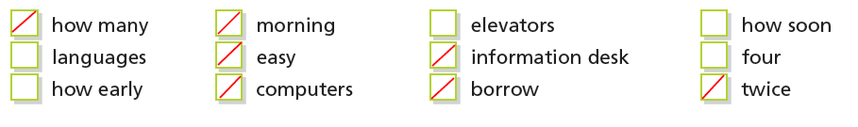

Unit 6 Lesson 5 It’s a really nice day.

1 Put a check mark next to the things students can see in a courtyard. Then try to write more.
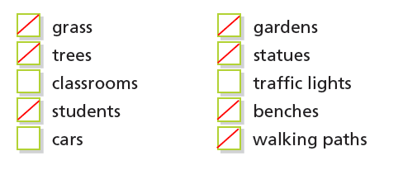
2 Match the pictures and the statements.
- b
- c
- a

3 Listen and underline the word in each sentence that has the greatest stress. Then listen again and practice. [Track 41]
- It’s too windy to use your umbrella!
- Wow, this campus is so beautiful.
- Oh, it’s so hot in here.
- The original Arts Building is very old.
- Well, the walk is a little far.
- This storm is really exciting!

4 Put the letters in order to make words.
- windy
- bench
- really
- courtyard
- weather
- sidewalk
- snow
- very
- warm
- foggy

Unit 6 Review
1 Vocabulary
Fill in the blanks with the words and phrases from the box.
- office
- empty
- lab; floor
- coffee maker
- May I
- take; message
- residence
- machine
- How often

2 Reading Comprehension
Read the article about office hours. Then put a check mark next to true or false.
- true
- false
- false
- true

3 Grammar
Match the two columns to make sentences.
- c
- e
- a
- b
- f
- d
- i
- h
- j
- g

4 Listening Comprehension
Listen to the conversation and fill in the blanks. [Track 42]
[KEY:
Brian: Dana, are you on the party planning committee?
Dana: The committee for the drama club? Yes, I am. Why? Do you want to help?
Brian: Well, kind of. Do you have a place for the party next week?
Dana: Yes, it’s in the room above the student lounge.
Brian: That room seems really small. There aren’t enough tables, either.
Dana: I know, but there’s no other room.
Brian: Well, why don’t we use dance studio two at the recreation center? I can make a reservation today.
Dana: That sounds great. But do they have any tables?
Brian: No, but the office next to it has some. We can use those.
Dana: How much does it cost?
Brian: It’s free, but we have to clean the studio after we finish.
Dana: That sounds perfect, Brian. Please make a reservation for five o’clock on Friday.
Brian: Okay. I’m on it.
Dana: And feel free to invite your friend!]

Module Review
1 Listen to the conversations. Then match them to the pictures. [Track 43]

Conversation #1: c
Conversation #2: b
Conversation #3: a

2 Underline the errors and rewrite the sentences correctly.
- Walk pass the front desk. The elevator is in front of the left.
Walk past the front desk. The elevator is on the left.

- Could you help me? How is I gets to the gym from here?
Could you help me? How do I get to the gym from here?

- You're at the 1st floor now. Go down to the 5th floor.
You're on the 1st floor now. Go down to the 5th floor.

- Excuse me. How do I follow the coffee shop?
Excuse me. How do I find the coffee shop?

- At the top of the hallway, turn left.
At the end of the hallway, turn left.

- Pardon you. Can I help you find the front door?
Pardon me. Can you help me find the front door?

3 Complete the sentences to describe your everyday life.
[KEY: Answers will vary.]
4 Jen has a busy day at Central University. Match the pictures with her schedule for today.
Activity | Photo
7:30 am - Meeting in Professor Singh’s office | b
10:00 – 3:30 - Classes in the Business Building | d
12:00 - Lunch in the courtyard with Joe | a
5:00 pm - Library (talk to Judy at info desk) | e
8:00 pm - Party in the student lounge | c

5 These are some comments Jen makes during her day on campus. Put the words in order to make sentences.
- I have a really early appointment.
- Professor Sullivan is a very smart woman.
- This garden is so lovely.
- Go down those really long stairs.
- The music in the lounge is loud.

6 Listen to Jen talk about the weather on campus. Fill in the blanks with the words you hear. [Track 44]
[KEY:
- Look! It’s so snowy and beautiful out there! Let’s get outside!
- Because of the rain and the cold, today is a good day to stay in the cafeteria and have a cup of coffee.
- It’s a really warm, sunny day – perfect for playing football in the courtyard!
- The air conditioning is too cold in the library. Let’s go outside where it’s nice and warm.
- I’m glad we don’t have classes in the heat of summer. The lecture halls would be really hot!]

7 Write a brief description of the weather this week where you live.
[KEY: Answers will vary.]

Unit 7 Study or Eat?
Unit 7 Lesson 1 Are you going to the cafeteria?

1 Match the questions and answers.
- d
- c
- a
- e
- b
- f

2 Listen to the conversations. Then match them to the pictures. [Track 45]

Conversation #1: b
Conversation #2: c
Conversation #3: a

3 Listen to the conversations again. Fill in the blanks to describe where the people are and what they’re doing. [Track 49]

- These students are doing homework in the coffee shop.
- This student is looking for his classmates in the library.
- This student is buying a book in the bookstore.

4 Put the words in order to make sentences.
- I’m not ordering dessert today.
- Is Brad driving them to the restaurant?
- We are searching for the Science section.
- Are you looking for something?

Unit 7 Lesson 2 In the Library

1 Fill in the blanks with the words from the box.
- would
- like
- returning
- want
- borrow
- I’d

2 Choose the best location(s) for each object or person.
Library | Bookstore | Cafeteria
Books | Books | Spaghetti
Librarian | Book shelves | Tea
Bookshelves | Call number | Beer
Waiting list |  | chicken
Call number

3 Read Martha’s email. The underlined words are grammar or vocabulary mistakes. Write the correct words below.
- working
- planning
- I’d like (I would like)
- title
- author
- reserve

Unit 7 Lesson 3 At the Cafeteria
1 Listen to the conversation and write the correct answer. [Track 46]

[KEY: They are going to the cafeteria.]

2 Listen again and put a check mark next to true or false. [Track 46]

- false
- true
- true
- false
- false

3 Put the conversation in the correct order. Then listen and check. [Track 47]
[KEY: Correct order = 3, 6, 1, 2, 7, 4, 5
Trevor: Hi Ricardo. I’m working on an assignment for Biology. It’s about healthy eating, so I thought I’d check the food in our cafeteria.
Ricardo: I see. So what kind of healthy food does the cafeteria serve?
Trevor: Well, they have some really good salads, sandwiches, pasta, and fruit juice.
Ricardo: Which foods here are bad for us?
Trevor: You can always find fries, ice cream, and drinks with a lot of sugar in them. I suggest that you don’t get what you usually eat. They serve great stew and salad here. What kind of fruit do you like?
Ricardo: I like apples, oranges, and grapes. Why?
Trevor: Just eat fruit for dessert this week. I see some nice grapes over there. Come on!]

4 Simon is looking for something. His friend Joanne is trying to help him. Fill in the blanks with what or what kind of to complete Joanne’s questions for Simon. Then listen and check. [Track 48]
- What
- What kind of
- What
- What

Unit 7 Lesson 4 At the Restaurant
1 Fill in the blanks with what or which.
- what
- which
- which
- what
- which
- what
2 Put the words in order to make sentences.
- Which fish do you want to order?
- What do you want for your birthday?
- I don’t know which ice cream to choose.
- What are you planning for dinner?
- Which restaurant does she work at?

3 Read the note and fill in the blanks with the words in the box.
- do
- books
- which
- have
- I’d
- What

Unit 7 Lesson 5 At the Café
1 Match each item with the correct picture. Then write countable or uncountable.
Item | Picture | Countable | Uncountable
1. pen | h | x
2. coffee | d |  | x
3. piece of pizza | b | x
4. book | f | x
5. sugar | c |  | x
6. orange juice | g |  | x
7. apple | e | x

2 Match the two columns to make questions.
- c
- e
- a
- g
- b
- d
- h
- f

3 Find and circle the words and phrases.
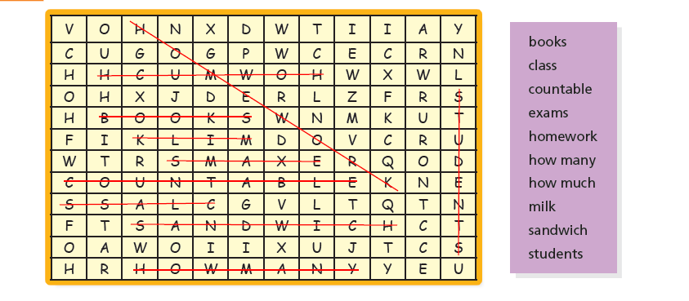

Unit 7 Review
1 Vocabulary
Choose the correct answers.
- d
- c
- b
- a
- b
- a

2 Grammar
Circle the correct answers.
- is watching
- cook
- like
- Which
- many
- What
- milk
- bottle of milk

3 Reading Comprehension
Read the message from Candice to her friend and put a check mark next to true or false.
- false
- true
- true
- false
- true
- true

4 Listening Comprehension
Listen to the conversations and fill in the blanks with the words from the box. [Track 49]
- is taking; semester
- library; starting; coffee
- like; spicy
- asking; kind; art history
- wants; buffet

Unit 8 Away from School
Unit 8 Lesson 1 Going Home
1 Match each picture to the related sentence.
- b
- a
- d
- c

2 Listen to the conversation and fill in the blanks. [Track 50]
[KEY:
Gina: When are you planning to leave work today?
Josh: I got here early, so I can go home at 3 o’clock.
Gina: Oh. Why are you leaving so early?
Josh: We’re moving this week, and I have to meet the movers at our old house.
Gina: Really! Where are you moving?
Josh: We bought a place on Wheelock Parkway. It is going to going to need a lot of work, but it was very cheap. The neighborhood is good for families, too. There are many parks, and it is near a lake. ]

3 Circle the correct answers.
- am going
- are driving
- are
- am meeting

Unit 8 Lesson 2 On the Way Home
1 Put the words in order to make negative imperative statements.

- You can’t turn right at this corner.
- Please don’t smoke in this room.
- Do not enter.
- No vehicles beyond this point.
- Do not block the intersection.

2 Fill in the blanks with the words and phrases from the box.

- don’t
- one-way
- straight ahead
- no parking
- don’t eat
- finishing
- yield

3 Write two rules for each place.
[KEY: Answers will very. Examples:
Rules at the school
- Arrive on time for class.
- Don’t forget your homework.
Rules at home
- Don’t go into the house with your shoes on.
- Always wash your hands before dinner.
Rules at the park
- Don’t give food to the birds.
- Put your garbage in the garbage can.]

Unit 8 Lesson 3 Arriving Home
1 Find and circle the words.
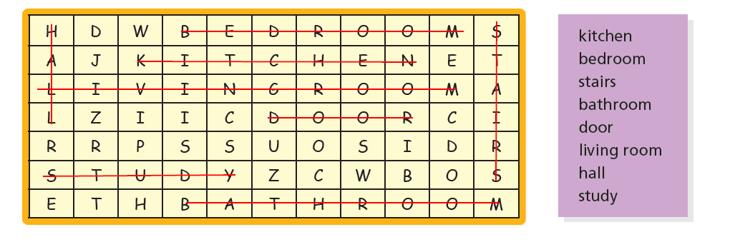

2 Fill in the blanks with and or but.

- but
- and
- and
- but
- but
- and

3 Write a description of the house. What rooms are there? How can you go from one to another?

[KEY: Answers will very.]

Unit 8 Lesson 4 Home Hobbies

1 What do you like? Complete each answer by filling in the blank with Yes, I like or No, I don’t like.

[KEY: Answers will very.
- Yes I like/No, I don’t like to go for walks.
- Yes I like/No, I don’t like to eat seafood.
- Yes I like/No, I don’t like to travel by train.
- Yes I like/No, I don’t like to stay up late.
- Yes I like/No, I don’t like to get up early.]

2 Listen to Brianne’s description and answer the following questions. Use complete sentences.
[KEY: Answers will very.
- She likes to play softball on Fridays.
- She likes riding her bike and playing softball.
- She likes to have a snack and relax at the kitchen table.
- She likes to visit her parents. ]

3 Complete each sentence with an appropriate word or phrase.
[KEY: Answers will very.
- eat pizza.
- watch television.
- go to the theater / watch movies ]

Unit 8 Lesson 5 Dinnertime

1 Listen to the conversation and fill in the blanks. [Track 52]

[KEY:
Tina: Hey George, can you help me cook this meat?
George: Sure, Tina. Oh wow, that’s a lot of meat! We’re barbecuing it, right?
Tina: Yeah. Thanks. I can’t do it alone, and I don’t want to burn it. I’m going to check the laundry. Oh, can you help me do the dishes later, too?
George: Well, all right. You’re giving me extra dessert for helping you so much, right?
Tina: Sure. And don’t whine, George. The food is free!]

2 Circle can or can’t and fill in the blanks with the words from the box.

- can't; cook
- Can; watch
- can; play
- can; have
- can’t; ride; wash
- can’t; read

3 Put the words in order to make sentences. More than one answer is possible.

[KEY: Answers will vary.

- I can play piano and guitar.
- Can you sing Happy Birthday to Mom?
- Can Dad make a cake?]

Unit 8 Review
1 Vocabulary
Fill in the blanks with the words from the box.
- bus, foot
- bedrooms, can, living
- watching
- subway
- can’t, game
- burn
- complaining
2 Grammar
Choose the correct answers.
- a
- c
- a
- a
- a
- b

3 Reading Comprehension
Read the email. Then underline the errors in the sentences below and rewrite them correctly.
- Steve can’t find a cheap place near his parents’ house.
- Steve and his uncle are building a room.
- Steve’s uncle lives above the new room.
- The new room has a small window.
- Steve asks Mike to move his furniture.
4 Listening Comprehension
Listen to the conversation and put a check mark next to true or false. [Track 53]
- false
- true
- true
- false
- false

Module Review

1 Fill in the blanks with the words and phrases from the box.
- writer; literature
- address
- server
- piece; cake
- soup
- call number; title
- play
- clean; kitchen; dishes
- stop; right now

2 Fill in the blanks with and, but, or or. In some blanks, can two answers be correct? Discuss.

[KEY: Answers can very.
- but
- or
- and
- or/and
- but
- and, but]

3 Underline the errors and write the correct word(s) in the blank. For correct sentences, write correct.
- correct
- Is Jim making a pizza for his mom’s party?
- What is he cooking for dinner?
- I’d like a piece of cake after dinner.
- How much does that laptop cost?
- Don’t smoke. It’s bad for your health.
- Correct
- I’d like a hamburger, French fries, and a soda.
- Correct
- No smoking.

4 Listen to the conversation and fill in the blanks. Then listen again and check. [Track 54]
[KEY:
Man: Just Eats Delivery. Can I take your order?
Woman: Hello. How many drinks come in Meal #1?
Man: That meal comes with four drinks.
Woman: Okay, that’s good. I’d like Meal #1 with two orders of noodles and two orders of rice.
Man: What kinds of drinks would you like?
Woman: Make all four colas, please. How much is all that?
Man: It’s $19.95. Can you tell me your address, please?
Woman: It’s 5 Bank Road, Apartment 3. There is no parking at the front. Please enter at the back. Call me when you leave the restaurant, and I can meet you downstairs.]

5 How do you relax at home? Write four things you do to relax. In class, discuss them with a partner.
[KEY: Answers will vary.]

6 How do you make your favorite food? Write instructions. Tell readers what to do and what not to do. Then find a picture of the food and attach it below, or draw it. Share your recipe with your classmates, family, and friends.
[KEY: Answers will vary.

