Unit 1 What to Do
Lesson 1 What are your plans?

1 Circle the correct answers.

1. right now.
2. next week
3. Right now
4. later

2 Look at the pictures and complete the sentences with the correct phrases from the box.

1. applying for a job
2. volunteering with kids
3. taking a gap year to travel
4. graduating early
5. getting experience in the hotel field

3 Put the words in order to make sentences.

1. I am working as a nanny.
2. Trevor is getting a student loan.
3. Are you thinking about volunteering with me?

Unit 1 Lesson 2 The Career Center

1 Listen to the announcement at the career center and put a check mark (√) next to the services they offer. [Track 02]

job board | √ | volunteer jobs | √ | help with interview | √ | intern information | √
résumé writing | √ | study space |  | personal problems |  | cooking lessons

2 Listen again and match the two columns to make sentences. [Track 02]

1. a
2. e
3. f
4. d
5. c
6. b

3 Circle the correct form of the verb according to the description.

1. lives
2. am taking
3. study
4. am going
5. has

4 Fill in the blanks with the correct words from the box.

Sean: I need to find a way to pay for school next year.
Counselor: Well, let’s think about your options, Sean. What are you studying?
Sean: I’m in my first year of the engineering program.
Counselor: Okay. Are you looking for employment right now?
Sean: Not now, but classes end for the summer next month. I’m thinking about getting a summer job close to campus—someplace local.
Counselor: We can work on writing your résumé and cover letter together.
Sean: That’s a good idea. I’m also thinking of practicing my interview skills.
Counselor: That’s a great idea, too.
Sean: Can I make an appointment for next week?
Counselor: Sure. Let’s say next Tuesday at 3:00. Here’s my card.
You can always get in touch with me by e-mail or phone.

Unit 1 Lesson 3 Making Decisions

1 Complete the crossword.

<Across>

4. technology
6. leader
7. outdoors

<Down>

1. stand
2. decision
3. worried
4. tough
5. shopping
6. look

2 Choose the correct answers.

1. c
2. b
3. a
4. c
5. a
6. b

3 Listen to the sentences. Put check mark (√) next to the ones with a pause. Then add a comma (,) where you hear the pause. [Track 03]

1. She’s studying IT because she’s really interested in computers.
2. Because Mary can’t decide on a major, she feels stressed. √
3. Most of my friends hate learning math because it’s very confusing.
4. Because he dislikes working outside, Rob isn’t studying agriculture. √
5. Because Natalia loves acting, she works in the entertainment field. √

Unit 1 Lesson 4 Deciding on the Future

1 Read the following ad. Guess which words go in the blanks, and write your guesses on the lines.

1. Would
2. to
3. Culinary
4. Carpentry
5. Education
6. want
7. will
8. want

2 Now listen to the ad and check your answers above. [Track 04]

Bayside Vocational College
Would you like to begin an interesting new career? Bayside Vocational College would like to help you reach your professional goals! Here are just a few of our programs:
▪ Culinary Arts: Restaurants and hotels are always looking for employees with good cooking skills.
▪ Carpentry: Learn about building, and even learn to make beautiful wood furniture.
▪ Education: Learn to teach young children and get ready for a job in childcare.
Our teachers have many years of experience in these fields, and they want their students to be successful!
Join us for a presentation on Thursday, May 12 from 2:00 – 4:00 p.m. We will answer your questions and help you prepare for your future!
At BCT, we want our students to reach their dreams!
www.bct.com

3 Match the questions and answers.

1. c
2. a
3. d
4. e
5. b

4 Underline the errors and rewrite the sentences correctly.

1. I will drop you off at the university.
2. The exam tomorrow won’t be easy
3. Your bags look heavy—I’ll help you.
4. That coffee smells good. Maybe I’ll have some.

Unit 1 Lesson 5 Ready for a Break

1 Put the words in order to make sentences. Then match the sentences with the pictures.

1. c , Are you tired of scrubbing the floor?
2. a , I’m tired of baking.
3. b , I’m taking a break instead of ironing.

2 Choose the correct answers.

1. a
2. a
3. b

3 Read the email and answer the questions. Write complete sentences.

1. Because her brother, Brandon, doesn’t like to cook, do the dishes, or vacuum.
2. She’s tired of hanging out with Brandon so much
3. They can save money. They will never be alone in the big city.

Unit 1 Review

1 Vocabulary

Circle the correct answers.

1. applying
2. architecture
3. culinary
4. résumé
5. tired
6. dog-sit
7. appointment
8. research
9. worried

2 Reading Comprehension

Read the information about Harvey. Then circle true or false.

1. false
2. true
3. true
4. false
5. false
6. true

3 Grammar

Fill in the blanks with the correct forms of the verbs.
Kevin: Hey, Sherri. Long time no see.
Sherri: Hi, Kevin. Nice to see you. What are you (doing) these days?
Kevin:( I’m taking) a gap year and (volunteering) at a library. What about you?
Sherri: I’m (leaving) for Ecuador tomorrow night. I (go) every summer.
Kevin: What do you (do) there?
Sherri: I (help) a doctor in a rural area. A dentist, actually. He checks and (cleans) children’s teeth.
Kevin: How did you get involved in that?
Sherri: I want to (be) a dentist, and volunteering is a good way to get experience. It’s great. I love (playing) with the kids.
Kevin: The library I (volunteer) at is (going) to throw away some books tomorrow. Do you want to (give) them to the kids?
Sherri: That’s a great idea! The local school (doesn’t have) a library. The kids really want books to (read).
Kevin: I (volunteer) in the afternoons. I’ll (ask) them today.
Sherri: I’m (meeting) my dad this afternoon. Can I come to the library tomorrow?
Kevin: Sure. I’m (putting) the books in boxes today. I’ll (save) a box for you. Come tomorrow afternoon.
Sherri: Great. I’ll (see) you then!

4 Listening Comprehension

Listen to the conversations and fill in the blanks with the correct words or phrases from the box. [Track 05]

1. going, Friday
2. studying, likes, to
3. meeting, job fair
4. would like, clean
5. tired of, going, local

Unit 2 Researching Your Options
Lesson 1 Searching for a Job

1 Read the job descriptions. Add a sentence to each one using the words from the box.

Answer will vary. Sample answers provided.

1. Must be hard-working and be able to work long hours.
2. Come work in one of the most interesting libraries in the city.
3. Must be able to handle challenging situations.

2 Circle the correct words.

1. write
2. don’t have
3. has
4. got to
5. had
6. didn’t have to

3 Read the notice. Then put a check mark (√) next to true or false.

1. true
2. false
3. true
4. true

Unit 2 Lesson 2 Applying for a Job

1 Complete the crossword

Across:
2. registrar
6. transcript
7. academic
8. valuable

Down:
1. excellent
3. submit
4. applicant
5. successful

2 Write about the signs below using must, must not, or have to.

1. You must not use a cell phone.
2. You must not park here.
3. You have to be quite here.

3 Listen to the conversation and circle the correct answers. [Track 06]

1. teaching assistant
2. next week
3. transcripts
4. Victoria

4 Listen again and fill in the blanks. [Track 06]

1. reference
2. excellent, organized
3. valuable

Unit 2 Lesson 3 Decisions, Decisions

1 Circle the correct answers

1. reputation
2. decision
3. decide
4. abroad
5. location
6. quality
7. courses
8. MBA

2 Put the words in order to make sentences.

1. Charmaine may start her Master’s degree next year.
2. The library might not be open during this storm.
3. I may buy a new computer.
4. This applicant might apply for a better position.
5. Peter may not quit his job this year.

3 Write sentences comparing each of the following pairs of things. Use comparative adjectives.

Answers will vary.

1. The country is quieter than the city.
2. Meat is more expensive than vegetables.
3. A college is bigger than a high school.
4. Driving is faster than biking.
5. My school is older than other schools.
6. English is easier than other subjects.
7. My classmates are funnier than me.

Unit 2 Lesson 4 University Ratings

1 Read the letter and fill in the blanks with the correct words from the box.

1. rated
2. categories
3. facilities
4. faculty
5. Academy
6. province

2 Fill in the blanks with the superlative form of the correct adjective from the box.

1. youngest
2. funniest
3. most challenging
4. most intelligent
5. worst

3 Listen to these predictions about the future and circle the stressed syllable in probably, perhaps, and maybe. [Track 07]

1. The fastest way home from work today will probably be the subway
2. Perhaps David will find a new job before the end of the summer.
3. May-be the weather will improve next week. The news said it might.

4 Think about the next year of your life. Write these sentences about what you might do.

Answers will vary.

Unit 2 Lesson 5 Studying Abroad

1 Complete the chart with the intensifiers form the box.

Mild | Strong | Very Strong
fairly | very | completely
rather | really | extremely
quite | so | totally
 | such

2 Find and circle the words.

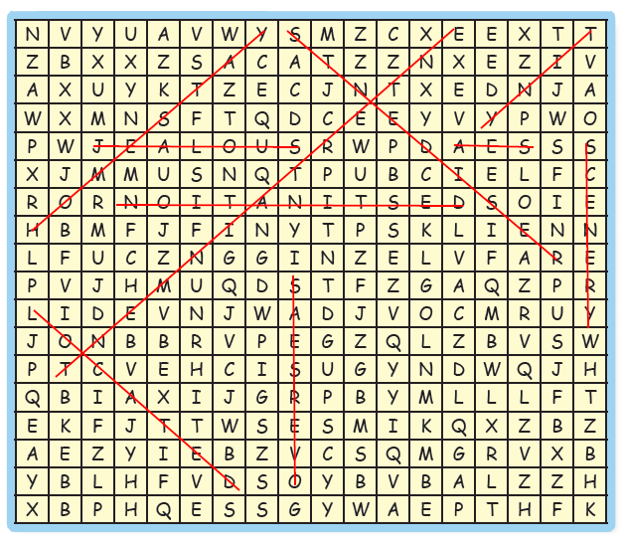

3 Anita is studying abroad. Look at the picture of Istanbul, the city she’s studying in. Imagine you are Anita. Write a letter to your family. Describe your city and your new school. Use some intensifiers and the vocabulary above to help you.

Answers will vary.

Unit 2 Review

1 Vocabulary

Match the words with their definitions.

1. f
2. a
3. j
4. c
5. d
6. b
7. e
8. h
9. i
10. g

2 Grammar

Circle the correct answers.

1. Maybe, have to
2. probably, have
3. didn’t have
4. must not
5. interested, interesting
6. so, such
7. quite, Perhaps
8. the best, better than
9. must

3 Reading Comprehension

Read the note. Then choose the correct answers.

1. a
2. a
3. c
4. c
5. b
6. c

4 Listening Comprehension

Listen to the conversations. Then put a check mark (√) under true or false. [Track 08]

1. false
2. true
3. true
4. false
5. false
6. true
7. false

Module Review

1 Put the conversation in the correct order. Then practice reading it with a partner.

6 Ben: You’re right. School fees are very high. Maybe you should use all your options.
1 Abby: I’m thinking of applying for a student loan for next year.
4 Ben: That’s true. Not many local employers are hiring this year.
9 Abby: Yes, that’s probably good advice.
2 Ben: Really? Why don’t you get a job instead?
5 Abby: And even with a part-time job, I still might not have enough money for tuition.
7 Abby: What do you mean?
8 Ben: I mean keep looking for a job, and apply for loans, and try to get scholarships.
3 Abby: I want to! I tried really hard to get a job, but it’s so difficult these days.

2 Match the fields to the jobs.

1. e
2. c
3. f
4. b
5. d
6. a

3 Put the words in order to make sentences.

1. Which university has a better reputation?
2. Perhaps I can help you with your cover letter
3. We hired him because he was the best applicant
4. Choosing a major was such a challenging decision.

4 Fill in the blanks with the correct words form the box.

1. motivated
2. successful
3. Applicants
4. submit
5. application
6. reference

5 Listen to the conversation and answer the questions. [Track 09]

1. a
2. b
3. b
4. a

6 You are writing a description of yourself for a career counselor so she can help you find the perfect job. Complete the sentences.

Answers will vary.

7 Make predictions about the following topics using will, might, may, possibly, perhaps, or probably.

Answers will vary.

Unit 3 Basics of the Process
Lesson 1 A Job Application

1 Listen to the conversation and fill in the blanks. [Track 10]

1. filling out
2. information
3. hours
4. employer

2 Listen again and answer the questions. [Track 10]

1. a
2. a
3. b
4. a
5. b

3 Listen to the answers and write questions using can or may. [Track 11]

1. May we contact your past employer?
2. Can I borrow this book now?
3. Can I throw out those papers?
4. Can we sit at these tables?
5. Can I drop by your office later?

4 Fill out the job application with your own personal data and preferences.

Answers will vary.

Unit 3 Lesson 2 Scheduling an Interview

1 Find and circle the words in the box.
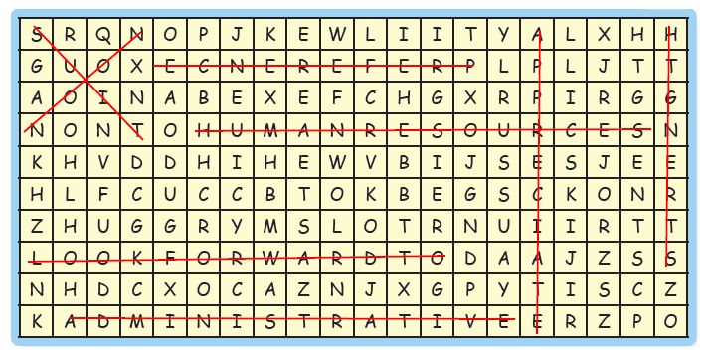

2 Read the email. Fill in the blanks using prefer or prefer to.

1. prefer
2. prefer to

3 Read the email again and answer the questions.

1. He emails her to invite her to an interview.
2. Jim prefers a Monday or a Tuesday.
3. Jim asks her to call to let him know when she prefers to meet him.

4 Listen to the conversation and circle true or false. [Track 12]

1. true
2. true
3. false
4. true

Unit 3 Lesson 3 Preparing for an Interview

1 Fill in the blanks with the correct words from the box.

1. plenty
2. outfit
3. First impressions
4. arrive
5. recommend

2 Circle the imperatives

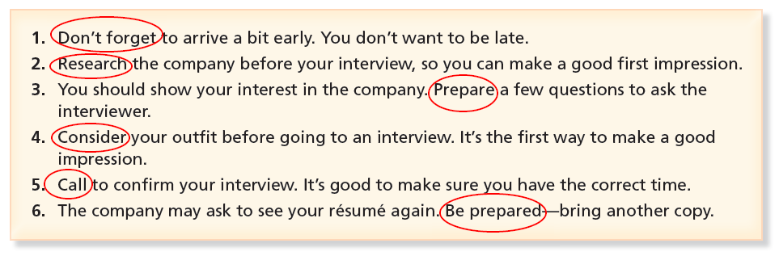

3 Fill in the blanks using should or suggest.

1. should
2. suggest
3. should
4. should
5. suggest

4 Listen to the conversations and fill in the blanks. Then listen and check. [Track 13]

Conversation 1: interview, late, résumé
Conversation 2: Guess, researched, questions, interviewer

Unit 3 Lesson 4 The interview begins.

1 Underline the errors and write the correct words in the blank.

1. Before we start, can I ask a few questions?
2. My boss knows that I am planning to quit..
3. I worked at a small supply company, before I began to work here.

2 Listen to the conversation and circle true or false. [Track 14]

1. true
2. true
3. false
4. true
5. true

3 Listen again and fill in the blanks. [Track 14]

Mr. Michaels: I’m glad you could come in today, Wendy. I have your résumé right here. It’s outstanding. So, did you research the company?
Wendy: Yes, I did, Mr. Michaels. I know that you established your company more than twenty years ago, and that you’re now the largest office supply company in the local area.
Mr. Michaels: You’re quite right. Excellent. And I see that you have a lot of sales experience. Why did you apply to Hartford Corporation?
Wendy: Well, I work for a small company, but I think my career might last longer at a larger one. And I know that your company offers professional development.
Mr. Michaels: That’s true. Alright, let’s go over the duties of the position.

4 Listen and fill in the blanks with the correct adverb of sequence. Then put the description in the correct order. [Track 15]

3 1. After that
1 2. First
4 3. Finally
2 4. Next

Listen and check your answers. [Track 16]

Dear Diary,
Today I had a job interview. Before the interview, I researched the company. At the interview, we talked a lot. First, Mr. Michaels asked me about my experience. Next, he told me about Hartford Corporation. The company is very large and successful. After that, Mr. Michaels asked why I want to leave my job at Star Advertising. Finally, we talked about the position. I think the interview went very well.

Unit 3 Lesson 5 The Job Description

1 Match the two columns to make sentences.

1. e
2. a
3. d
4. b
5. c
6. g
7. f

2 Put the words in order to make sentences.

1. Are you familiar with this software?
2. He knows how to work with the media.
3. Who is in charge of hiring?
4. You must know how to work closely with clients.

3 Unscramble the words. Then fill in the blanks below with the correct words.

communications director
marketing supervisor
web designer
project manager
content developer
art director

1. project manager
2. content developer
3. marketing supervisor
4. web designer
5. art director
6. communications director

Unit 3 Review

1 Vocabulary

Circle the correct answers.

1. a
2. d
3. b
4. b
5. a
6. c
7. a

2 Grammar

Underline the errors and write the correct word(s) in the blanks

1. Here’s an application. Please fill it out and bring it back.
2. I’d suggest reading a little about the company first.
3. I prefer not to eat anything for breakfast.
4. Before I leave, I’d like to ask you something.
5. You can find your seat on the train.
6. I know that you have a lot of experience.
7. May I/we contact your last employer?

3 Reading Comprehension

Read the advertisement. Then put a check mark next to true of false

1. true
2. false
3. true
4. false
5. false
6. true

4 Listening Comprehension

Listen to the conversation and complete the summary. [Track 17]

A man and a woman are talking. The man wants to work in the field of information technology. He has an interview tomorrow, and he’s excited about it. He’s also worried, but the woman tells him that he has the right qualifications for the job. The man doesn’t have any experience with job interviews, so he asks the woman for some tips. She tells him he should research the company, but he already did. He says it’s an outstanding company. She tells him he should make a good first impression and asks about the outfit he will wear. He says he will decide later. She tells him to arrive early, but he’s already planning to do that. He’s worried about answering questions, so the woman suggests doing a role-play—she’ll be the interviewer. The man says he appreciates her help, and they start.

Unit 4 Deeper into the Interview
Lesson 1 Basic Questions

1 Match the words and phrases to the correct definitions.

1. c
2. g
3. a
4. i
5. h
6. d
7. j
8. f
9. b
10. e

2 Listen to the conversation and choose the correct answers. [Track 18]

1. a
2. b
3. a
4. b
5. b

3 Look at the pronouns in bold. Circle object or reflexive.

1. reflexive
2. object
3. object
4. object
5. reflexive

4 Underline the errors and rewrite the sentences correctly

1. Does Pete take a lot of pictures of himself?
2. Can you tell me about her?
3. It is so nice to meet you.
4. Tell me about your job experience.

Unit 4 Lesson 2 Talking About Your Last Job

1 Complete the crossword.

Across:
1. teamwork
4. trends
6. overtime
7. deadline
8. background

Down:
2. easygoing
3. encouraging
5. describe

2 Read the conversation and fill in the blanks with words and phrased from the box.

1. was
2. entry-level
3. like
4. easygoing
5. deadline
6. overtime
7. were
8. come up with

3 Circle the correct answers to complete the questions. Then look back at exercise 2 and write answers to the questions.

1. was It was an entry-level position at a computer company.
2. were There were five people on his team.
3. were They were easygoing.
4. were Yes, there were some deadlines.
5. was Yes, there was some overtime.
6. was He overcame challenges by coming up with creative solutions.

Unit 4 Lesson 3 Talking About Your Education

1 Fill in the blanks with the correct words from the box. Use the simple past tense.

1. graduated
2. studied
3. managed
4. realized
5. planned
6. benefited

2 Match the two columns to make sentences.

1. f
2. b
3. a
4. e
5. c
6. d
7. g

3 Listen to the monologues and fill in the blanks. Then listen again and check. [Track 19]

I graduated last year with a Bachelor of Arts. At school, I majored in history and minored in geography. I loved learning about places and societies around the world. I also completed a course in project planning at another college last month.

A few years ago, I graduated from college with a degree in fine arts. When I was in school, I majored in visual arts. I learned a lot about art and design. Last year, I studied graphic design. I’m really enjoying my current position as a graphic designer.

Unit 4 Lesson 4 Some Difficult Questions

1 Read the email. Then read the statements and circle true or false.

1. false
2. true
3. false
4. true
5. false
6. true
7. false

2 Read the email again. Underline all the past tense verbs. Then make a list of the regular and irregular verbs you find.

Regular Past Tense Verbs | Irregular Past Tense Verbs
asked, answered, stayed, finished, smiled, promised | was, gave, woke up, ate, had, felt, saw, spoke, thought, told

3 Complete the sentences with information that is true for you.

Answers will vary.

Unit 4 Lesson 5 The End of the Interview

1 Fill in the blanks with the correct words from the box.

1. candidates
2. someday
3. department
4. wrap up
5. work on
6. starting date
7. hear from
8. long-term

2 Put the words in order to make sentences.

1. Who will run the department when you leave?
2. We’ll tell you when we finish interviewing the candidates.
3. He’s going to sleep when he gets home.
4. I’ll look for a job when I finish school.
5. Where will you quit when you go?

3 Read the paragraph about Amy’s future plans. Then complete the sentences.

1. she finishes school
2. she tells them she will move to Montreal
3. she gets a great job as a lawyer and invite them to visit

Unit 4 Review

1 Vocabulary

Circle the correct answers.

1. b
2. c
3. a
4. a
5. d
6. a
7. b

2 Grammar

Put the words in order to make sentences

1. How many people were at the meeting?
2. I’ll be happy when I find a job.
3. What was your math teacher like?
4. My friends really enjoyed the party last week.
5. Brian was happy when you saw him.

3 Reading Comprehension

Read the email. Then put a check mark next to true or false.

1. true
2. true
3. false
4. true
5. true
6. true
7. false

4 Listening Comprehension

Listen to the conversation and fill in the blanks with the correct words and phrases from the box. [Track 20]

1. previous
2. overtime
3. deadlines
4. easygoing
5. Unfortunately, come up
6. responds, encouraging
7. attitude

Module Review

1 Put the conversation in the correct order. Listen and check. Then practice. [Track 21]

5 Excellent. Would you be able to meet with me on Monday or Tuesday afternoon of next week?
4 That’s nice to hear. And yes, I’m still available.
3 Yes. Your qualifications are outstanding. Are you still available for an interview?
1 Hello, Ms. Montes? This is Tom Price, the human resources manager at Smith Graphic Design.
2 Oh, hello. Thanks for contacting me. Are you calling about my application?
7 Okay, that works. Can I call you on Tuesday morning to confirm the exact time?
6 I have classes Monday afternoon, so I’d prefer Tuesday if possible.
8 That sounds good. I’m looking forward to hearing from you.

2 Fill in the blanks using the correct simple past verbs.

1. was
2. worked
3. were, were
4. finished, took
5. left, felt

3 Write the simple past form of each verb. Then listen and repeat. [Track 22]

Verb | Simple Past | Verb | Simple Past | Verb | Simple Past
1. learn | learned | 4. stop | stopped | 7. copy | copied
2. see | saw | 5. love | loved | 8. call | called
3. graduate | graduated | 6. eat | ate | 9. think | thought

4 Underline the errors and write the correct word(s) on the lines.

1. I suggest wearing your best outfit to the interview.
2. May I ask you a few more questions?
3. Always research the company before the interview.
4. You should bring a copy of your résumé when you go.
5. Applicants need to submit three reference letters.

5 Match the two columns to make sentences.

1. c
2. a
3. e
4. b
5. d

6 Write the words under the correct pictures.

1. relocate
2. deadline
3. noon
4. outfit
5. candidate

7 Fill in the blanks with the correct phrases from the box.

1. know how to
2. in order to
3. need to
4. able to
5. prefer to

8 Look at Steve’s plans for the future. Fill in the blanks.

When I graduate from college, I’ll look for a job. I’ll apply at several companies and prepare myself for my interviews. When I get a job, I’ll work hard and learn as much as possible. Then, when I’m 30 years old, I’ll start and manage a business. When I have confidence that my company will be successful, I’ll buy a house.

Unit 5 Changing Your Major
Lesson 1 Deciding What to Study

1 Listen to the conversation and circle the correct answers. [Track 23]

1. c
2. a
3. b
4. b
5. a
6. c

2 Match the words form the conversation with the correct definitions.

1. b
2. d
3. e
4. a
5. f
6. c

3 Put a comma (,) in the sentences that need one.

1. If you want to choose a university, there are many factors to think about.
2. Doesn’t need a comma.
3. Doesn’t need a comma.
4. If a student has to make an academic decision, she should discuss her options with a counselor or professor.

4 Complete the zero-conditional sentences with your own ideas.

Answers will vary. Sample answers provided.

1. If I have enough time, I usually study.
2. If students study hard, they get good grades.
3. If a class is boring, students will be bored.
4. If you don’t like your major, you will be unhappy.
5. If you are sick, you can feel pretty unhappy.
6. If you work hard, you can get a good job later in life.

Unit 5 Lesson 2 Choosing Your Major

1 Complete the crossword.

Across:
1. assist
3. social
4. theory
5. politics
6. products
7. similarities

Down:
1. advertising
2. relations
5. profession

2 Put the words in order to make sentences.

1. You have to be competitive in order to succeed.
2. Megan studies social work to learn to help people.
3. Contact the registrar’s office to change your major.
4. Jayce takes advertising to prepare for his future profession.
5. I study philosophy in order to understand different theories.

3 Answer the question with information that is true for you. Use(in order) to + verb.

Answers will vary.

1. I study English in order to be an English teacher.
2. I want to visit Egypt in order to see the pyramids.

Unit 5 Lesson 3 Changing Majors

1 Fill in the blanks with the correct words from the box.

1. argue; persuade
2. spends; knowledge
3. passion; motivated
4. details

2 Read the letter. Then put a check mark next to true or false.

1. false
2. true
3. true

3 Circle the correct answers. More than one answer is possible.

1. using computers, motivating coworkers
2. designing
3. increase
4. find / to find

4 Use the pictures below to write sentences about what the people are good or bad at doing

Answers will vary. Sample answers provided.

1. The woman is good at singing.
2. The man is bad at driving.
3. The couple is good at cooking.

Unit 5 Lesson 4 What would you rather study?

1 Match the majors and the descriptions of people’s careers.

1. f
2. c
3. d
4. a
5. b
6. e

2 Circle the correct answers.

1. work
2. than
3. or
4. I’d
5. Would
6. would rather not

3 Listen to the conversation and fill in the blanks. Then listen again and check your answers. [Track 24]

Tomoko: I can’t decide if I should major in hospitality management or interior design. I love them both.
Rob: Wow, those subjects are so different from each other. Would you rather work in a hotel or a design lab?
Tomoko: Well, I don’t know. I’ll meet more people working in a hotel. But I’ll work more creatively if I study design.
Rob: Would you rather travel a lot or stay in one place?
Tomoko: I’d rather not travel for business. Working right here in the city is best for my family.
Rob: Who would you rather work for, yourself or someone else?
Tomoko: Having a bad boss is the worst situation. I would rather manage my own hotel.
Rob: Then, I think you should major in hospitality. You could minor in interior design so you could plan the design of your hotel.
Tomoko: That’s perfect, Rob. That’s exactly what I’ll do.

4 Complete the chart below with “Would you rather…?” questions and answers that are true for you.

Answers will vary. Sample answers provided.

1. cat vs. dog / Would you rather have a cat or a dog? / I’d rather have a cat than a dog.
2. Japan vs. India / Would you rather visit Japan or India? / I’d rather visit Japan than India.
3. soccer vs. skiing / Would you rather play soccer or go skiing? / I’d rather go skiing than play soccer.

Unit 5 Lesson 5 Communicating Your Choice

1 Fill in the blanks with the correct words from the box.

1. generous support
2. finally
3. switch, therapy
4. practical

2 Listen to the sentences and underline the words that receive the most stress. Then practice repeating the sentences. [Track 25]

1. Celia studies harder than Melanie does.
2. My new professor speaks less clearly than my old professor.
3. Graduates with a master’s degree find jobs more easily than those with a bachelor’s degree.
4. My parents didn’t support me as much as your parents supported you.

3 Fill in the blanks with other, another, or else.

1. else
2. another
3. other
4. else
5. other
6. another

4 Read the email and circle the correct answers.

1. better
2. harder
3. the fastest
4. better
5. carefully

Unit 5 Review

1 Vocabulary

Circle the correct answers.

1. b
2. c
3. b
4. a
5. c
6. b
7. a

2 Grammar

Match the two columns to make sentences.

1. c
2. d
3. g
4. a
5. f
6. b
7. e
8. h

3 Reading Comprehension

Read the email and complete the sentences.

1. ask for some advice about school
2. counselor, Lakefield College
3. very good facilities, faculty, and programs
4. a good urban location
5. major, travel and tourism, hospitality management
6. more practical, profession
7. talk about his interests and opportunities
8. him decide on a major

4 Listening Comprehension

Listen to the conversations and circle the correct answers. [Track 26]

1. b
2. b
3. a
4. a
5. b
6. a
7. a

Unit 6 Transferring
Lesson 1 Looking for a School

1 Put a check mark next to P (preposition) or A (Adverb of place) for each bold word.

1. A
2. P
3. P
4. A
5. A

2 Match the columns to make sentences.

1. c
2. a
3. d
4. b
5. e

3 Listen to the announcement about Leslieville University. Who is this advertisement for? [Track 27]

Key: students choosing a school

4 Listen again and check the words that you hear. [Track 27]

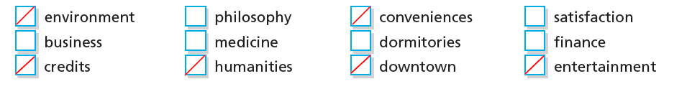

5 Read these profiles and decide whether Leslieville University is the right school for these people.

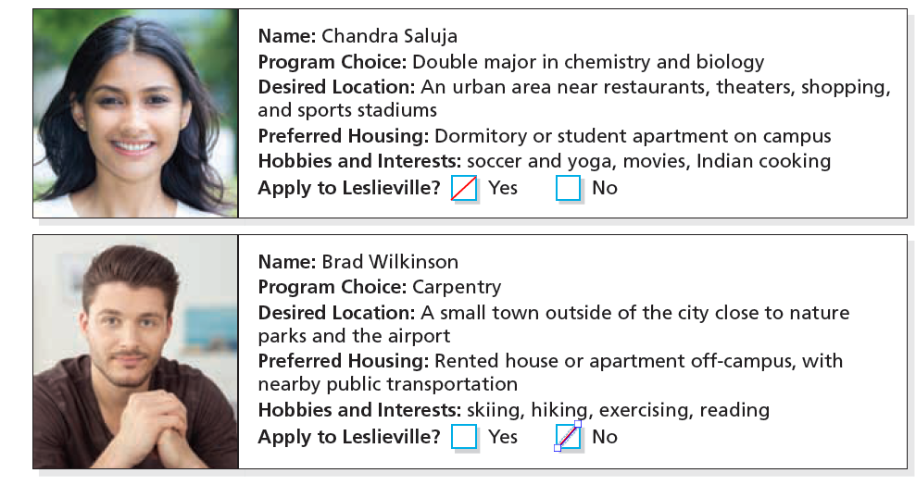

Unit 6 Lesson 2 Changing Schools

1 Fill in the blanks with the correct words and phrases from the box.

1. statistics
2. environmental science
3. Physical therapy
4. fail
5. warning
6. intense

2 For each statement, write a suggestion using had better of let’s.

Answers will vary. Sample answers provided.

1. You had better join a club.
2. Let’s study hard from now on.
3. Michelle had better visit the registrar’s office.
4. Jay had better talk with his roommate.
5. Let’s go on a day trip.

3 Read the email and circle the correct answers.

1. You’d better
2. you’d better
3. Let’s
4. you’d better not
5. Is it

4 Read the email again and circle true or false.

1. true
2. false
3. false
4. false

Unit 6 Lesson 3 Researching Options

1 Match the words with the correct definitions.

1. d
2. b
3. g
4. e
5. f
6. c
7. a

2 Fill in the blanks with the correct words and phrases form the box.

1. graduate
2. have
3. consider
4. get
5. inspire
6. learn
7. make
8. assist

3 Complete the sentences with your own ideas. Use the first conditional.

Answers will vary. Sample answers provided.

1. I will stay home
2. my parents will buy me a laptop
3. I drink a coffee
4. finish my homework today
5. I’ll get a good job if I graduate from a good university.

4 Listen to the sentences. Put a check mark next to the ones with a pause. Then add a comma (,) where you hear the pause. [Track 28]

1. If I fail this test, I’ll have to take the class again next semester.
2. no pause
3. no pause
4. If you have problems with your major, the counselor will give you assistance.

Unit 6 Lesson 4 Visiting a Campus

1 Find and circle the words from the box.
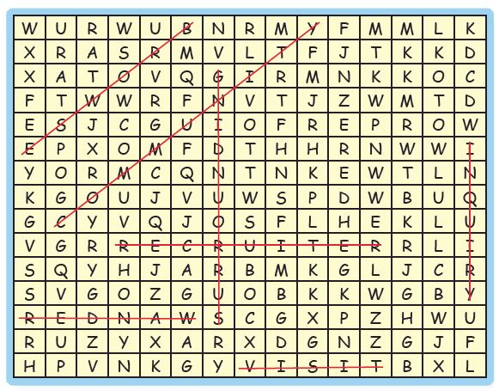

2 Put the words in order to make sentences.

1. Jason doesn’t think that I should change my major.
2. Does your professor think that you made a mistake?
3. Which website do you think we should browse?
4. I think my parents are happy for me.
5. How about sitting in on that class?
6. What about living in the surrounding area?

3 Match the questions with the correct responses.

1. b
2. c
3. e
4. d
5. a

Unit 6 Lesson 5 Going Abroad to Study

1 Match the words and phrases with the correct pictures.

1. f
2. c
3. d
4. e
5. b
6. a

2 Fill in the blanks with the correct words from the box. Then listen and check your answers. [Track 29]

KEY: keep; take; do; don’t; traveling; saying; visit; come

3 Give suggestions for each situation.

Answers will vary.

1. Why don’t you study with a friend?
2. Why not change majors?
3. Why don’t you get a part-time job?
4. Why don’t you try studying abroad?
5. You should go online and research.

Unit 6 Review

1 Vocabulary

Fill in the blanks with the correct words form the box.

1. intense
2. switch
3. insurance
4. conveniences
5. community
6. visa
7. limited

2 Reading Comprehension

Read the article. Are the statements below true (t) or false (f)?

1. false
2. false
3. true
4. true
5. true

3 Grammar

Put the words in order to make sentences.

1. Let’s wander around the building.
2. I think you’d better study environmental science.
3. You’ll get a warning if you are late twice. / If you are late twice, you’ll get a warning.
4. She keeps talking about her TESOL course.
5. Do you have to teach a class right now?
6. Jason continues to teach English in China.
7. The water fountain is right outside.
8. Why don’t you go and ask her?

4 Listening Comprehension

Listen to the conversation. Then fill in the blanks with correct words from the box. [Track 30]

Conversation 1: get into; enrolling; transferring
Conversation 2: to discuss; humanities; satisfaction; faculty

Module Review

1 Fill in the blanks with the correct words from the box.

1. quickly
2. take
3. good
4. won’t
5. if
6. better
7. rather
8. will

2 Match the words with the correct definitions.

1. i
2. f
3. d
4. h
5. j
6. b
7. a
8. e
9. c
10. g

3 Underline the errors and rewrite the sentences correctly.

1. We are closed now. Please visit the registrar’s office another day.
2. He studied life sciences in order to get into medical school and be a doctor.
3. Amelia asked Marco to help her study Spanish.
4. It’s too hot. Let’s go inside and get some cool air.
5. Jasmines’ very bad at doing math problems.
6. I’d rather study abroad than stay home this summer.

4 Put the letters in order to make words that match the definitions.

1. conveniences
2. downtown
3. knowledge
4. recruiter
5. budget

5 Put the words in order to make sentences.

1. Let’s have a look at some brochures.
2. Is anyone helping you move?
3. I have to write a letter. / I have a letter to write.
4. This recruiter has some information to show us.
5. Does anyone have to make an inquiry?

6 Fill in the blanks with the correct phrases from the box. (Answers may vary, and you may use some phrases more than once.) Then practice the conversation.

Answers will vary.
Why not; Let’s; What about; I’d rather; had better; How about; had better; Why don’t

7 Write sentences to describe the pictures.

Answers will vary. Sample answers provided.
1. playing tennis
2. me move
3. take a train than a bus
4. exercising every day
Unit 7 Time Off
Lesson 1 Taking a Semester Off

1 Write the past participle of each verb.

1. found
2. read
3. thought
4. done
5. eaten
6. chosen
7. bought
8. heard

2 Match the two columns to make sentences.

1. c
2. d
3. a
4. e
5. b

3 Fill in the blanks with the correct bold words and phrases from exercise 2. Not all of the words will be used.

1. blog
2. figure out
3. backpacking
4. pros and cons
5. waste, earn

4 Put a check mark next to the correct answer.

1. Yes, I have.
2. Yes, he has.
3. No, they haven’t.
4. No, I haven’t.
5. Yes, he has.
6. Yes, I have.

5 Put the words in order to make sentences.

1. I haven’t taken a semester off yet.
2. Josh volunteered at a hospital last year.
3. We haven’t found a good program.
4. Have considered studying abroad?
5. I’ve never thought about it before.

Unit 7 Lesson 2 An Email Home

1 Match the two columns to make sentences.

1. c
2. e
3. a
4. b
5. d

2 Put a check mark next to the correct response.

1. A few of them are.
2. No, none of them do.
3. Yes, a few of them have.

3 Read the email. Circle the correct answers.

1. made
2. haven’t found
3. has gotten
4. haven’t spoken
5. made
6. had

4 Circle the errors and rewrite the sentences correctly.

1. I still haven’t done any research on study-abroad programs.
2. I haven’t spoken to the tutor about my study skills yet.
3. We met with our professor yesterday.
4. Liam has a few appointments with the advisor.
5. To me, none of this music sounds very good.

Unit 7 Lesson 3 Going Home

1 Listen to the conversation. Read the statements and circle true or false. [Track 31]

1. true
2. false
3. true
4. true
5. false
6. true
7. false

2 Listen again and circle the correct words. [Track 31]

1. in
2. It’s
3. since
4. for; for
5. in
6. It’s
7. since

3 Fill in the blanks to make true sentences about yourself.

Answers will vary.

4 Listen and circle the correct answers. Then listen again and check. [Track 32]

1. it’ll
2. It’s
3. It’s
4. It’ll
5. It’s

Unit 7 Lesson 4 Go traveling!

1 Complete the crossword.

Across:
3. post
5. help
6. sightseeing
7. climb

Down:
1. litter
2. dolphin
4. plant
6. sail

2 Put the words in order to make sentences

1. Have you ever thought about volunteering?
2. I’ve never climbed a mountain.
3. My roommate always studies at the library.
4. Lily has always wanted to go backpacking.
5. Do you ever help your family out?
6. He never stays up past midnight.

3 Circle the correct answers.

1. during
2. while
3. while
4. during
5. During
6. while

Unit 7 Lesson 5 Part-time Job

1 Fill in the blanks with the correct words from the box.

1. IT skills
2. wages
3. organization
4. customer service
5. advancement
6. leadership

2 Listen to the conversation. Circle true or false. [Track 33]

1. false
2. true
3. false
4. false
5. true

3 Listen again. Put a check mark next to all the working conditions and work skills that you hear. [Track 33]

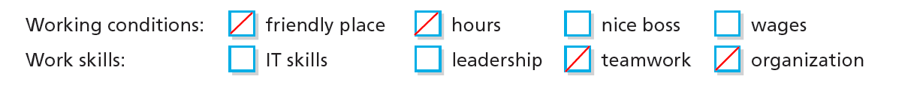

4 Match each question with the correct response.

1. b
2. c
3. e
4. a
5. d

5 Circle the correct words.

1. since
2. so far
3. so far
4. so far
5. since
6. since

Unit 7 Review

1 Vocabulary

Match each sentence on the left with an activity on the right.

1. b
2. f
3. g
4. a
5. d
6. e
7. c

2 Grammar

Underline the errors and rewrite the sentences correctly.

Answers may vary.
1. I have never taken time off from school.
2. My sister still hasn’t made up her mind about lunch.
3. My parents visited me here last year.
4. He had a part-time job during school.
5. Marie has come to class every day.
6. I’ve begun taking some courses in leadership.
7. She has been backpacking for the last three months.

3 Reading Comprehension

Read the article. Then read each statement and circle true or false.

1. true
2. true
3. true
4. false
5. true
6. false

4 Listening Comprehension

Listen to the conversation. Then fill in the blanks with correct words and phrases from the box. [Track 34]

1. figured out
2. dying
3. for; since
4. waste time
5. earn
6. a while
7. uncertain

Unit 8 Studying Abroad
Lesson 1 Canada or the USA?

1 Put the conversation in the correct order. Listen and check. Then practice. [Track 35]

KEY: 1; 10; 7; 2; 9; 8; 5; 6; 3; 4

Jamie: What are you doing, Sally?
Sally: Oh, hi, Jamie. I’m researching study-abroad programs on the Internet.
Jamie: Oh, really? Where would you like to go?
Sally: I’ve researched it thoroughly, and the main city I’m interested in is Melbourne. I’m a big fan of the sea and warm weather.
Jamie: Sounds good. Do you think you’ll stay in a dorm or with a family?
Sally: I think a dorm would be better, especially for making friends. I could also travel with them.
Jamie: I agree. It’s extremely important to make friends when you live abroad.
Sally: Exactly. What about you? Would you like to study abroad?
Jamie: I’ve always wanted to, but I’m not sure if I could afford it or not.
Sally: Then, let’s do some research. I bet we can find a program suitable for your budget.

2 Listen again. Then circle true or false. [Track 35]

1. true
2. false
3. true
4. false
5. true

3 Put the words in order to make sentences.

1. I don’t know whether she’ll arrive on Friday or Saturday.
2. We aren’t sure if he went home or not.
3. He doesn’t know whether to study English or French.
4. Do you usually enjoy the nightlife or stay home?
5. My parents aren’t sure if they‘ll take a vacation.
6. Do you know whether you’ll go to Canada or America?

Unit 8 Lesson 2 US City Guides

1 Match the words to their definitions.

1. f
2. c
3. e
4. b
5. a
6. d

2 Read the sentences. Circle the correct answers.

1. least
2. least beautiful
3. less
4. more
5. most expensive
6. less rainy
7. both

3 Read the email and circle the correct words.

1. high-tech
2. international
3. least
4. and
5. studying

4 Read the email again and answer the questions.

1. b
2. b
3. b

Unit 8 Lesson 3 Which language center?

1 Match the beginnings and endings to make sentences. Then practice speaking the sentences.

1. g
2. e
3. b
4. c
5. d
6. a
7. f

2 Fill in the blanks with the words as, than, fewer, or less.

1. as
2. less
3. than
4. less
5. fewer
6. less
7. as

3 Listen to the monologues and fill in the blanks. Then listen again and check. [Track 36]

Sandybrook Language College has a modern campus with many high-tech facilities. Students at SLC can enjoy group activities, comfortable dorms, and wonderful cultural events. Classes here have fewer students than at most universities. Also, the campus is outside the city, which means there is less traffic around the campus than at other campuses.

Kent School of Languages is a historic campus. It has fewer buildings than most universities, so there’s more room for gardens. Students at KSL can join many clubs and sports teams. The campus is located downtown, so most students choose to live on campus. Dorm rooms are available, but a recent survey said it may be less affordable than at other schools.

Unit 8 Lesson 4 Study Spanish abroad.

1 Complete the dialogues using the given words and phrases. Use can or could in your sentences.

Answers will vary.

1. I can help you free of charge.
2. I could meet you at 6:30, but 7:00 is more convenient.
3. You can download them.
4. I could grab a hamburger too.
5. You can turn on English subtitles.

2 Listen to the conversation. Then read the sentences and circle true of false. [Track 37]

1. true
2. true
3. false
4. false
5. false
6. true

3 Listen again and fill in the blanks. Then listen and check. [Track 37]

1. sunny
2. free of charge
3. city’s
4. next semester break

Unit 8 Lesson 5 Let’s chat.

1 Fill in the blanks using the correct words from the box.

1. drag
2. homesick
3. cruise
4. average-sized
5. magnificent

2 Circle the correct answers.

1. a
2. b
3. a
4. b
5. a

3 Read the online comments. Then write your own comment about studying abroad.

Answers will vary.

Unit 8 Review

1 Vocabulary

Choose the correct answers.

1. c
2. a
3. d
4. b
5. c
6. a
7. a

2 Grammar

Match the columns to make sentences.

1. c
2. d
3. e
4. g
5. a
6. b
7. f

3 Reading Comprehension

Read the email. Then circle true or false.

1. false
2. false
3. true
4. true
5. false
6. true
7. true

4 Listening Comprehension

Listen to the conversation and circle the correct answers. [Track 38]

1. practice English
2. studying grammar
3. practice English together
4. Emilia
5. Frederick
6. Emilia
7. download

Module Review

1 Match the words to their opportunities.

1. d
2. b
3. a
4. f
5. c
6. e

2 Put the conversation in the correct order. Listen and check. [Track 39]

KEY: 3; 2; 5; 6; 1; 4; 7

Tonya: What do you think of studying English in Canada for a semester?
Jack: I think it’s a great idea. You can meet new people, travel, and learn a new language.
Tonya: You’re right. I just haven’t made up my mind whether to go to Toronto or Montreal. What do you think about Montreal?
Jack: That’s a possibility. It’s an interesting place with a lot of cultural activities. But they also speak French there, so you might need to learn two languages.
Tonya: Oh. I didn’t think of that. What about Toronto? The campus is bigger, and there’s an active nightlife.
Jack: I agree. You could have fun sightseeing, too You could go to the CN Tower.
Tonya: That’s true. I’d like that. I’ve made my decision. I’m going to Toronto!

3 Choose the correct answers.

1. b
2. b
3. a
4. b

4 You work as a student counselor. Match each student with the right activity based on the information.

1. b
2. a
3. d
4. c

5 Match the sentences with the correct pictures.

1. c
2. a
3. d
4. b

6 Put the words in order to make the sentences.

1. I haven’t seriously looked for a job yet.
2. I don’t know whether she’ll arrive on Friday or Saturday.
3. Michael helped out at a homeless center last summer
4. Have you ever climbed a mountain?
5. Marie still hasn’t been to South America.

7 Circle the correct answers.

1. neither
2. Either
3. both
4. both
5. Neither

8 Fill in the blanks with the correct words or phrases from the box.

1. so far
2. since
3. never
4. How long
5. for
6. ever
7. while

