Unit 1
Class | : | Name | :
No. | Words | Part of speech | image
1 | waterfall | n. | 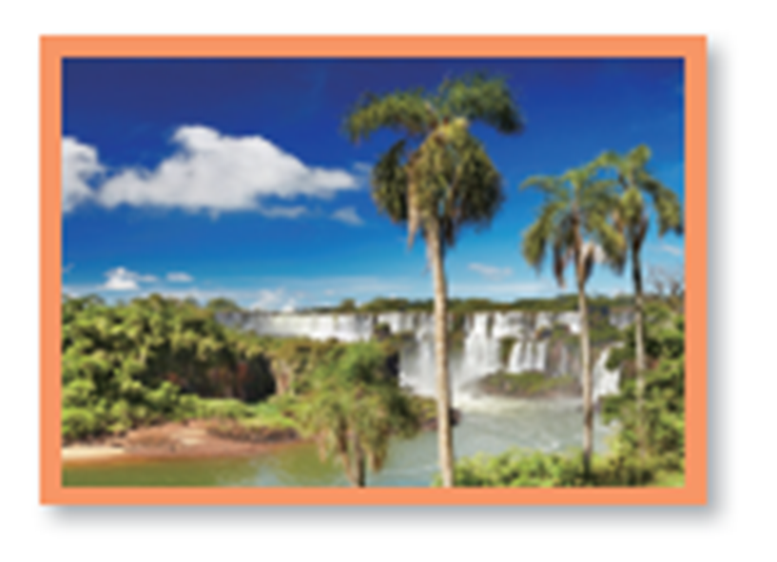
2 | green | adj. | 
3 | watermelon | n. | 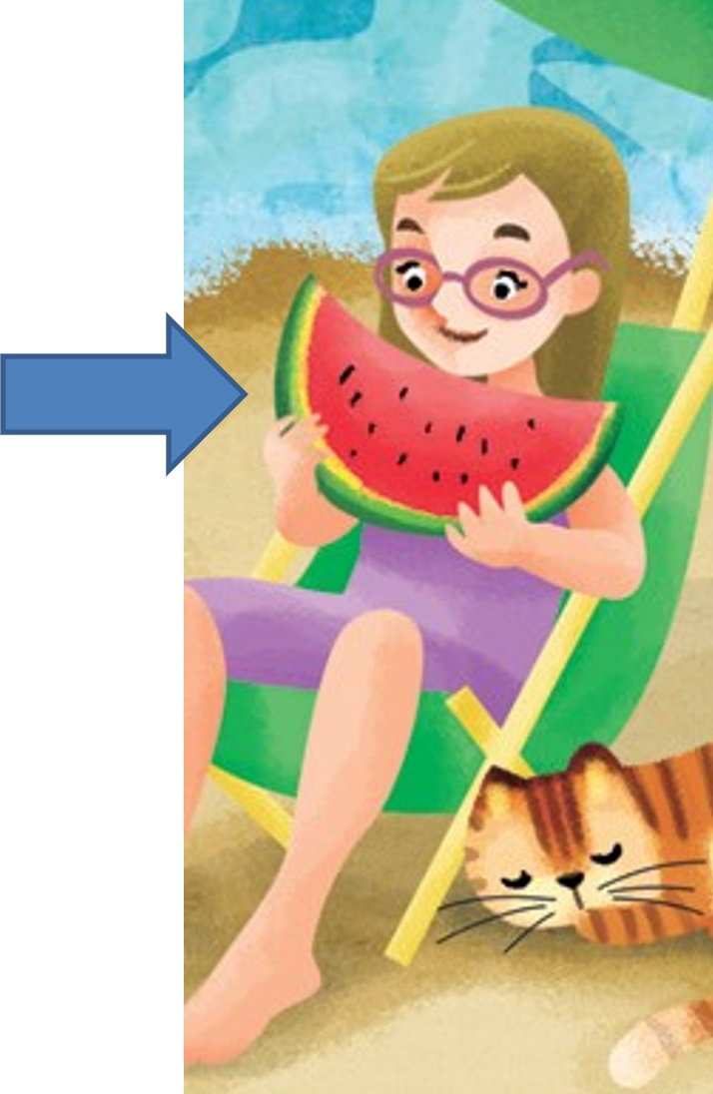
4 | rabbit | n. | 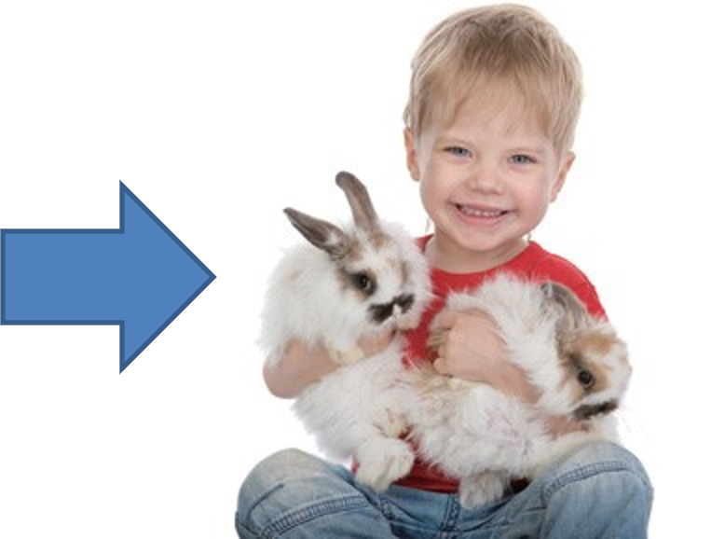
5 | drum | n. | 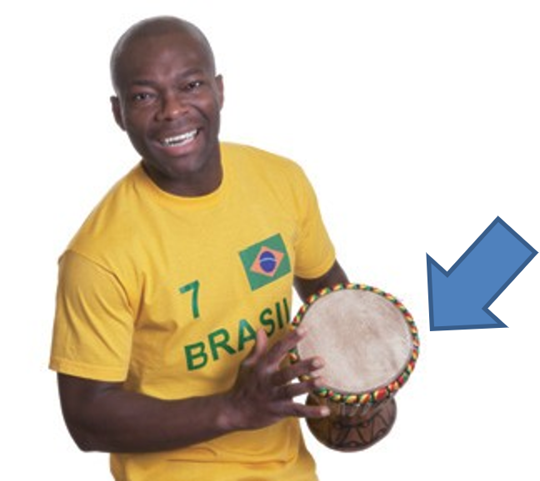
6 | brother | n. | 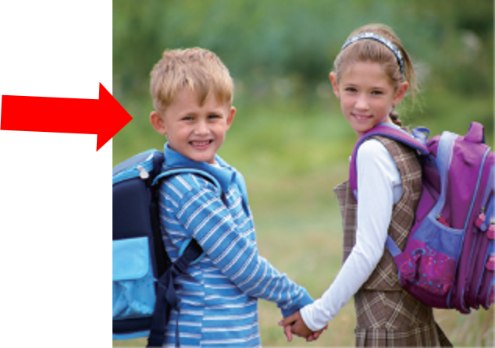
7 | dinner | n. | 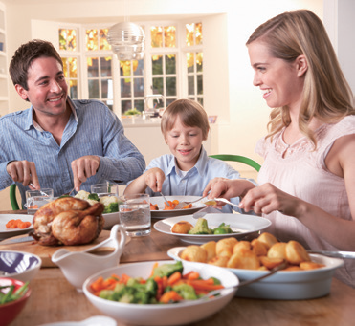
8 | book | n. | 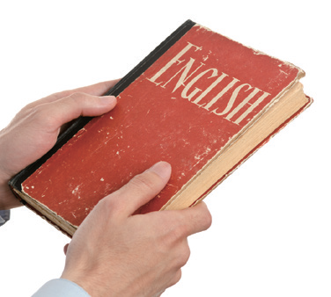
9 | shoes | n. | 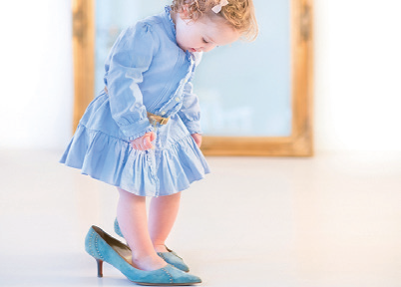
Unit 2
Class | : | Name | :
No. | Words | Part of speech | image
1 | fish | n. | 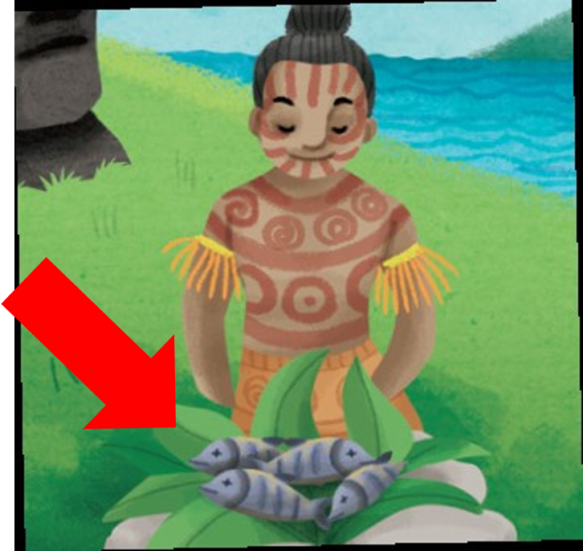
2 | white | adj. | 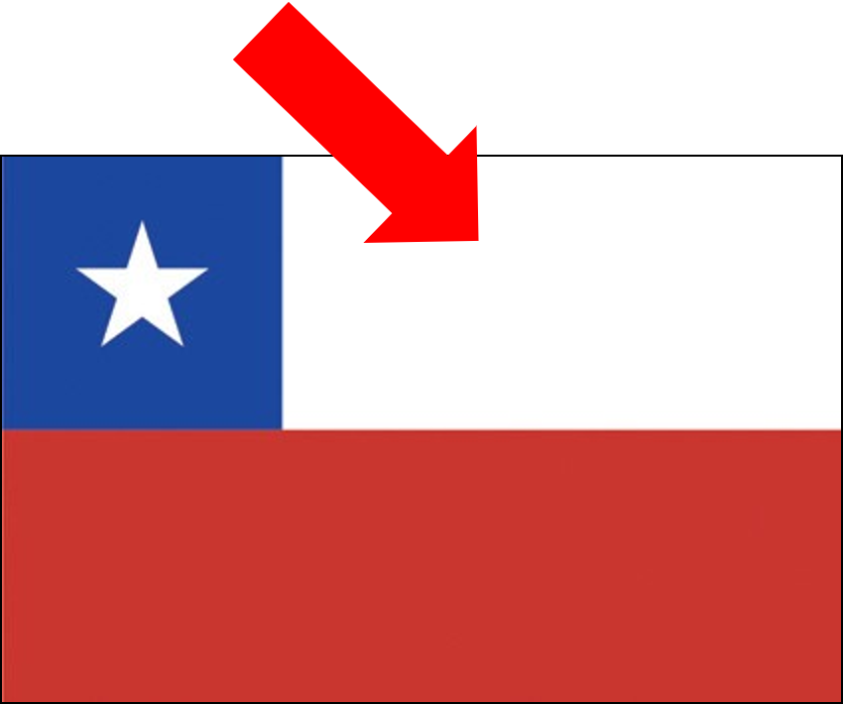
3 | hold | v. | 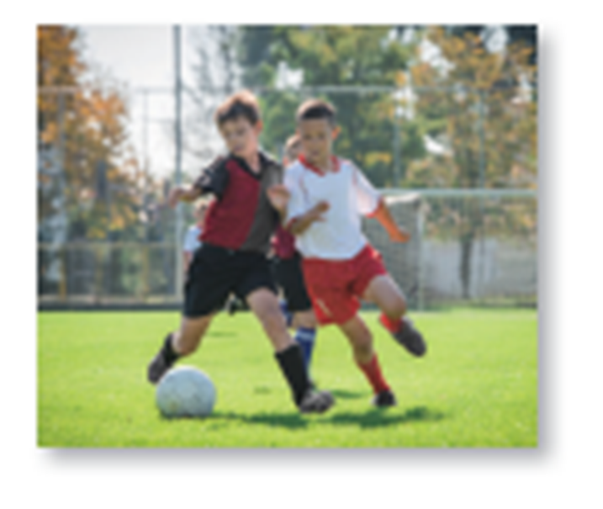
4 | laundry | n. | 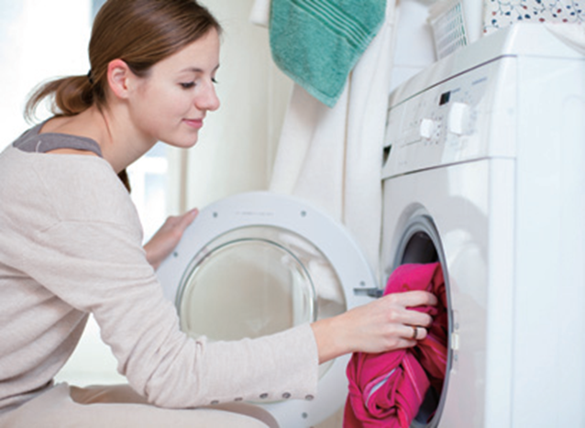
5 | sell | v. | 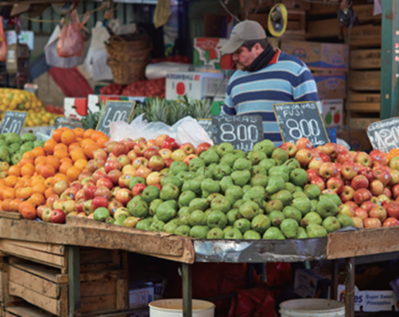
6 | wear | v. | 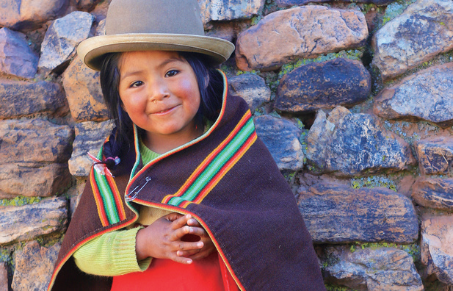
7 | read | v. | 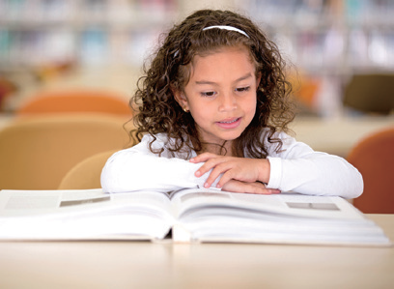
8 | ride | v. | 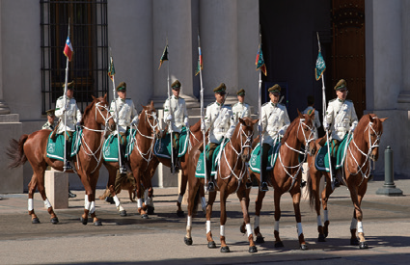
Unit 3
Class | : | Name | :
No. | Words | Part of speech | image
1 | pie | n. | 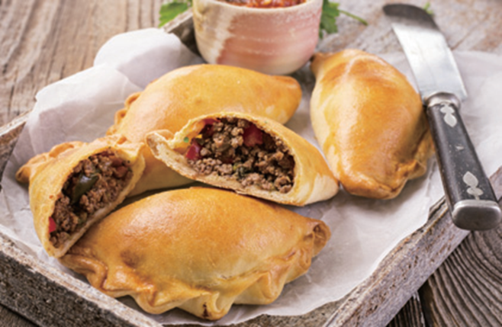
2 | dancer | n. | 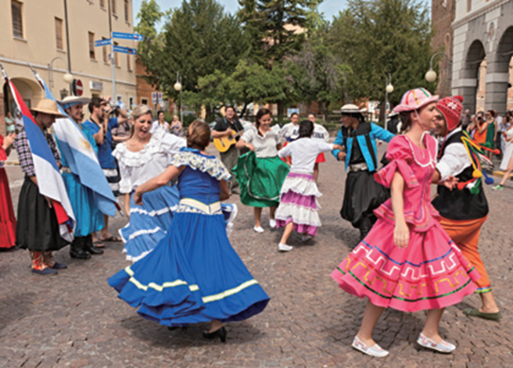
3 | cowboy | n. | 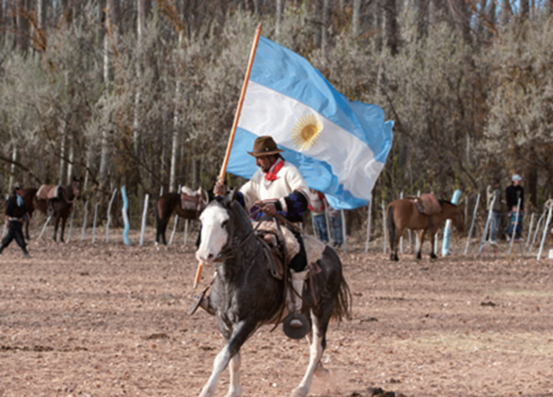
4 | meat | n. | 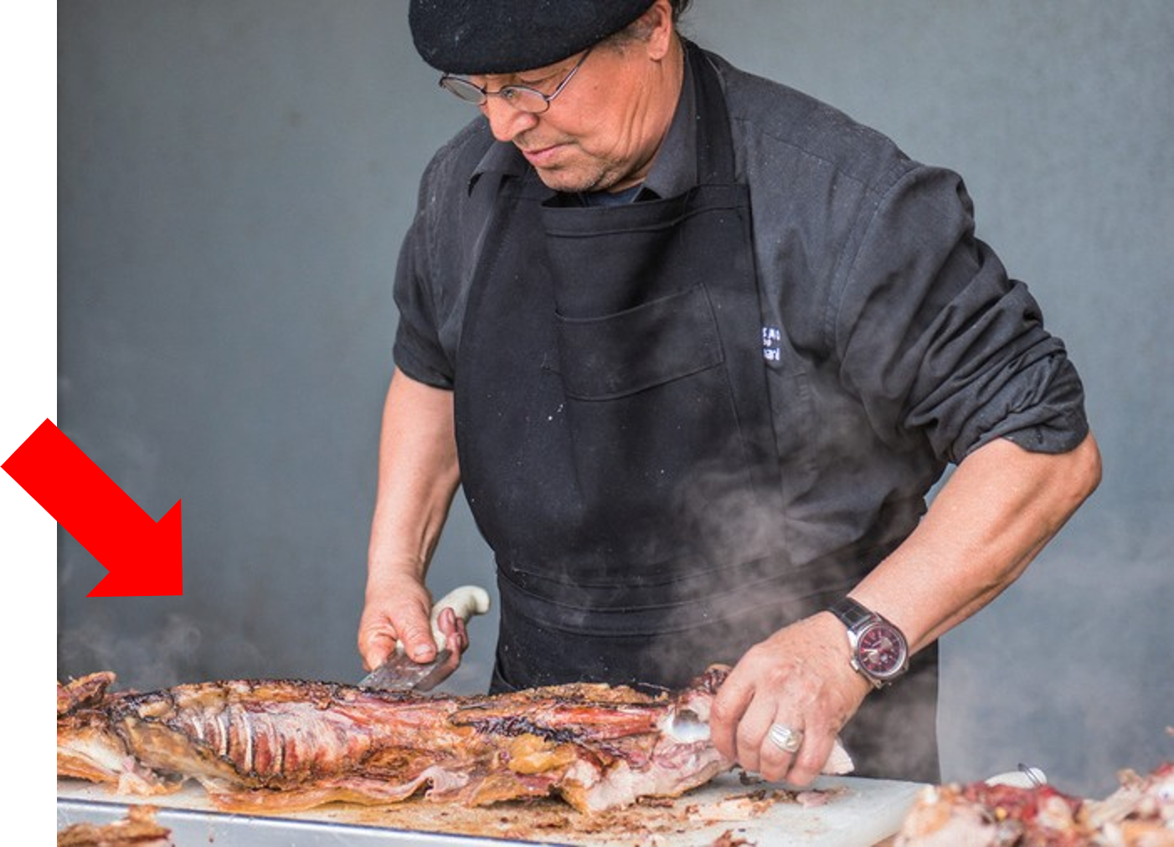
5 | building | n. | 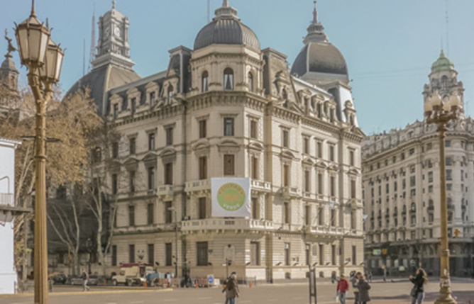
6 | flag | n. | 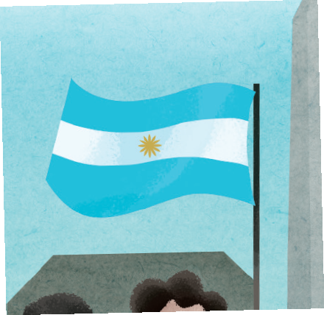
7 | children | n. | 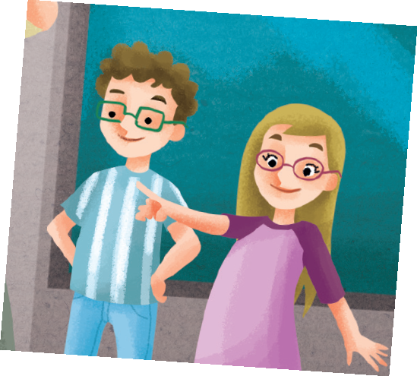
8 | pretty | adj. | 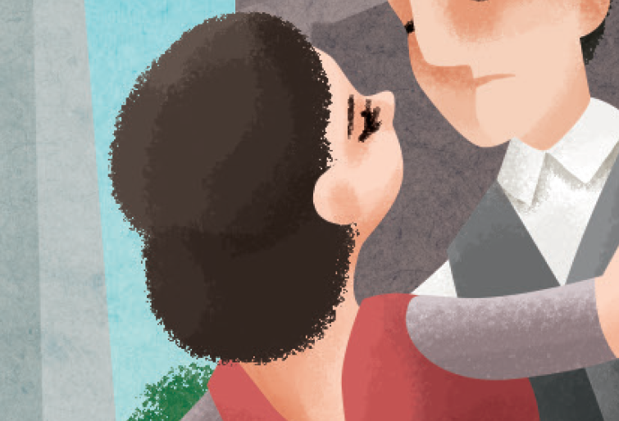
9 | doctor | n. | 
Unit 4
Class | : | Name | :
No. | Words | Part of speech | image
1 | sleep | v. | 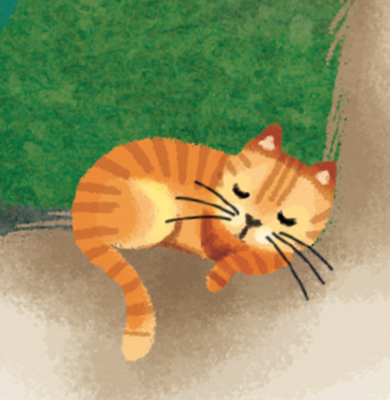
2 | smile | v. | 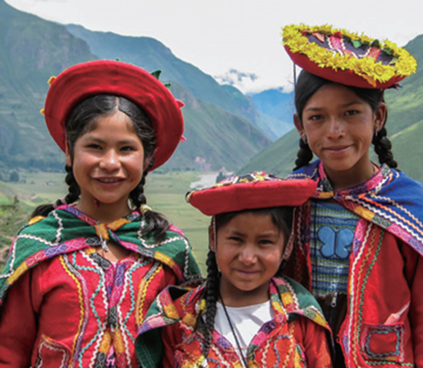
3 | look | v. | 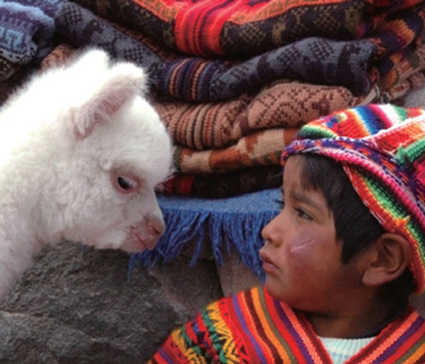
4 | piano | n. | 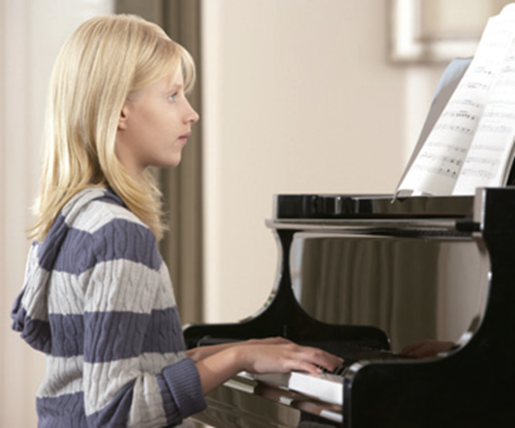
5 | carry | v. | 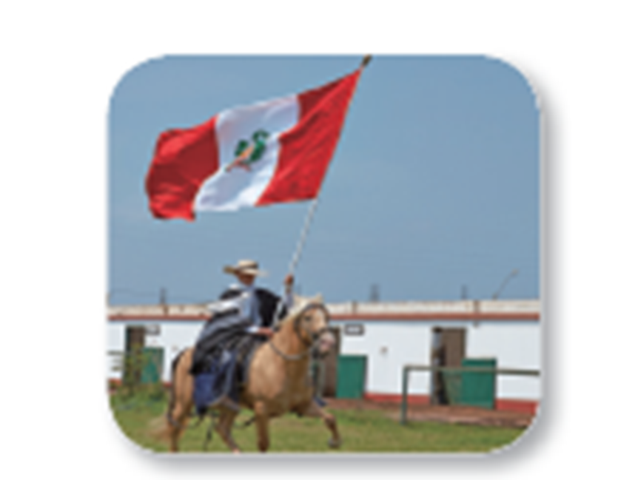
6 | cook | v. | 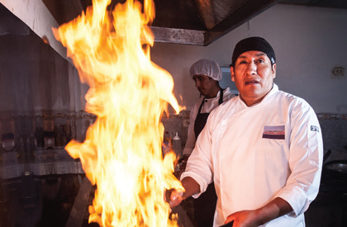
7 | sing | v. | 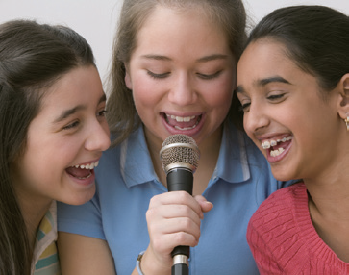
8 | guitar | n. | 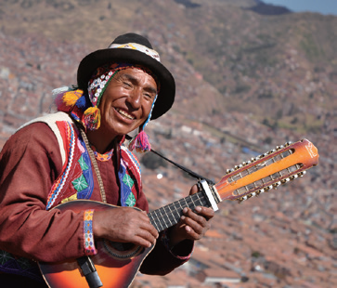
Unit 5
Class | : | Name | :
No. | Words | Part of speech | image
1 | fight | v. | 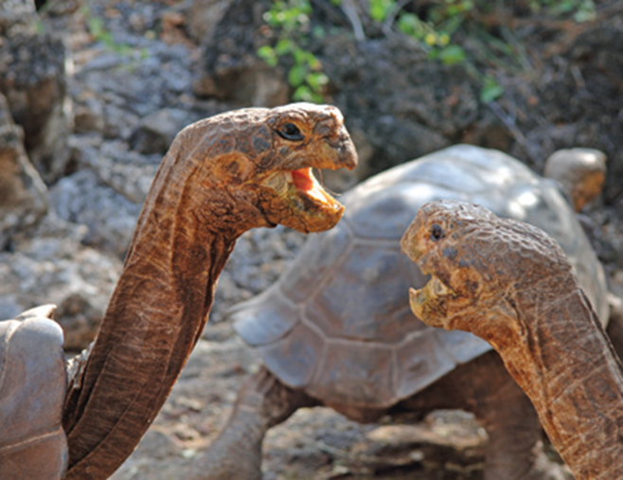
2 | sunny | adj. | 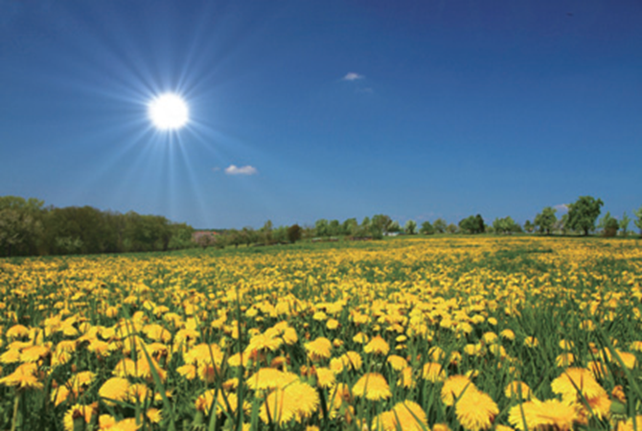
3 | rainy | adj. | 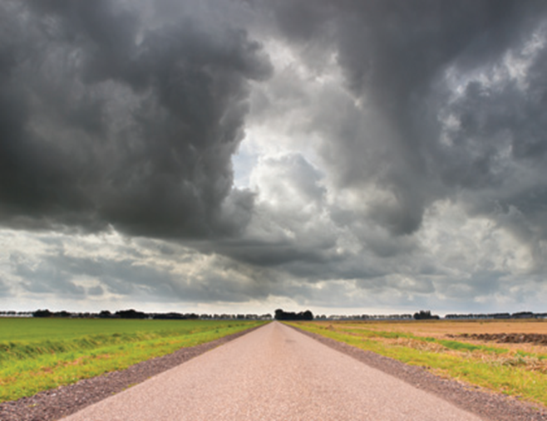
4 | paint | v. | 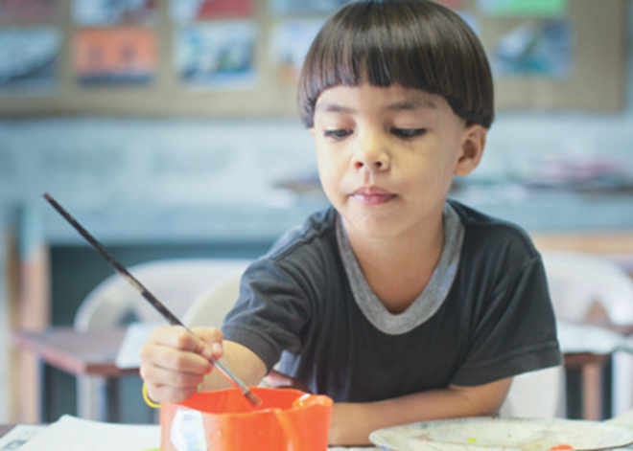
5 | study | v. | 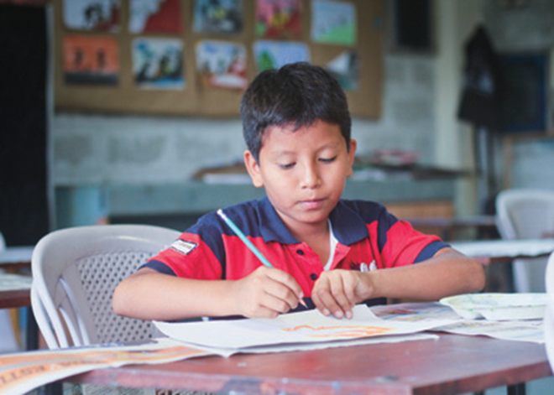
6 | sand | n. | 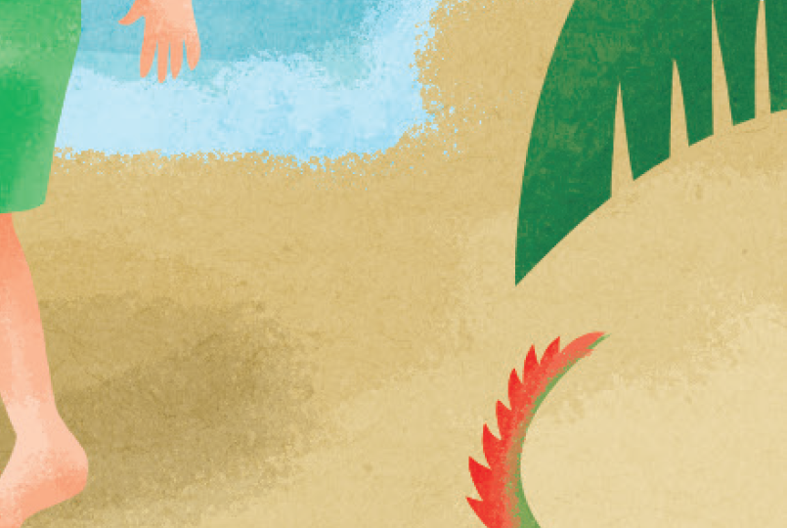
7 | doll | n. | 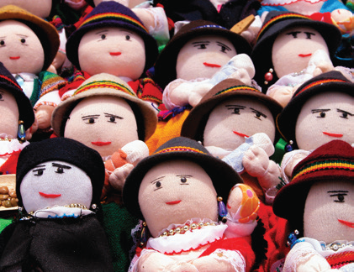
8 | swim | v. | 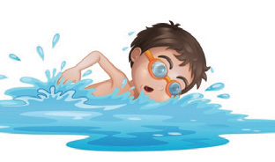
Unit 6
Class | : | Name | :
No. | Words | Part of speech | image
1 | monkey | n. | 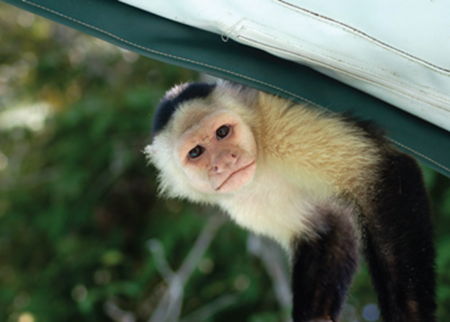
2 | play | v. | 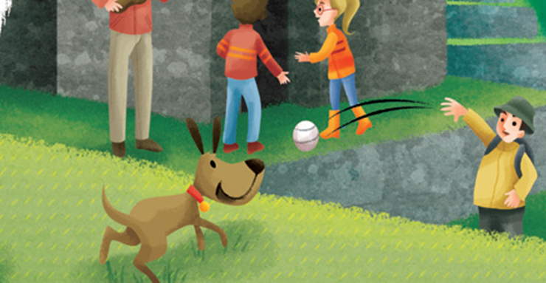
3 | catch | v. | 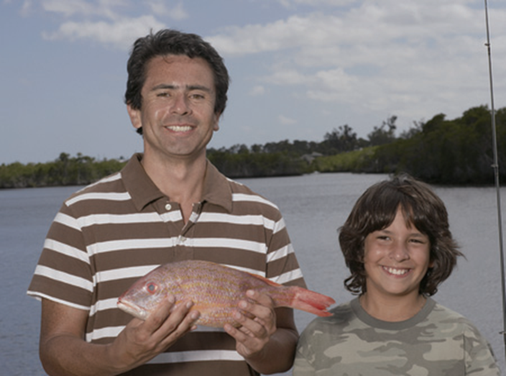
4 | fly | v. | 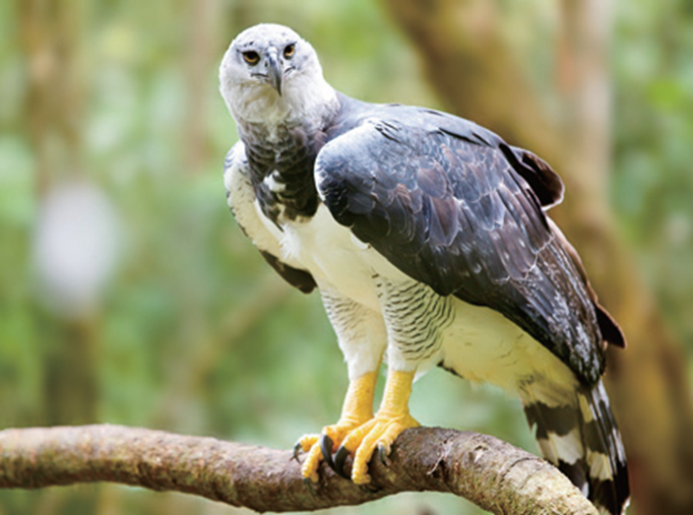
5 | pull | v. | 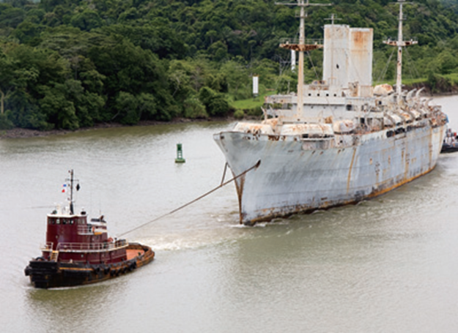
6 | movie | n. | 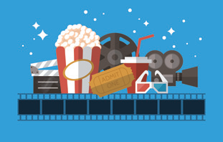
7 | banana | n. | 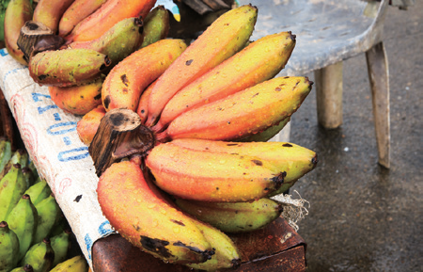
8 | take a photo | phr v. | 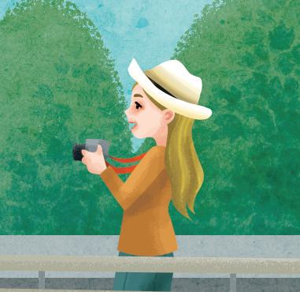
Unit 7
Class | : | Name | :
No. | Words | Part of speech | image
1 | bird | n. | 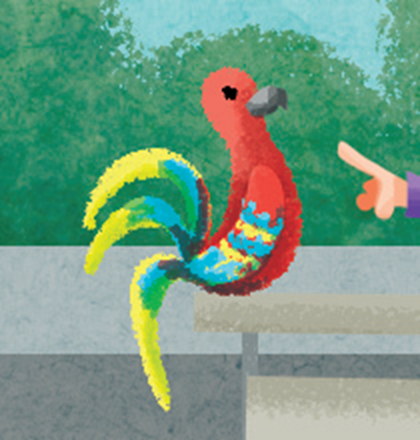
2 | shark | n. | 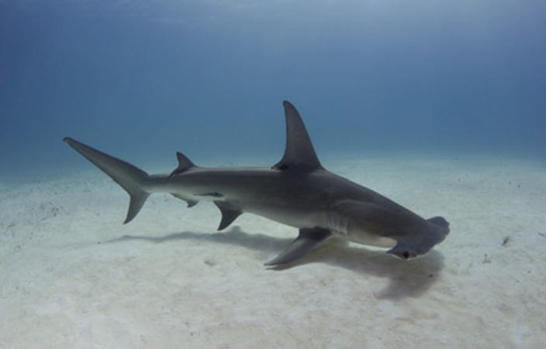
3 | turtle | n. | 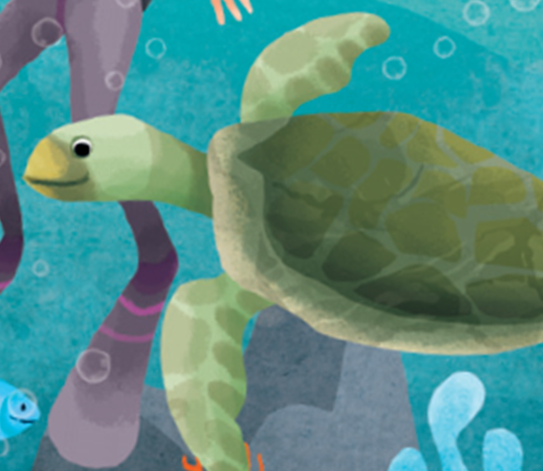
4 | sea | n. | 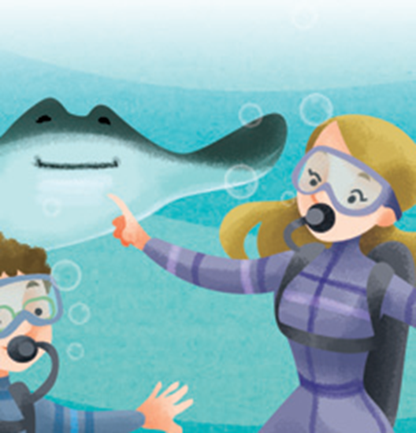
5 | beach | n. | 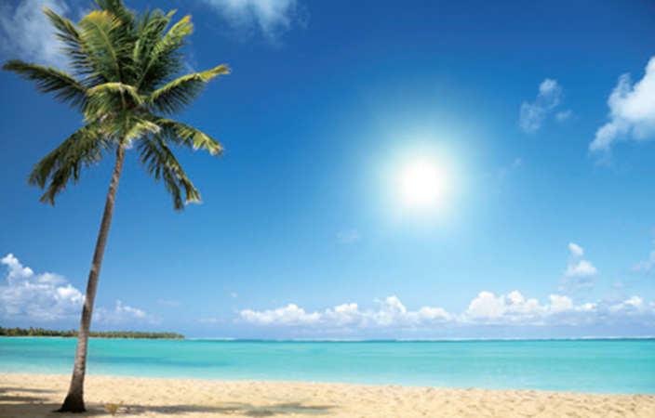
6 | new | adj. | 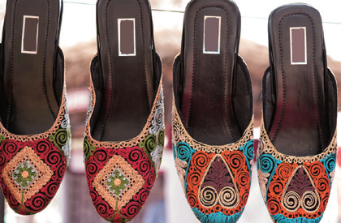
7 | boat | n. | 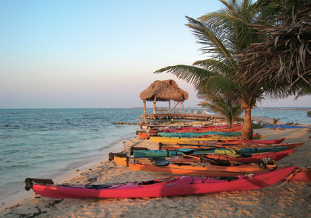
8 | many | adj. | 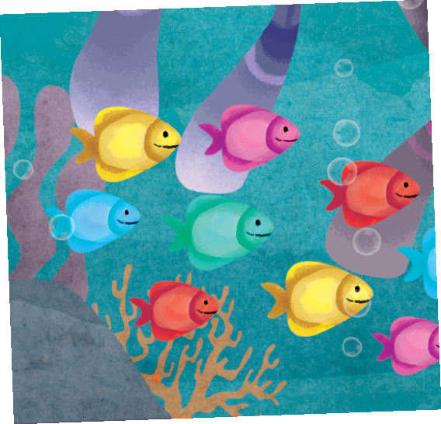
Unit 8
Class | : | Name | :
No. | Words | Part of speech | image
1 | library | n. | 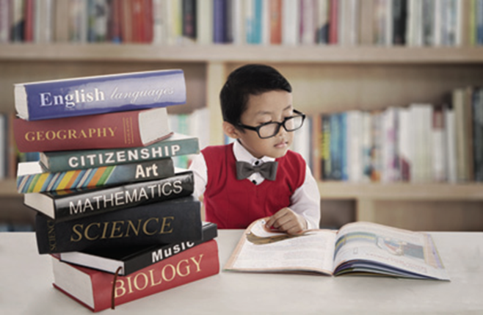
2 | pyramid | n. | 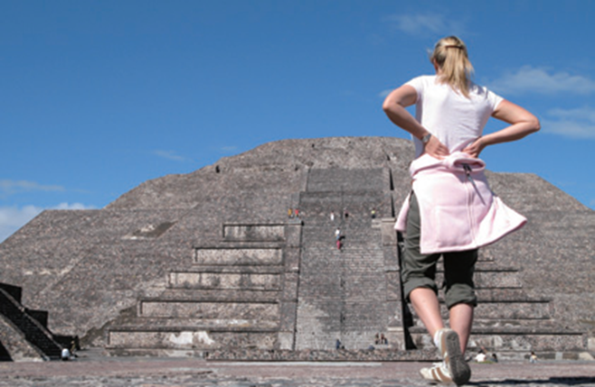
3 | game | n. | 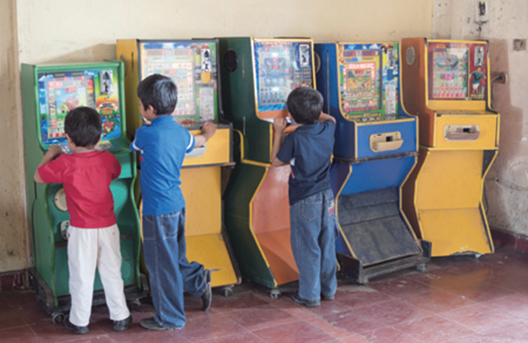
4 | ask | v. | 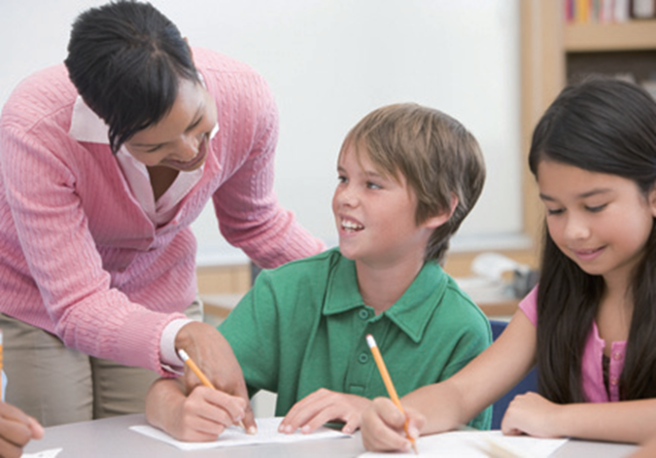
5 | practice | v. | 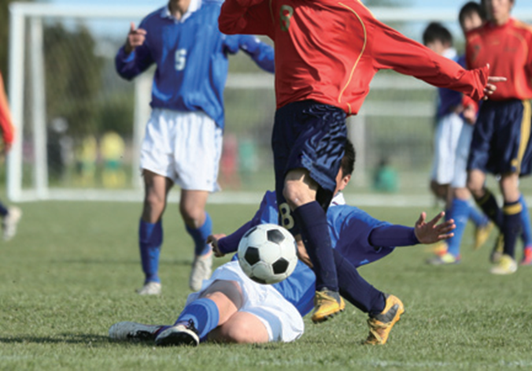
6 | statue | n. | 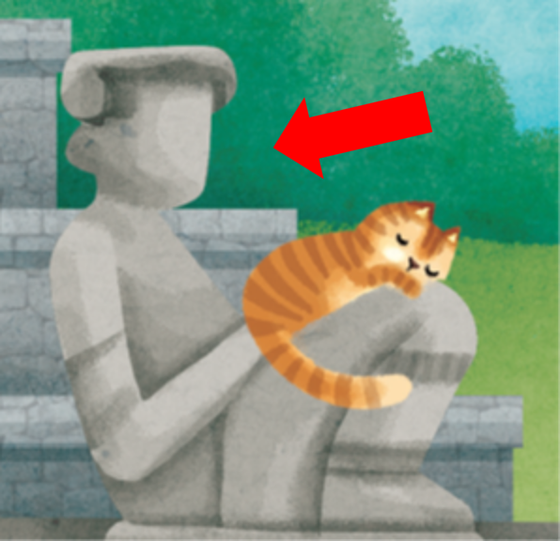
7 | live | v. | 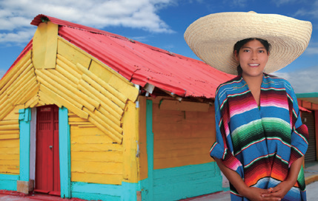
8 | volcano | n. | 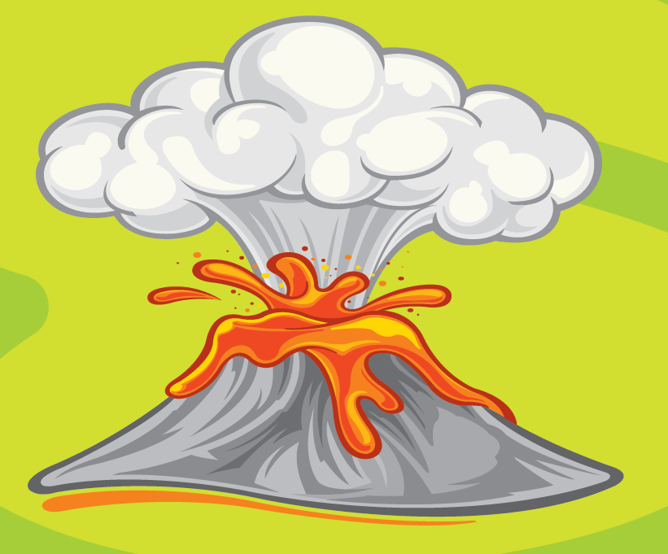
Unit 9
Class | : | Name | :
No. | Words | Part of speech | image
1 | write | v. | 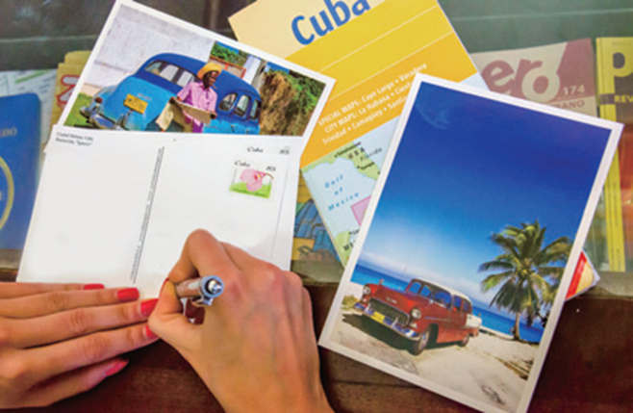
2 | make | v. | 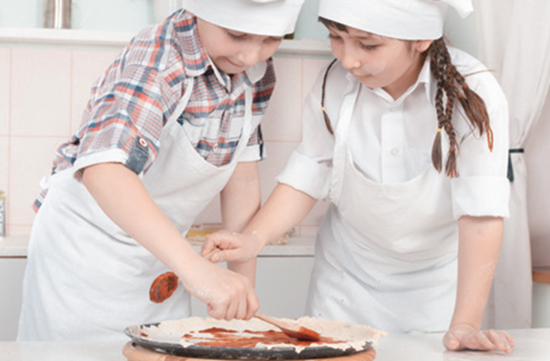
3 | eat | v. | 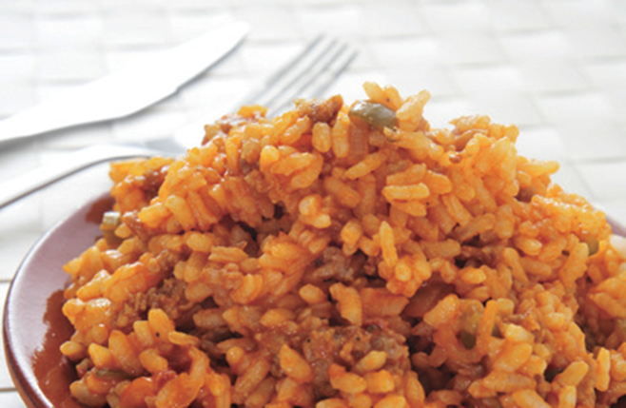
4 | see | v. | 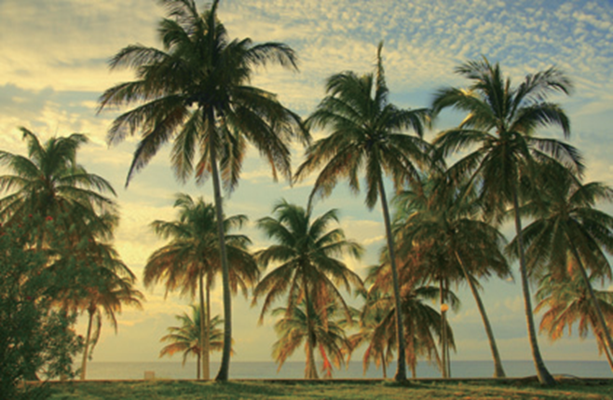
5 | go | v. | 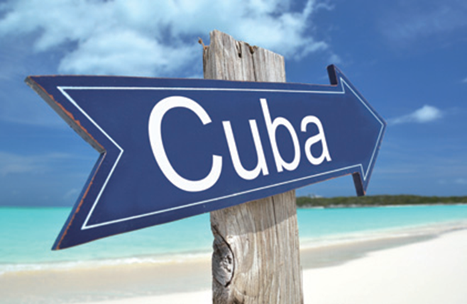
6 | shirt | n. | 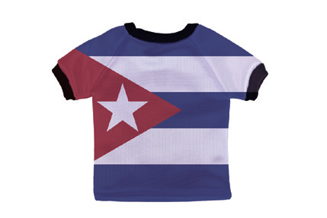
7 | car | n. | 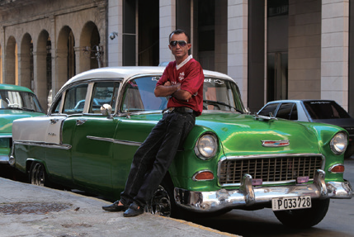
8 | drink | v. | 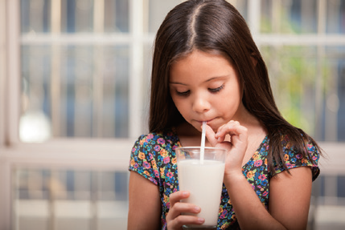
Unit 10
Class | : | Name | :
No. | Words | Part of speech | image
1 | hiking | n. | 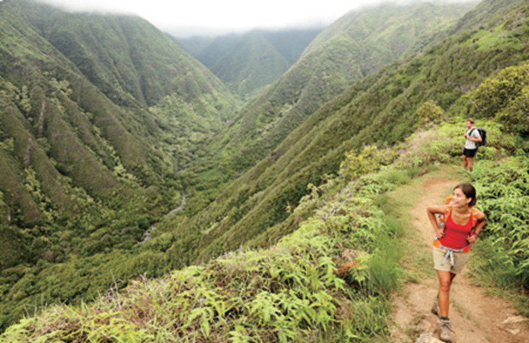
2 | violin | n. | 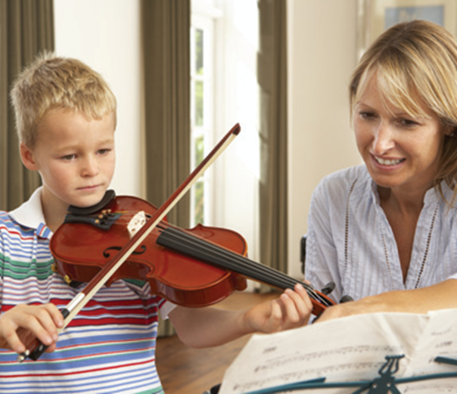
3 | baseball | n. | 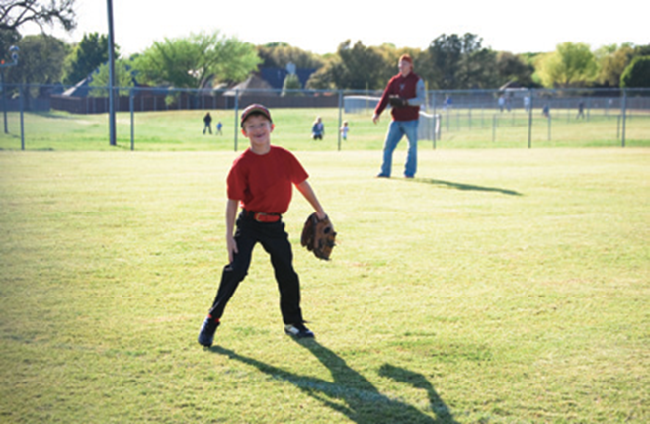
4 | train | n. | 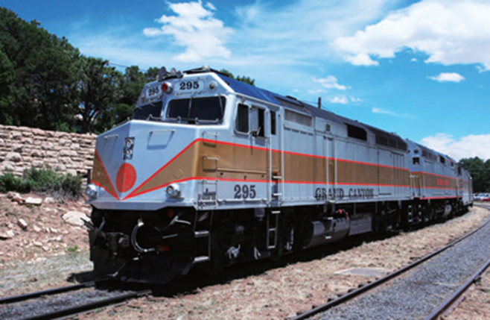
5 | listen | n. / v. | 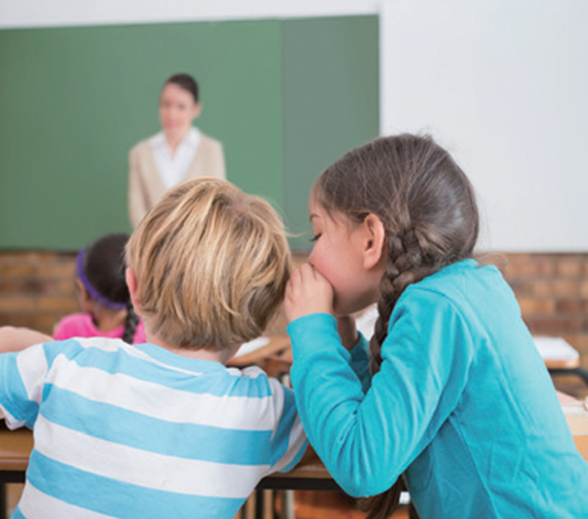
6 | help | n. / v. | 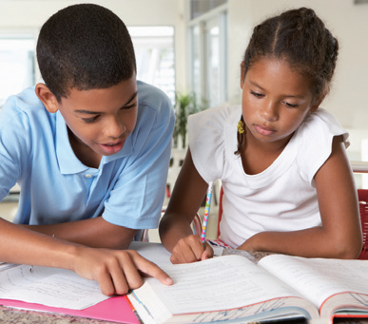
7 | horse | n. | 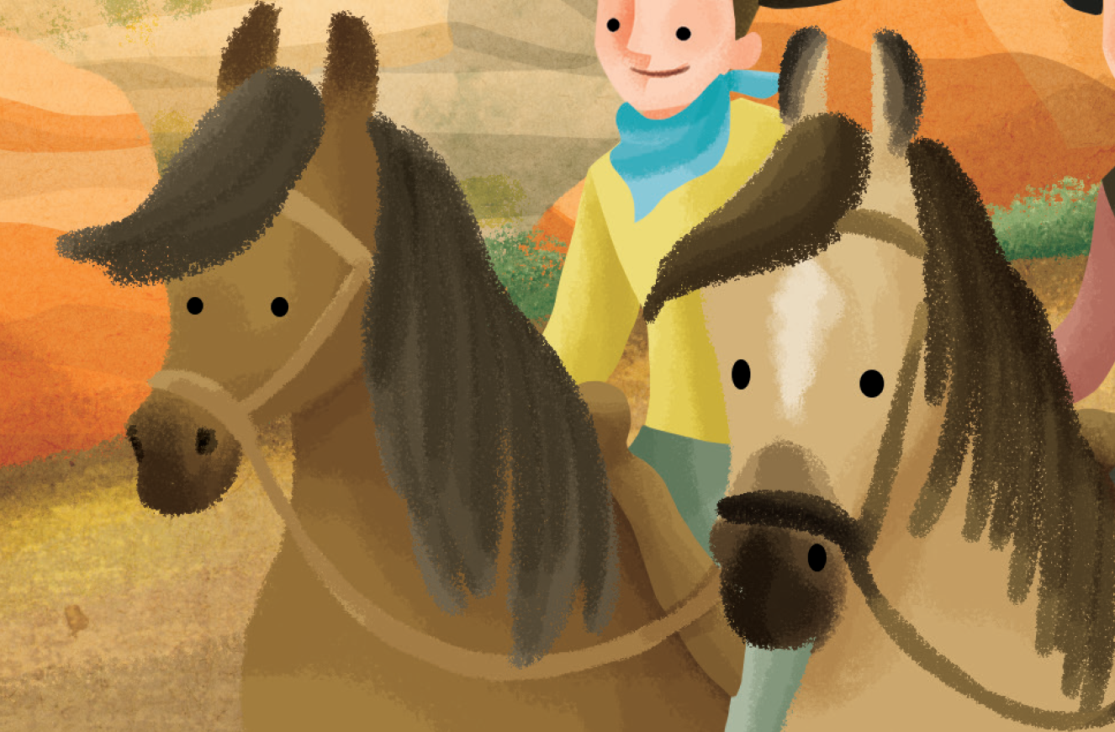
8 | wake | v. | 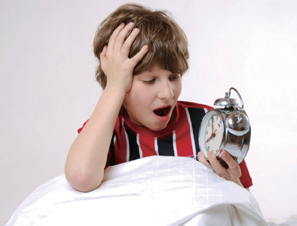
Unit 11
Class | : | Name | :
No. | Words | Part of speech | image
1 | snowman | n. | 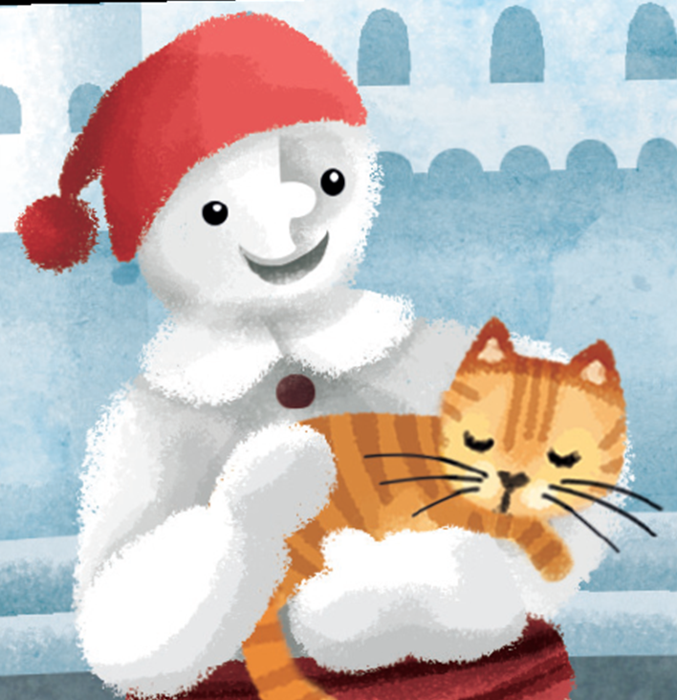
2 | bear | n. | 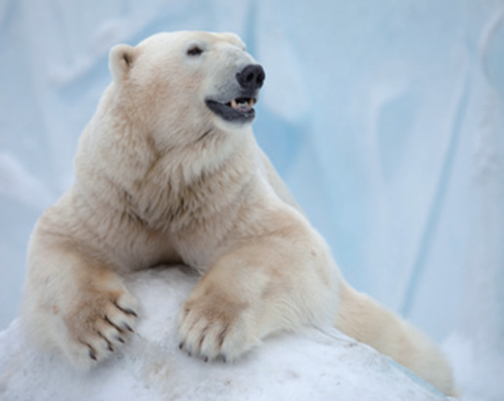
3 | tired | adj. | 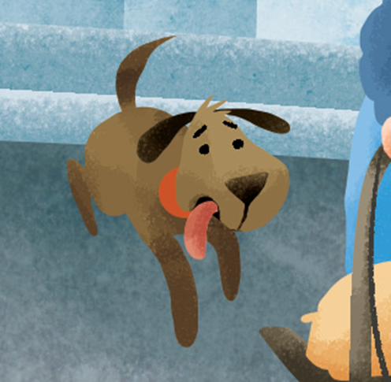
4 | room | n. | 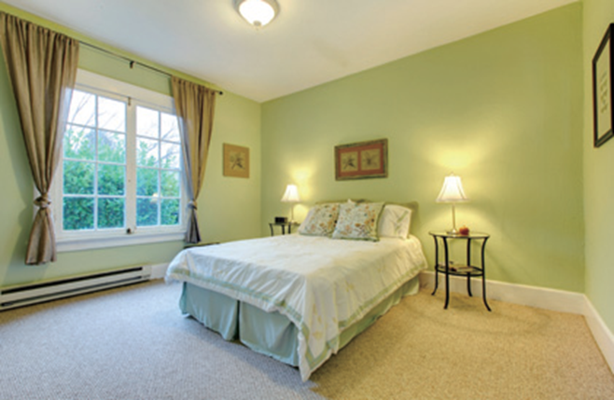
5 | dangerous | adj. | 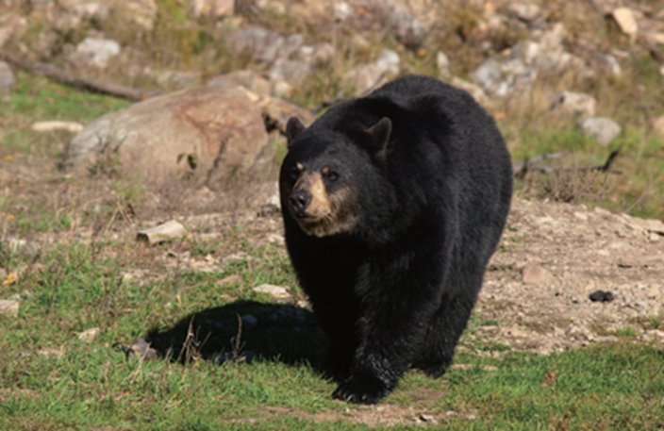
6 | happy | adj. | 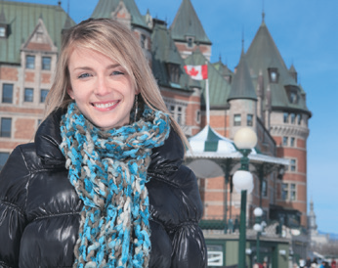
7 | sad | adj. | 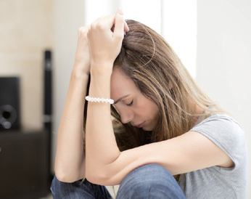
8 | good | adj. | 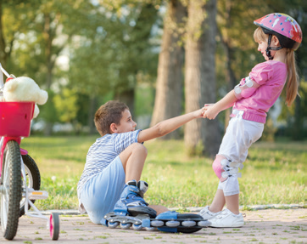
Unit 12
Class | : | Name | :
No. | Words | Part of speech | image
1 | slow | adj. | 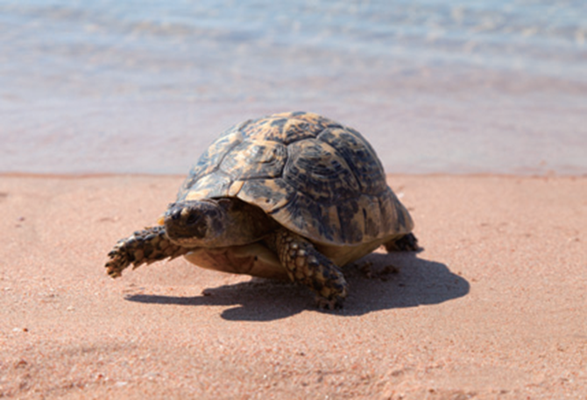
2 | fast | adj. / adv. | 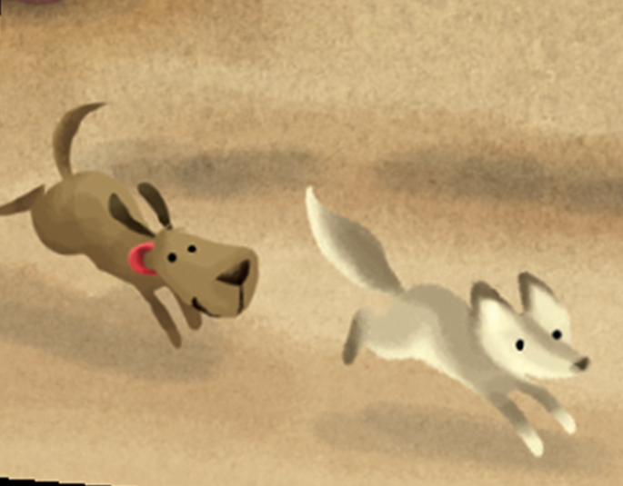
3 | well | adv. | 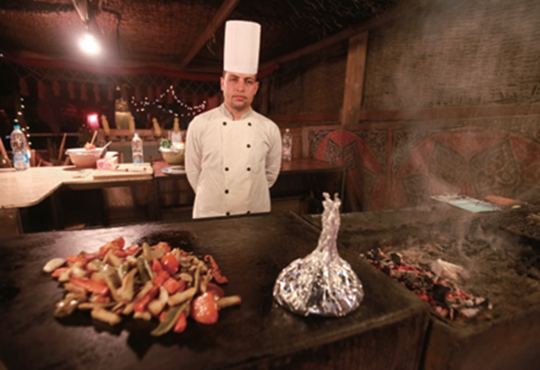
4 | cheer | n, v. | 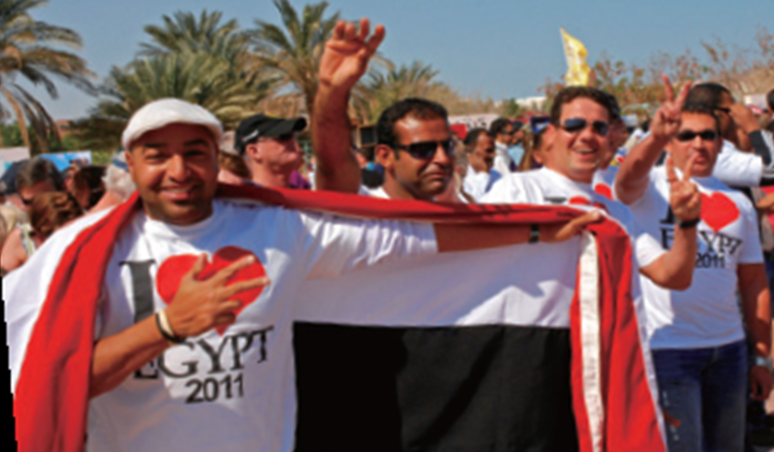
5 | hard | adv. | 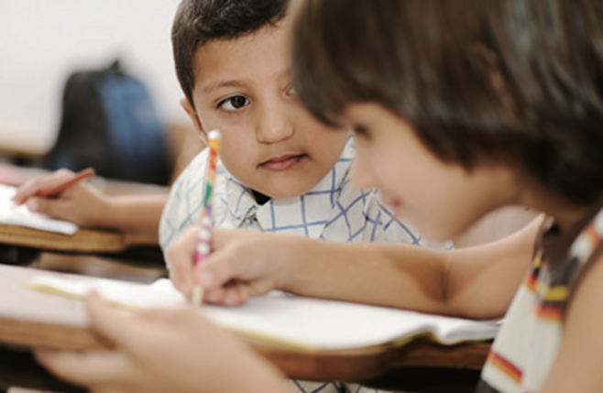
6 | loudly | adv. | 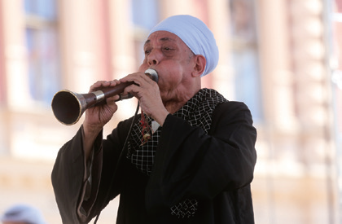
7 | come | v. | 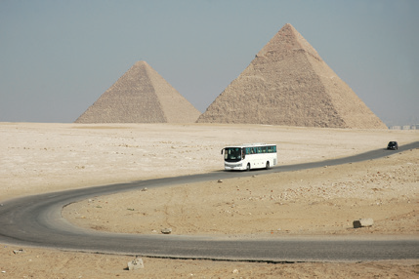
8 | beautifully | adv. | 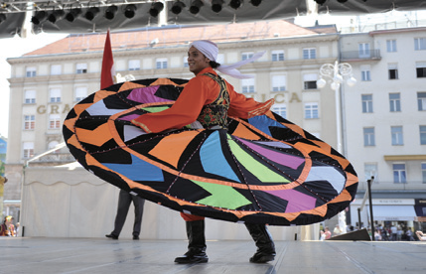
Unit 13
Class | : | Name | :
No. | Words | Part of speech | image
1 | dry | adj. | 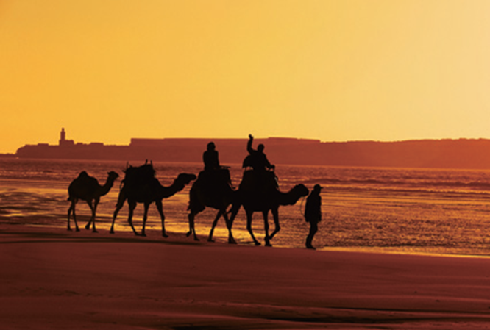
2 | delicious | adj. | 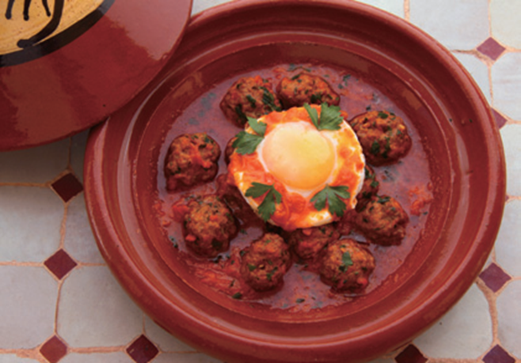
3 | clean | adj. | 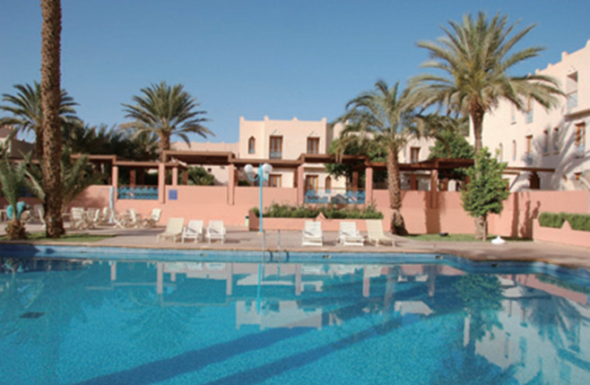
4 | hot | adj. | 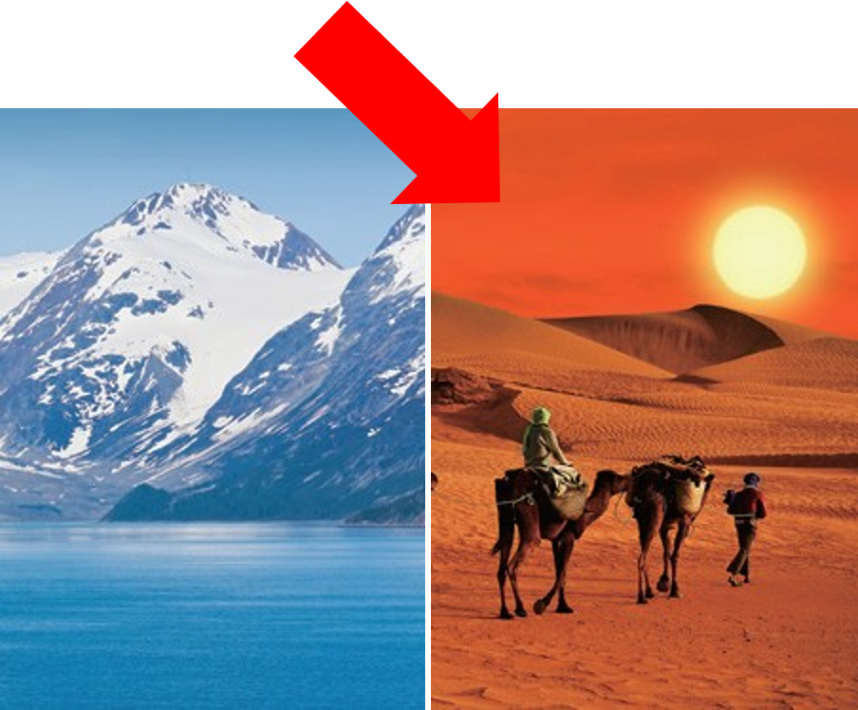
5 | bicycle | n. | 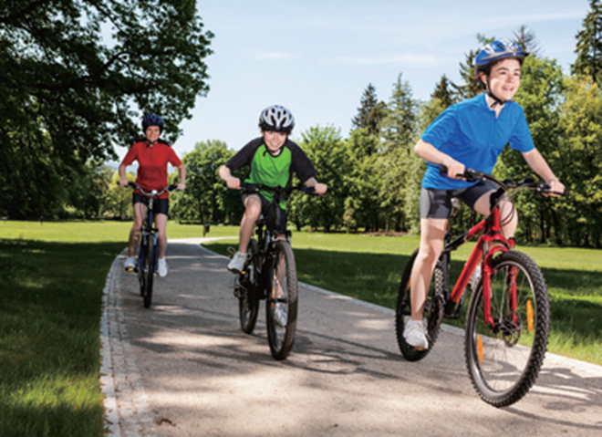
6 | cheap | adj. | 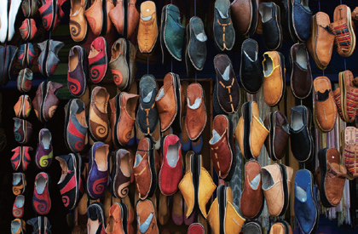
7 | old | adj. | 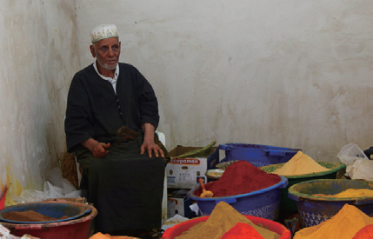
8 | expensive | adj. | 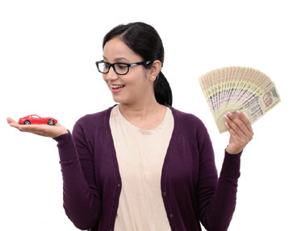
Unit 14
Class | : | Name | :
No. | Words | Part of speech | image
1 | zebra | n. | 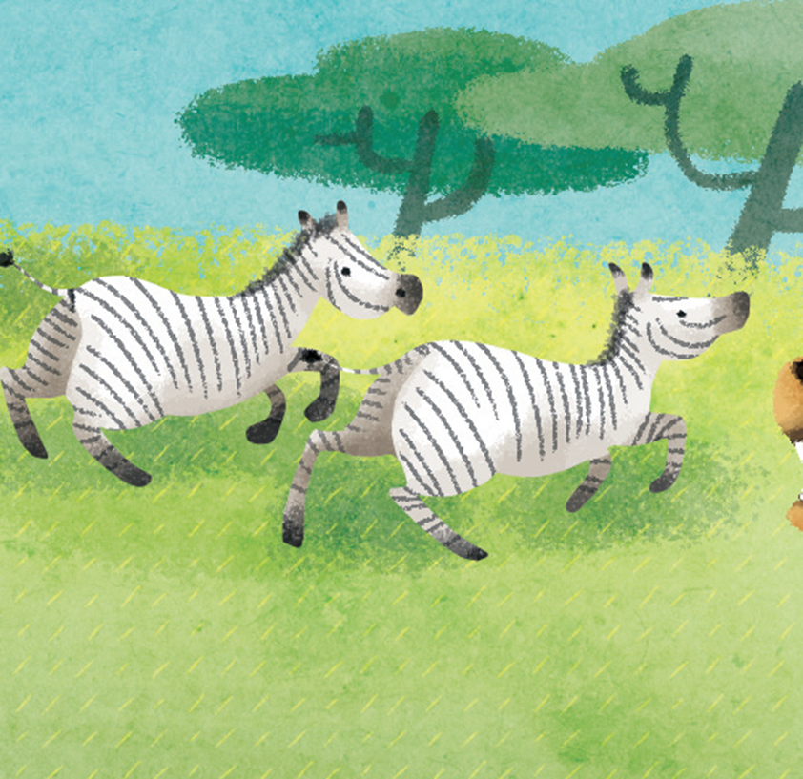
2 | giraffe | n. | 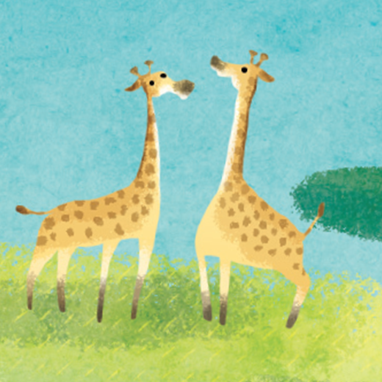
3 | run | n. / v. | 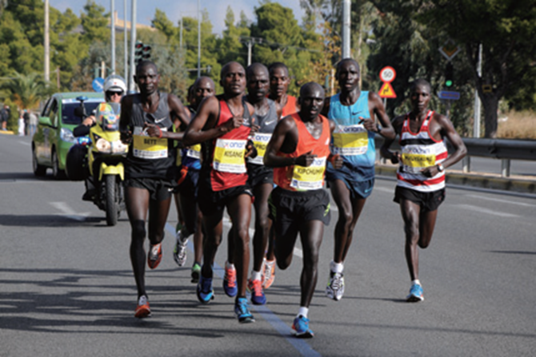
4 | lion | n. | 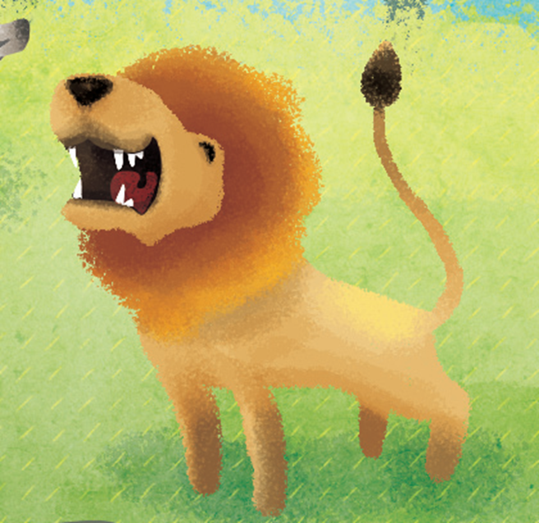
5 | heavy | adj. | 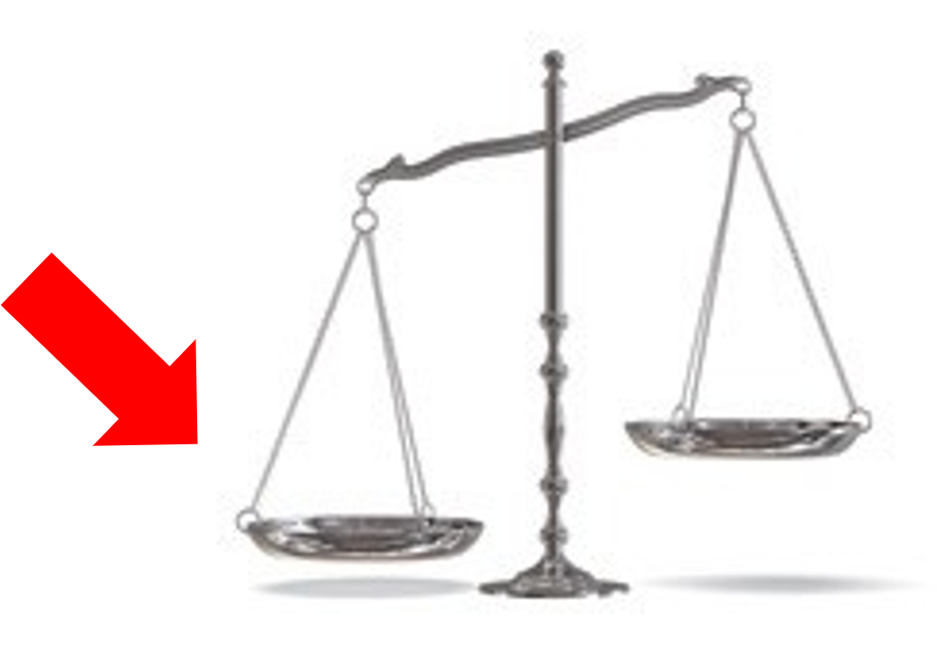
6 | elephant | n. | 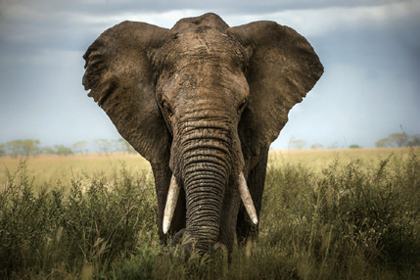
7 | meal | n. | 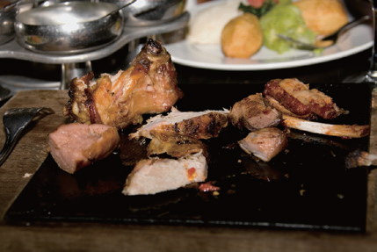
8 | large | adj. | 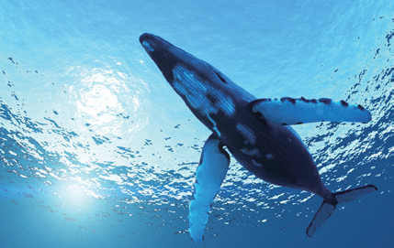
Unit 15
Class | : | Name | :
No. | Words | Part of speech | image
1 | time | n. | 
2 | penguin | n. | 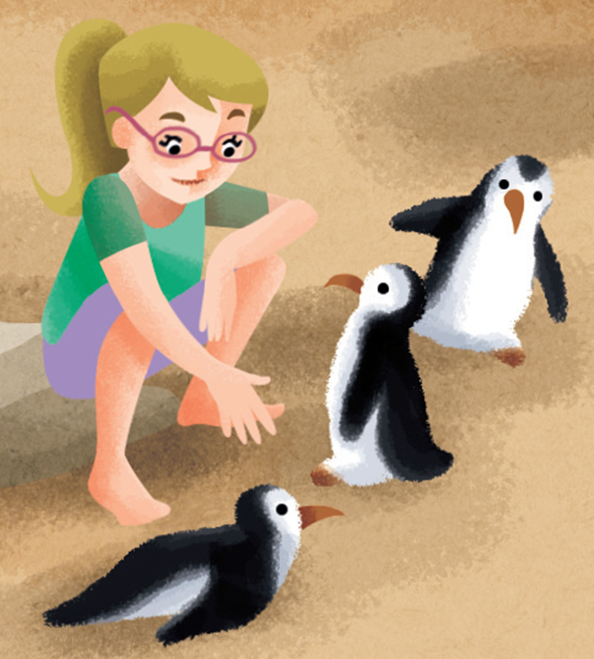
3 | fruit | n. | 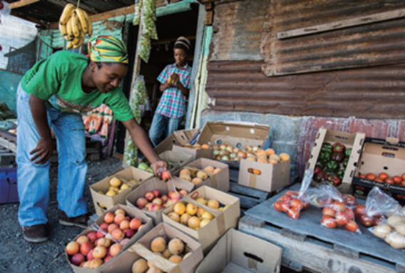
4 | show | n. / v. | 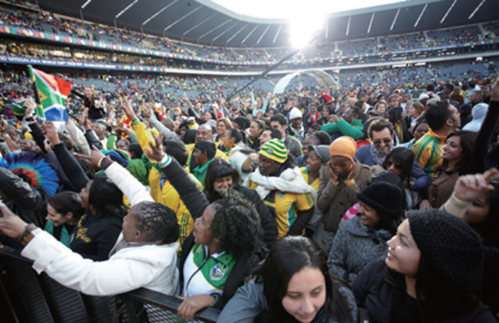
5 | birthday | n. | 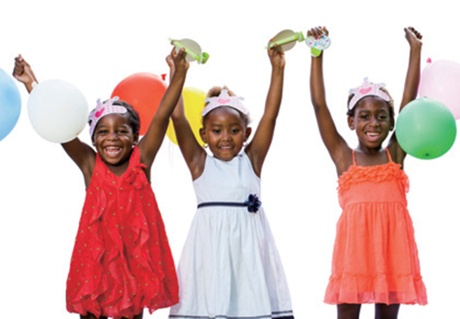
6 | vacation | n. | 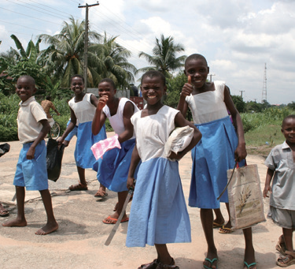
7 | work | v. | 
8 | grape | n. | 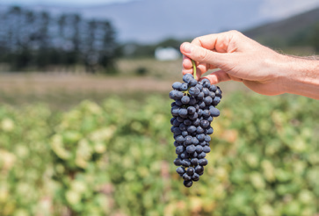
Unit 16
Class | : | Name | :
No. | Words | Part of speech | image
1 | climb | v, | 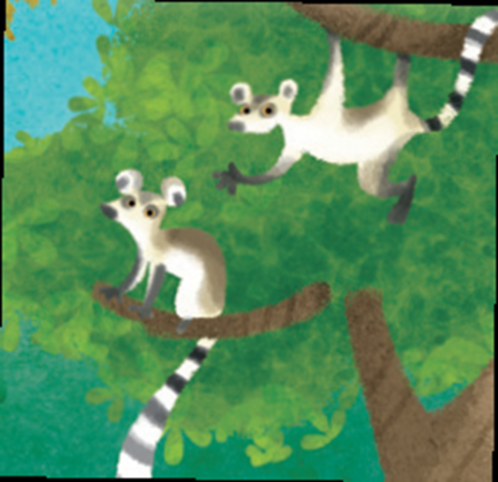
2 | baby | n. | 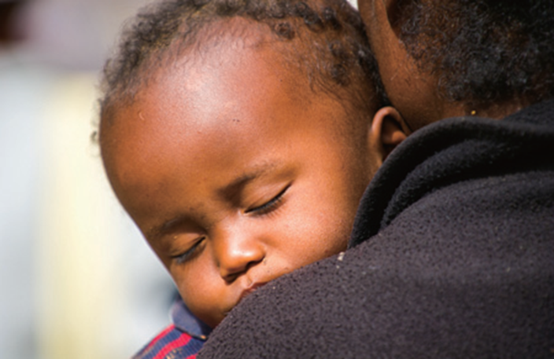
3 | strong | adj. | 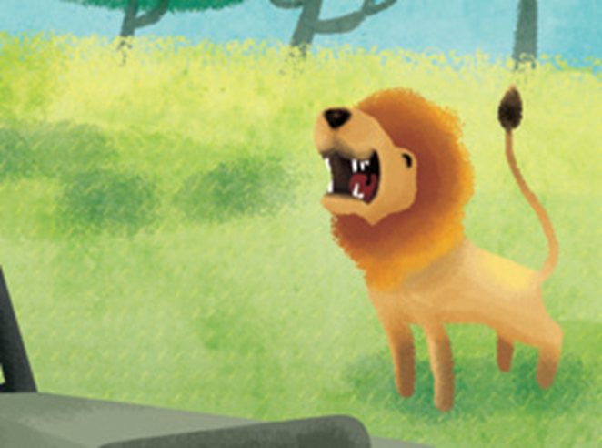
4 | walk | v. | 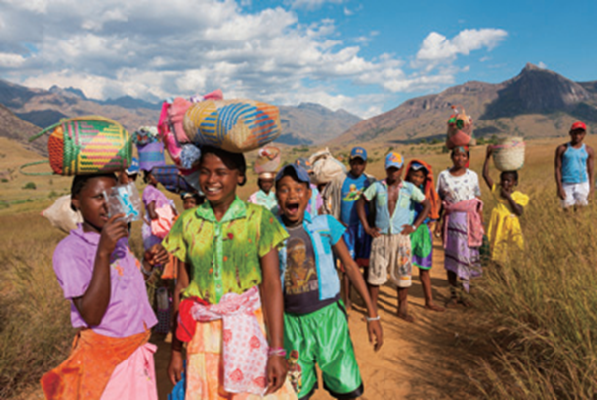
5 | drink | v. | 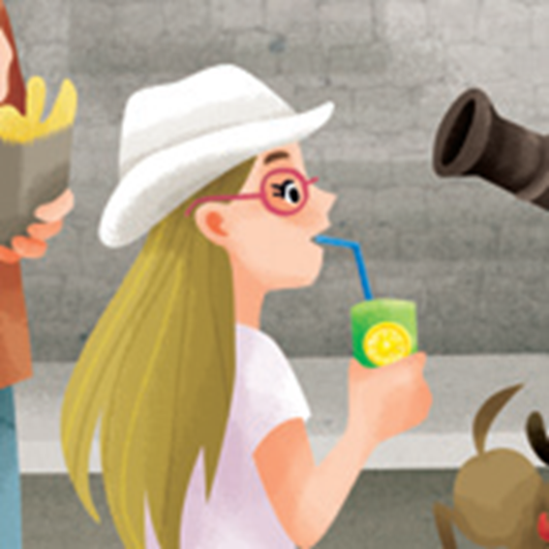
6 | busy | adj. | 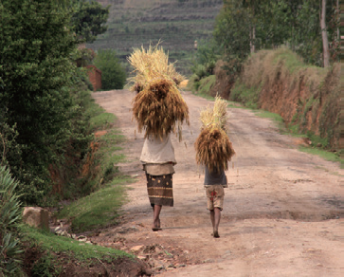
7 | tree | n. | 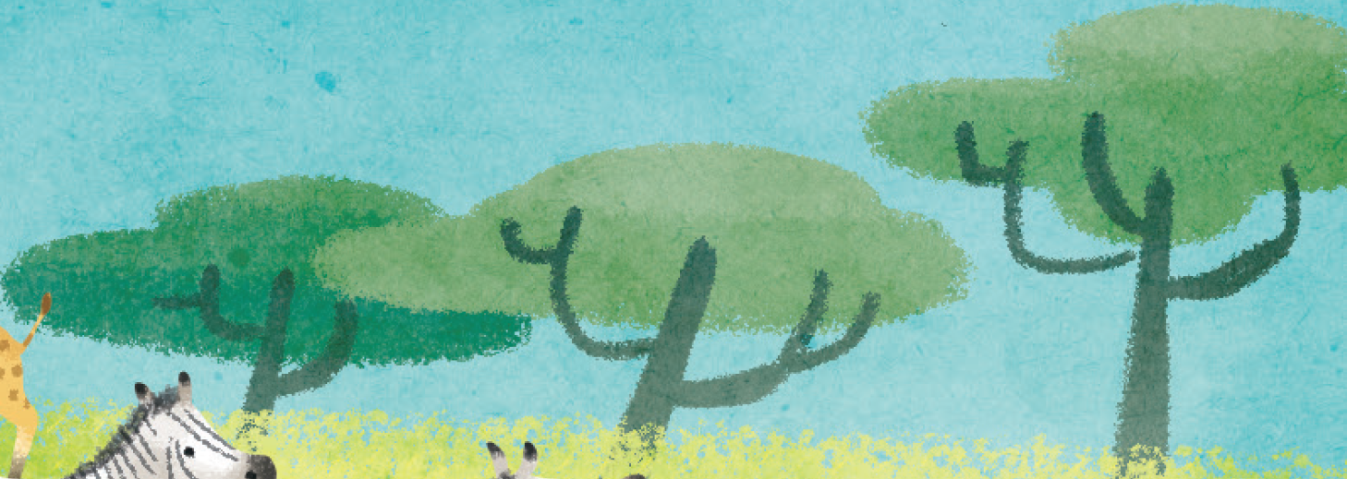
8 | animal | n. | 