ANSWERS

Hang Out! Plus Student Book 5

# Welcome Unit

1. Daniel
2. Jenny
3. Alex
4. Mateo
5. Li
6. Nadir

## B.

1. f
2. e
3. d
4. b
5. c
6. a

## C.

1. Australia
2. Ecuador
3. United Kingdom
4. Brazil
5. Thailand
6. Canada
7. Malaysia
8. Morocco
9. Nigeria
10. USA
11. Germany
12. Italy

## D.

1. Italy
2. Ecuador
3. Australia
4. Brazil
5. Germany

E.

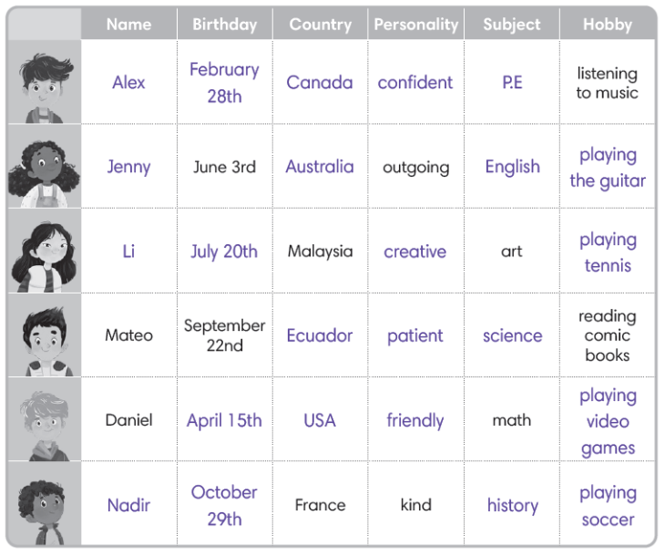

## F.

1. Mateo
2. Li
3. Jenny
4. Nadir
5. Daniel
6. Alex

## G.

*Answers will vary.*

## I.

*Answers will vary*.

**Lesson 1**

**Unit 1**

## C.

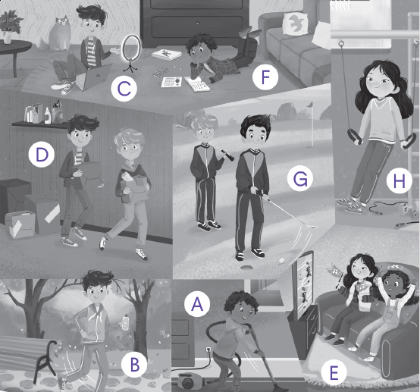

# Lesson 2

# Reading

## B.

* 1. b
  2. She is going for a run on Wednesday.
  3. She is having a sleepover with Li and Sara.
  4. She is checking her homework and golfing with her brothers.

# Speaking

*Answers will vary.*

# Lesson 3 Story

## A.

## every day

## mall

## weekend

## busy

## type

## C.

1. a
2. c
3. c
4. c

# Expand

## B.

1. A
2. D
3. F
4. H
5. E
6. C
7. B
8. G

## C.

1. What are you doing on Monday? 🡪 I need to purchase books.
2. What are you doing on Tuesday? 🡪 I need to go to the recycling center.
3. What are you doing on Wednesday? 🡪 I need to organize my desk.
4. What are you doing on Thursday? 🡪I need to go to the bike shop.
5. What are you doing on Friday? 🡪 I need to go to the dentist.
6. What are you doing on Saturday? 🡪 I need to repair my glasses.

# Lesson 4

## **Grammar**

## A.

1. she, doing, is purchasing books
2. they, doing, are watching the soccer game
3. are, doing, are going to the mall
4. are, doing, am helping out my friend
5. are, doing, are typing a paper
6. you, doing, am going to the dentist

## B.

1. needs 🡪 need
2. need to 🡪 needs to
3. are need 🡪 need
4. needs 🡪 need
5. need to checks 🡪 needs to check
6. needs to repairing🡪 need to repair

**Lesson 5**

## **Writing**

## A.

**My Plans**

I have a lot of things to do this week. I need to type a paper for my English class. I’m not sure when I will do that. On Tuesday and Thursday, I’m going to gymnastics class after school. I need to do housework on Thursday because I am having a sleepover with my friends on Friday. Then, on Saturday, we are going to the mall together. So, I will be pretty busy all week. What are you doing this week**?**

## B.

*Answers will vary.*

# Lesson 6 CLIL

## B.

1. Chelsea is a famous soccer team from England, based in London. The team started in 1905.

2. Eating healthy food keeps their bodies and minds strong.

3. 3:00 p.m.

## C.

1. b

2. c

3. d

4. c

## D.

1. b

2. c

3. b

## E.

*Answers will vary.*

**Unit 2**

# Lesson 1

## C.

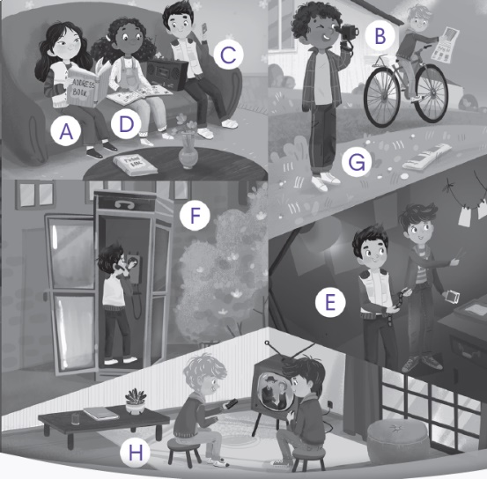

# Lesson 2 Reading

## B.

1. a, record videos

2. Close the door and press LOCK.

3. Press the ON button.

4. It used to make a noise in ZOOM mode.

# Speaking

# *Answers will vary.*

# Lesson 3

# Story

## A.

1. silent film
2. develop
3. watch
4. tape
5. used to
6. Recording

## C.

## b

## c

## a

## c

# Expand

## B.

## E

## B

## G

## A

## D

## H

## F

## C

## C.

## Did you use to cry a lot when you were younger? 🡪 Yes. I used to cry a lot.

## Did you use to feed your siblings when you were younger? 🡪 No. I didn’t use to feed my siblings.

## Did you use to crawl when you were younger? 🡪 Yes. I used to crawl.

## Did you use to catch butterflies when you were younger? 🡪 Yes. I used to catch butterflies.

## Did you used to have a babysitter when you were younger? 🡪 No. I didn’t use to have a babysitter.

## Did you use to take naps when you were younger? 🡪 No. I didn’t use to take naps.

# Lesson 4

# Grammar

## A.

1. She used to catch butterflies when she was a child.
2. He used to keep an address book when he was younger.
3. They used to take naps when they were younger.
4. She used to have a babysitter when she was younger.
5. He used to deliver newspapers when he was a child.
6. They used to collect stamps when they were children.

## B.

1. Did, use to, used to
2. Did, use to, didn’t use to play cassettes
3. Did, use to, used to crawl
4. Did, use to, didn’t use to fall down
5. Did, use to, didn’t use to feed my siblings
6. Did, use to, used to develop photos

# Lesson 5

# Writing

## A.

1. 1
2. 4
3. 2
4. 3

## B.

## *Answers will vary.*

# Lesson 6

# CLIL

## B.

1. The first device used to play recorded sounds was the phonograph.
2. People used to play cassette tapes in their cars and on portable tape players.
3. CDs store digital music.

## C.

1. a
2. c
3. c
4. c

## D.

1. a

2. b

3. c

## E.

## Answers will vary.

## **Review 1 (Units 1-2)**

## A.

## golf

## crawl

## blog

## recycling

## newspaper

## collect

## purchase

## babysitter

## 

## B.

1. a
2. b
3. a
4. b

## C.

## do🡪 doing

## helping🡪 help

## watched 🡪 watch

## me🡪 you

## going🡪 go

## used🡪use

## D.

1. Did you use to catch butterflies when you were younger?
2. What are you doing on Thursday?
3. Kevin used to cry a lot when he was younger.
4. I need to go to gymnastics after school.

**Unit 3**

# Lesson 1

## C.

## 

# Lesson 2

# Reading

## B.

* 1. c
  2. You can’t play with them.
  3. Jenny’s mom thinks rabbits are fun to play with.
  4. Jenny’s dad used to have a bird.

# Speaking

# *Answers will vary.*

# Lesson 3 Story

## A.

1. kitten
2. rather
3. cute
4. prefer
5. friendlier
6. playful

## C.

1. c
2. b
3. a
4. c

# Expand

## B.

1. G
2. C
3. A
4. E
5. B
6. D
7. F
8. H

## C.

## 1. Which pet would you prefer, a lizard or a kitten?

## *➞ Answers will vary.*

## 2. Which pet would you prefer, a snake or aparrot?

## *➞ Answers will vary.*

## 3. Which pet would you prefer, a kitten or a rabbit?

## *➞ Answers will vary.*

## 4. Which pet would you prefer, a goldfish or a parrot?

## *➞ Answers will vary.*

## 5. Which pet would you prefer, a rabbit or a goldfish?

## *➞ Answers will vary.*

## 6. Which pet would you prefer, a lizard or a turtle*?*

*➞ Answers will vary.*

# Lesson 4

## **Grammar**

## A.

1. He would rather get a hamster than a rabbit.
2. She would rather get a goldfish than a parrot.
3. They would rather get a kitten than a rabbit.
4. I would rather get a lizard than a snake.
5. We would rather get a hamster than a kitten.
6. You would rather get a snake than a turtle.

## B.

1. I would prefer a kitten to a hamster because it is friendly.
2. He would prefer a rabbit to a lizard because it is cute.
3. She would prefer a turtle to a kitten because it is easy to care for.
4. You would prefer a goldfish to a parrot because it is quiet.
5. They would prefer a kitten to a snake because it is soft.
6. We would prefer a snake to a goldfish because it is clever.

# Lesson 5

## **Writing**

## A.

## Hook: When I was in kindergarten, my family had a pet hamster named Pickle who

would always get into trouble.

Q: d, a personal story

B.

## *Answers will vary.*

# Lesson 6

## **CLIL**

## B.

1. Capuchin monkeys are good helpers.
2. They make a mess and even fly into windows.
3. Many years ago, before cars were popular, people used horses to pull carriages.

## C.

1. c
2. a
3. c
4. b

## D.

1. c
2. a
3. b

## E.

*Answers will vary*.

**Unit 4**

# Lesson 1

## C.

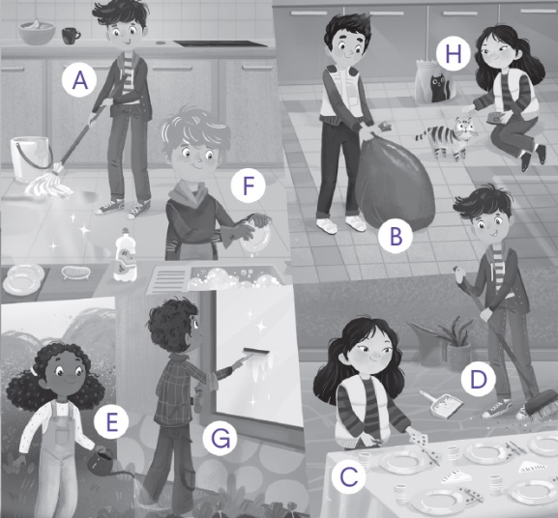

# Lesson 2

# Reading

## B.

* 1. b
  2. Her grandmother is coming tomorrow.
  3. Mateo has already cleaned the windows.
  4. He swept the floor.

# Speaking

*Answers will vary.*

# Lesson 3 Story

## A.

1. chores
2. trash
3. already
4. mopped
5. yet
6. dust
7. dirtier

## C.

1. b
2. a
3. b
4. c

# Expand

## B.

1. H
2. B
3. E
4. C
5. F
6. G
7. D
8. A

## C.

## (*Names may vary)*

1. Has anyone cut the grass yet? 🡪 Yes, Mateo has already done it.
2. Has anyone vacuumed the carpet yet? 🡪 No, no one has done it yet.
3. Has anyone dusted the furniture yet? 🡪 No, no one has done it yet.
4. Has anyone cleaned the bathroom yet? 🡪 Yes, Emma has already done it.
5. Has anyone weeded the garden yet? 🡪 No, no one has done it yet.
6. Has anyone folded the laundry yet? 🡪 Yes, Nadir has already done it.

# Lesson 4 Grammar

## A.

1. Have you vacuumed the carpet yet? 🡪Yes, I’ve already done it.
2. Has he cleaned the bathroom yet? 🡪 No, he hasn’t cleaned it yet.
3. Have we folded the laundry yet? 🡪 Yes, we’ve already done it.
4. Have you cleaned your room yet? 🡪 No, I haven’t cleaned it yet.
5. Has she done the dishes yet? 🡪 No, she hasn’t done the dishes yet.

## B.

1. weeded the garden, has already done
2. dusted the furniture, no one has done, yet
3. fed the cat, has already done
4. mopped the floor, no one has done, yet
5. set the table, has already done

Lesson 5

# Writing

## A.

**Helping Out at Home** Thesis:I think the best way for me to help around the house more is probably to do the laundry for my mom.

Rewritten thesis: *Answers may vary. Sample answer:* The best way I can help around the house is by doing the laundry for my mom.

## B.

*Answers will vary.*

# Lesson 6 CLIL

## B.

1. First, people had to wash clothes in a tub with a washing board.
2. squeeze the water out of wet clothing
3. there wasn’t electricity

## C.

1. b
2. b
3. c
4. d

## D.

1. b

2. c

3. a

## E.

*Answers will vary.*

# Review 2 (Units 3-4)

## A.

1. carpet

2. playful

3. sweep

4. rabbit

5. laundry

6. quiet

7. furniture

8. goldfish

Secret Word: cleaning

## B.

1. a
2. b
3. a
4. a

## C.

1. will🡪 would
2. than🡪 to
3. fold🡪folded
4. already🡪 yet
5. for🡪to
6. sweep🡪swept

## D.

1. I would prefer a kitten to a rabbit because it is playful.
2. I would rather get a lizard than a snake.
3. No, I haven’t done the dishes yet.
4. Ryan has already done them.

**Lesson 1**

## C.

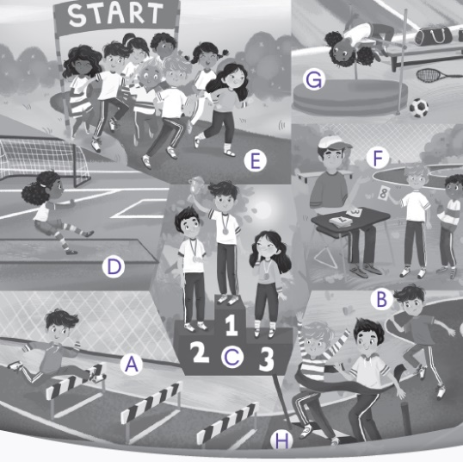

# Lesson 2

# Reading

## B.

1. c

2. Ryan won the boy’s long jump.

3. Sarah ran her hurdle race in 21.3 seconds.

4. Mr. Evans won the teacher’s high jump competition.

# Speaking

*Answers will vary.*

# Lesson 3 Story

## A.

1. hurdle
2. competed
3. before
4. twice

**Unit 5**

1. practice
2. meters

## C.

1. a
2. c
3. b
4. c

# Expand

## B.

1. F
2. B
3. D
4. H
5. C
6. A
7. E
8. G

## C.

1. Have you ever competed in a relay race? 🡪 *Answers will vary.*
2. Have you ever played rugby? 🡪 *Answers will vary.*
3. Have you ever competed in a javelin competition? 🡪 *Answers will vary.*
4. Have you ever played field hockey? 🡪 *Answers will vary.*
5. Have you ever played handball? 🡪 *Answers will vary.*
6. Have you ever played badminton? 🡪 *Answers will vary.*

# Lesson 4 Grammar

## A.

1. I have never lost an event.
2. She has run the hurdles.
3. He has never tied a race.
4. I have never done the long jump.
5. We have taken part in a competition.
6. They have won a prize.

## B.

1. Have you ever played handball?
2. Have you ever competed in a shot put competition?
3. Have you ever competed in a javelin competition?
4. I have won a prize twice.
5. I have never played rugby.
6. I have played badminton before.

**Lesson 5**

# Writing

## A.

## Subtopics:

## Paragraph #1: handball is an exciting sport

## Paragraph #3: handball is a team sport

## Topic sentence: *Answers will vary.* Sample Answer: Handball is a sport that can be played in many different locations.

## B.

## *Answers will vary.*

# Lesson 6 CLIL

## B.

1. in Greece in 776 BCE
2. schools in Great Britain
3. a round path with boundary lines called lanes

## C.

1. b
2. c
3. c
4. a

## D.

1. a
2. b
3. c

## E.

*Answers will vary.*

Lesson 1

**Unit 6**

## C.

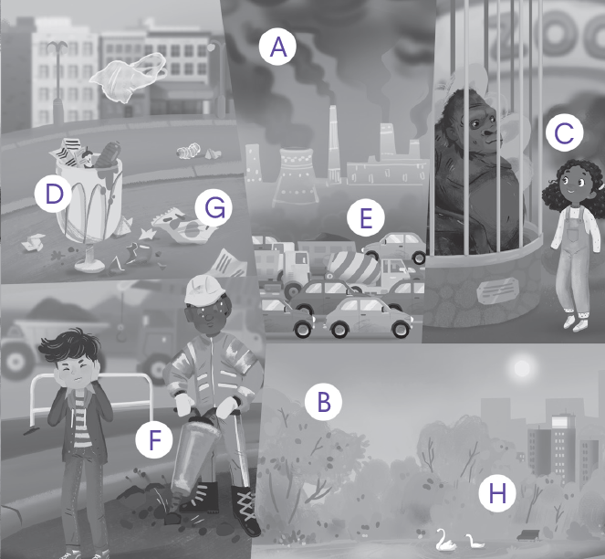

# Lesson 2

**Reading**

## B.

* 1. b
  2. The trees in green areas keep the air fresh and clean.
  3. They walk, run, ride bikes, and play sports.
  4. He thinks there are not enough.

# Speaking

## B.

*Answers will vary.*

# Lesson 3 Story

## A.

1. too much
2. not enough
3. can
4. could
5. the garbage
6. picking

## C.

1. b
2. c
3. c
4. a

# Expand

## B.

1. B
2. F
3. C
4. G
5. D
6. H
7. E
8. A

## C.

1. There are too many traffic jams. 🡪 We could ride bikes.
2. There is too much air pollution. 🡪 We could take public transportation.
3. There is too much garbage. 🡪 We could recycle.
4. There are not enough trash cans. 🡪 We can write a letter.
5. There are not enough green areas. 🡪 We can plant trees.
6. There are too many endangered animals. 🡪 We could hold a town hall meeting.

# Lesson 4 Grammar

## A.

1. too many 🡪 too much
2. not many🡪 too much / not much
3. too🡪 not (or just delete “too”)
4. are🡪 is
5. too much 🡪 not enough
6. much 🡪 many

## B.

1. We could plant trees.
2. I can pick up garbage.
3. We could have a town meeting.
4. He can take public transportation.
5. We could start a fun campaign.
6. You can ride your bike.

**Lesson 5**

# Writing:

## A.

## c

## a

## b

## B.

## *Answers will vary.*

# Lesson 6 CLIL

## B.

1. Wide Fund for Nature is an organization that works to protect the environment.
2. Also, humans are destroying animals’ homes to make space for buildings. Pollution and hunting can cause animals to be endangered, too.
3. teach family and friends about endangered animals, write letters to our local newspapers or politicians, pick up garbage to reduce pollution and recycle

## C.

1. b
2. d
3. a
4. b

## D.

1. c
2. c
3. a

## E.

*Answers will vary.*

# Review 3 (Units 5-6)

## A.

## Across:

## 2. pollution

## 4.marathon

## 5.bike

## 6.hurdle

## 8.rugby

Down:

1.endangered

3.noisy

7.relay

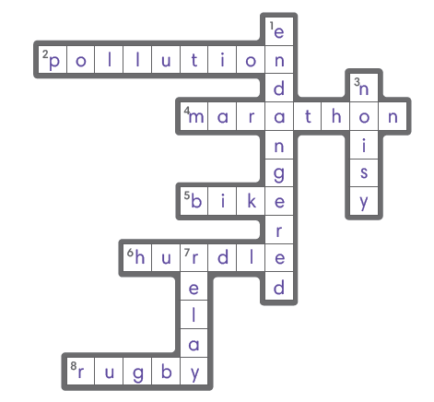

## B.

1. b
2. b
3. a
4. a

## C.

1. Has🡪 Have
2. did🡪 done
3. take🡪 taken
4. many🡪 much
5. to take🡪 take
6. is🡪 are

## D.

## 1. There are, trash cans, park

## 2. There is, garbage, sports field

## 3. Have you, run, before

## 4. have never, field hockey

**Unit 7**

# Lesson 1

## C.

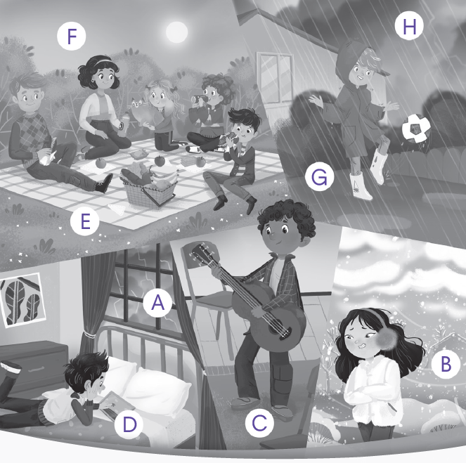

# Lesson 2

# Reading

## B.

1. a
2. If it is sunny, Daniel will play in his backyard.
3. He’s going to watch the baseball game because his favorite team is playing.
4. If the weather is stormy, his family might come to his house for his grandmother’s birthday.

# Speaking

## *Answers may vary.*

# Lesson 3 Story

## A.

1. weather
2. tablet
3. park
4. boiling
5. swimming
6. homework

## C.

1. b
2. c
3. c
4. b

# Expand

## B.

1. F
2. H
3. A
4. G
5. B
6. E
7. D
8. C

## C.

## [*Weather may vary.*]

1. Will you do your homework if it’s boiling? 🡪 *Answers will vary.*

1. Will you go to the park if it’s freezing? 🡪 *Answers will vary.*
2. Will you visit the library if it’s boiling? 🡪 *Answers will vary.*
3. Will you go swimming if it’s cool? 🡪 *Answers will vary.*
4. Will they go on a picnic if it’s cool? 🡪 *Answers will vary.*
5. Will she practice the guitar if it’s snowy? 🡪 *Answers will vary*.

# Lesson 4 Grammar

## A.

1. If it’s rainy, I’ll practice the guitar.
2. If it’s stormy, he’ll stay home.
3. If it’s snowy, we’ll play in the yard.
4. If it’s chilly, she’ll do her homework.
5. If it’s boiling, Viola will go swimming.
6. If it’s cool, my sister will play on the tablet.

## B.

1. Will, if it’s, No, won’t
2. Will, if it’s, Yes, will
3. Will, if it’s, No, won’t
4. Will, if it’s, Yes, will
5. Will, if it’s, No, won't
6. Will, if it’s, Yes, will

Lesson 5

# Writing

## A.

1. 3
2. 1
3. 2

## B.

## *Answers will vary*.

# Lesson 5

# CLIL

## B.

1. In the summer, this causes the weather to change and become hot and wet.
2. If it gets that hot this summer, Aditya will go swimming at India Gate with his friends.
3. If it’s a rainy weekend, Aditya stays at home. He will play board games with his family.

## C.

1. c
2. c
3. a
4. b

## D.

1. b

2. c

3. c

## E.

## *Answers will vary.*

**Unit 8**

# Lesson 1

## C.

## 

# Lesson 2

# Reading

## B.

1. a

2. The Lions won the game.

3. The Lions were warming up at 1:30 p.m.

4. The crowd was cheering at 3:15 p.m.

# Speaking

## *Answers will vary.*

# Lesson 3 Story

A.

1. working
2. passing
3. cheering
4. player
5. filming
6. game

## C.

1. a
2. b
3. b
4. b

# Expand

## B.

1. D
2. B
3. G
4. A
5. F
6. E
7. H
8. C

## C.

1. The player was running when the referee blew the whistle.
2. The team was losing when the coach screamed.
3. The crowd was cheering when the player ran.
4. The player was running when he slipped.
5. The crowd was screaming when the referee blew the whistle.
6. The coach was screaming when the player slipped.

# Lesson 4 Grammar

A.

1. We were discussing a plan at 10:00 a.m.
2. He was doing an interview at 5:30 p.m.
3. She was celebrating at 9:00 p.m.
4. I was taking a break at 11:00 a.m.
5. The team was warming up at 6:00 a.m.
6. My friends were filming at 2:00 p.m.

B.

1. was, slipping, blew
2. was, running, screamed
3. was, cheering, won
4. were, listening, discussed
5. were, running, shot
6. were, clapping, received

# Lesson 5

# Writing

## A.

## Underline: To sum up, Simone Biles is a gymnast who is talented, works hard, and dreams of success.

Main points:

1. Simone Biles is a talented gymnast.

2. Simone Biles works hard.

3. Simone Biles dreams of success.

## B.

*Answers will vary.*

# Lesson 6

# CLIL

## B.

1. a real quidditch team started in the US in 2005

2. Chess boxing was created by Iepe Rubingh

3. The sport is also known as Octopush.

## C.

1. d
2. a
3. a
4. b

## D.

1. a
2. b
3. b

# Review 4: Units 7-8

## A.

## rainy

## snowy

## picnic

## library

## coach

## whistle

## clap

## trophy

## 

## B.

1. b
2. a
3. a
4. b

## C.

1. it will boil 🡪 it is boiling
2. I visit 🡪 I will visit
3. cheer🡪 cheering
4. were🡪was
5. will be 🡪 is
6. blow🡪 blew

## D.

## *Answers will vary.*

**Unit 9**

# Lesson 1

## C.

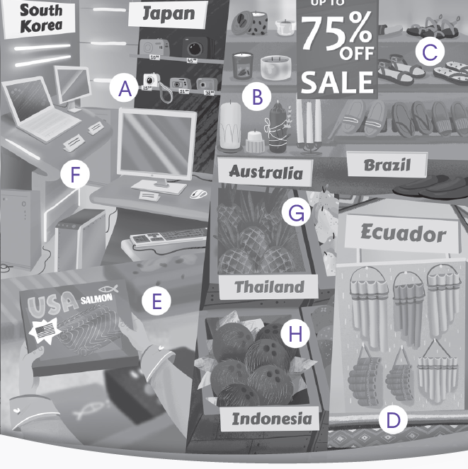

# Lesson 2

# Reading

## B.

* 1. b
  2. The Venitron computer is made in South Korea.
  3. The towels are made in Egypt.
  4. The pineapples are grown in Thailand.

# Speaking

*Answers will vary.*

# Lesson 3 Story

## A.

1. umbrella
2. uniforms
3. Italy
4. fifth
5. made
6. expensive

## C.

1. a
2. b
3. c
4. c

# Expand

## B.

1. H
2. B
3. E
4. G
5. F
6. A
7. D
8. C

## C.

## 1. That suitcase is made in France, isn’t it? ➞ *Answers will vary.*

## 2. Those skis are made in Japan, aren’t they? ➞ *Answers will vary.*

## 3. That umbrella is made in Brazil, isn’t it? ➞ *Answers will vary.*

## 4. That drum is made in South Korea, isn’t it? ➞ *Answers will vary.*

## 5. That uniform is made in Italy, isn’t it? ➞ *Answers will vary.*

6. That trumpet is made in Australia, isn’t it? ➞ *Answers will vary.*

# Lesson 4 Grammar

## A.

1. is, made
2. are, made
3. is, grown
4. are, made
5. is, made
6. are caught

## B.

1. is made, isn’t it, No, isn’t
2. are made, aren’t they, Yes, are
3. is made, isn’t it, No, isn’t
4. are made, aren’t they, Yes, are
5. are grown, aren’t they, No, aren’t
6. is made, isn’t it, Yes, is

**Lesson 5**

# Writing

## A.

Closing Statement: c

## B.

*Answers will vary.*

# Lesson 6 CLIL

B.

1. Goods were transported over land by camels and horses.
2. It connected China, Southeast Asia, India, The Middle East, Africa, and Europe.
3. Romans loved Chinese silk for its beautiful design and soft texture.

C.

1. d
2. c
3. b
4. d

## D.

1. a

2. c

3. a

## E.

*Answers will vary.*

**Unit 10**

# Lesson 1

## C.

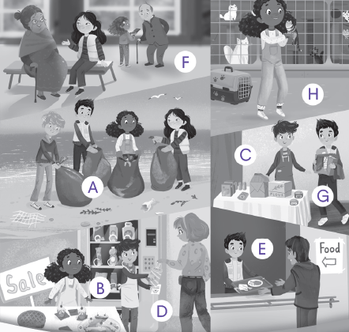

# Lesson 2

## **Reading**

## B.

1. c
2. They will have a bake sale.
3. Mike said that he volunteered at an animal shelter.
4. Ryan said that his family donated clothes.

## **Speaking**

*Answers will vary.*

# Lesson 3

## **Story**

## A.

1. muffins
2. bake sale
3. He said
4. community
5. donating clothes
6. warm

C.

1. a

2. b

3. c

4. a

## **Expand**

## B.

1. A
2. C
3. F
4. H
5. D
6. B
7. G
8. E

## C.

## [Time may vary]

1. I changed a tire last week. 🡪 He/She said that he/she had changed a tire last week.
2. I put up a picture last week. 🡪 He/She said that he/she had put up a picture last week.
3. I lent a textbook yesterday. 🡪He/She said that he/she had lent a textbook yesterday.
4. I shoveled snow last week. 🡪 He/She said that he/she shoveled snow last week.
5. I washed a car yesterday. 🡪 He/She said that he/she washed a car last week.
6. I carried bags last week. 🡪 He/She said that he/she carried bags last week.

# Lesson 4

## **Grammar**

## A.

1. helped the homeless
2. visited elderly people
3. didn’t clean up beaches
4. didn’t collect money for charity
5. carried bags for my neighbor.

## B.

1. He said that he had shoveled snow yesterday.
2. She said that she had put up a picture last weekend.
3. He said he had lent his friend a textbook this morning.
4. She said she had given her daughter advice last week.
5. We said that we had donated clothes to the shop two days ago.
6. She said that she had held a bake sale last fall.

# Lesson 5

## **Writing**

## A.

One way we can help the elderly is to help them with grocery **shoping**. My

friend goes shopping with her elderly neighbor every **saturday**. She **read** signs and carries bags. ~~When I go shopping with my mom, I always ask for an ice cream~~ ~~afterward.~~ My friend says that “her neighbor is always so happy for her help**.”**

## B.

## *Answers will vary.*

# Lesson 6

## **CLIL**

## B.

1. She enjoys taking the subway and living in a place with so much to do.
2. They also said they enjoy biking around the neighborhood and grilling food in their backyard.
3. Sam said he likes to look at the stars.

## C.

1. a
2. a
3. d
4. c

## D.

## c

## b

## a

## E.

## *Answers will vary.*

# Review 5 (Units 9-10)

## A

## **Across:**

## 2. textbook

## 4. smartphone

## 6. bake sale

## 7. fix

## **Down:**

## 1. umbrella

## 3. sandal

## 4. souvenir

## 5. tire

## 

## B.

1. b
2. a
3. b
4. a

## C.

1. making 🡪 made
2. isn’t 🡪 aren’t
3. had held 🡪 held
4. he changed 🡪 he had changed

## D.

1. He said that he had fixed the computer last weekend.
2. She said that she gave good advice.
3. These pineapples are grown in Thailand, aren’t they?
4. The best digital cameras are made in Japan.