 | 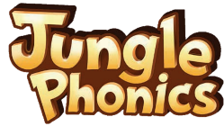 |  | Word List |  |  | 
Class |  |  |  | Name

Unit 1. bl-, cl-, fl-, pl-

Picture | Word | Picture | Word
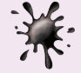 | black | 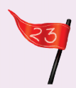 | flag
 | blue | 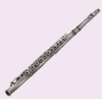 | flute
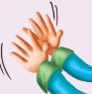 | clap | 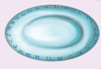 | plate
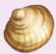 | clam | 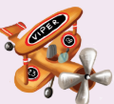 | plane

 |  |  | Word List
Class |  |  |  | Name

Unit 2. br-, cr-, fr-, pr-

Picture | Word | Picture | Word
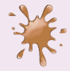 | brown | 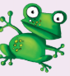 | frog
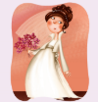 | bride | 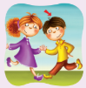 | friend
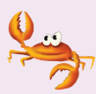 | crab | 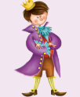 | prince
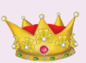 | crown |  | prize

 |  |  | Word List
Class |  |  |  | Name

Unit 3. sn-, sw-, -nk, -ng

Picture | Word | Picture | Word
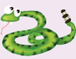 | snake | 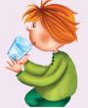 | drink
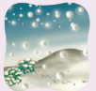 | snow | 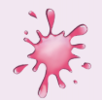 | pink
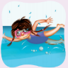 | swim | 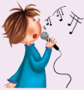 | sing
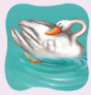 | swan | 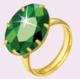 | ring

 |  |  | Word List
Class |  |  |  | Name

Unit 4. sh-, -sh, -ch, wh-

Picture | Word | Picture | Word
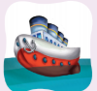 | ship | 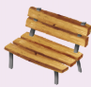 | bench
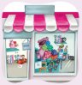 | shop | 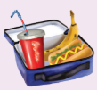 | lunch
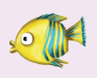 | fish | 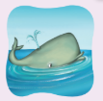 | whale
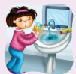 | wash | 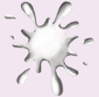 | white

 |  |  | Word List
Class |  |  |  | Name

Unit 5. -ai-, -ay, -ea-, -ee

Picture | Word | Picture | Word
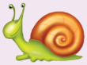 | snail | 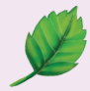 | leaf
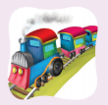 | train | 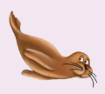 | seal
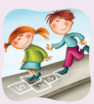 | play | 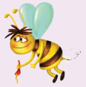 | bee
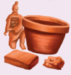 | clay | 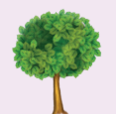 | tree

 |  |  | Word List
Class |  |  |  | Name

Unit 6. -oa-, -ow, -oi-, -oy

Picture | Word | Picture | Word
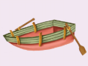 | boat | 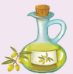 | oil
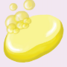 | soap | 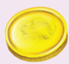 | coin
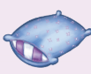 | pillow | 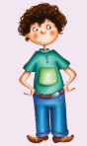 | boy
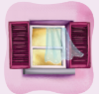 | window | 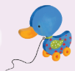 | toy

 |  |  | Word List
Class |  |  |  | Name

Unit 7. -oo-, -oo-, -ou-, -ow-

Picture | Word | Picture | Word
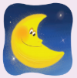 | moon | 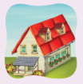 | house
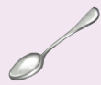 | spoon | 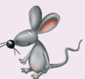 | mouse
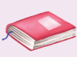 | book | 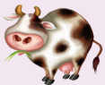 | cow
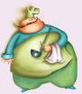 | cook | 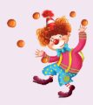 | clown

 |  |  | Word List
Class |  |  |  | Name

Unit 8. -ar-, -or-, -er-, -ir-, -ur-

Picture | Word | Picture | Word
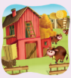 | farm |  | letter
 | star | 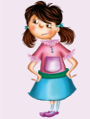 | girl
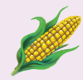 | corn | 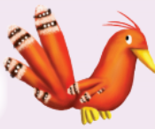 | bird
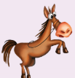 | horse | 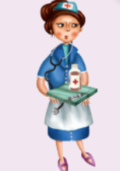 | nurse
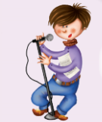 | singer | 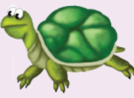 | turtle

