New Frontiers 1 Workbook
Answer Key

Unit 1 - Lesson A
(1) 1. b 2. c 3. b 4. c
(2) 1. She’s my sister.
2. He’s my brother.
3. She’s my aunt.
4. He’s my father.
(3) 1. He’s 2. He’s 3. She’s 4. He’s
(4) 1. T 2. F 3. F 4. T

Unit 1 - Lesson B
(1) 1. police officer
2. doctor
3. pilot
4. singer
5. artist
6. soccer player
7. farmer
8. chef

(2) 1. name 2. officer 3. doctor 4. are 5. is
(3) 1. a 2. a 3. b
(4) (Answers will vary)
(5) (Answers will vary)

Unit 1 - Lesson C
(1) 1. d 2. e 3. a 4. c 5. b
(2) 1. name 2. birthday 3. old
(3) 1. is -> are 2. is -> are 3. are -> is 4. are -> is
(4) (Possible Answers)
My birthday is September 2nd.
My eyes are blue.
My address is 15 Brent Street.
My email address is yername@zmail.com.
(5) 1. bed, fin, cup 2. age, boat, side

Unit 1 - Lesson D
(1) 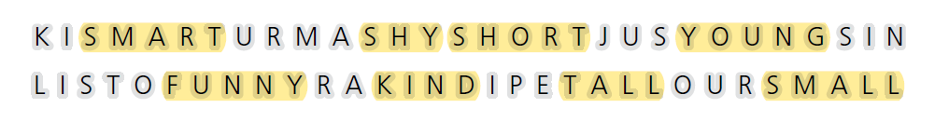
(2) 1. tall 2. young 3. funny 4. smart 5. shy
6. small
(3) 1. are -> is 2. am -> are 3. are -> is
(4) 1. sister -> shy 2. uncle -> pilot
3. cousin -> short 4. grandmother -> artist

Unit 1 - Lesson E
(1) mother, artist, father, pilot, uncle, brother
(2) 1. mother 2. pilot 3. brother 4. artist
(3) 1. Are your eyes brown?
2. Is your uncle a doctor?
3. Is your brother a soccer player?
4. Are your cousins short?
(4) 1. is 2. he isn’t 3. are

Unit 1 - Review
(1) 1. He’s 2. She’s 3. He’s 4. She’s
(2) 1. T 2. F 3. F 4. T
(3) 1. Ellen 2. father 3. Suzie 4. brother. Sam
(4) (Answers will vary)
(5) (Answers will vary)

Unit 2 - Lesson A
(1) 1. a 2. a 3. c
(2) 1. a 2. c 3. c
(3) a. pencils b. colored pencils c. a pencil case
d. folders e. a notebook

Unit 2 - Lesson B
(1) 1. c 2. b 3. d 4. a
(2) 1. Who is he?
2. Is she a teacher?
3. She is my classmate.
4. He is not a teacher.
(3) 1. a 2. c 3. b 4. a 5. c
(4) (Possible Answers)
1. Who is she? She is my teacher.
2. Is he your teacher? Yes, she is also my teacher.
3. What do you need for class? I need a notebook.
4. What do you need for class? I need a ruler.

Unit 2 - Lesson C
(1) 1. classroom 2. teacher 3. chair 4. computers 5. dictionary 6. bookcase
(2)
1. Mike: That is our classroom.
2. Sarah: Is that our teacher?
3. Mike: These are computers for us to use.
4. Sarah: Can we use those dictionaries too?
(3) 1. bookcase 2. school, classroom
3. teacher 4. chair
(4) 1. This is 2. Is this; It is 3. are those?; my shoes. 4. that

Unit 2 - Lesson D
(1) 1. English 2. Science 3. Mathematics
4. Physical Education 5. Art
(2) 1. F 2. F 3. T 4. T 5 T
(3) 1. What is that on the wall? That is a map.
2. What class is this? This is history class.
3. What are these? These are my school supplies.
4. Are those your classmates? Yes. Those are my classmates.
5. Is this your science class? No. It isnt’.
(4) 1. This is my writing class. It is the best class! Our teacher helps us write fun stories. We need to learn grammar in this class.
2. I love my science class. We learn about biology. We need to know about math, too. This class isn’t easy. But it is a lot of fun.

Unit 2 - Lesson E
(1) 1. music, book, math, robot, pen, case
(2) 1. posters 2. long 3. math 4. pencil case
5. music
(3) 1. What time does the club start?
2. Where do you meet?
3. What is the name of the club?
4. It is at s o’clock.
5. The name is “Battle Bots.”
(4) 1. in 2. in 3. at 4. at 5. on 6. at 7. on

Unit 2 - Review
(1) (Answers will vary)
(2) 1. F 2. T 3. T
(3) (Answers will vary)
(4) (Answers will vary)
(5) (Answers will vary)

Review (Unit 1-2)
(1) 1. d 2. a 3. d 4. a 5. d 6. c 7. a
8. b
(2) 1. name 2. grade 3. old 4. class 5. is
6. homework 7. chef 8. her 9. sister 10. are
11. kind 12. backpack 13. need 14. they
15. computer 16. need 17. that’s
1. b 2. c
(3) 1. am 2. is 3. is not 4. are 5. is
(4) 1. He 2. Her 3. they 4. it 5. they
(5) 1. needs 2. doesn’t 3. don’t 4. needs
5. don’t
(6)
1. Name : Laura
Age : 15
Job : Student
Looks : black hair and dark brown eyes
Extra Information : favorite class is history
2. Name : Nicole Anderson
Age : 34
Job : Doctor
Looks : tall, blonde hair and blue eyes
Extra Information : have a younger sister and a younger brother
3. Name : Abby
Age : 56
Job : Teacher
Looks : short white hair
Extra Information : likes to wear skirts to work

Unit 3 - Lesson A
(1) 1. 1 2. 2 3. 5 4. 4 5. 2 6. 5 7. 3 8. 1
9. 3 10. 4
(2) 1. c. in the bedroom
2. d. in the living room
3. a. in the bathroom
4. e. in the dining room
5. b. in the kitchen
(3) 1. in 2. is 3. and 4. are 5.There's
(4) 1. c 2. a 3. c 4. b

Unit 3 - Lesson B
(1) 1. clothes 2. armchair 3. closet 4. sink
5. stove 6. lamp 7. bed 8. shower 9. toilet
10. mirror
(2) 1. Bedroom: bed, closet
2. Kitchen: stove, sink
3. Bathroom: shower, toilet, mirror
4. Living room: armchair, lamp,
(3) 1. in 2. in 3. beside 4. on 5. beside
6. in 7 beside

Unit 3 - Lesson C
(2) 1. d 2. a 3. e 4. b 5. c
(3) (Answers will vary)
(4) 1. There are five rooms in the house.
2. (Answers will vary)

Unit 3 - Lesson D
(1) 1. d 2. c 3. a 4. f 5. b 6. e 7. h 8. g
(2) yard, garden, television, stairs, door
(3) 1. 1 2. 3 3. 3 4. 2

Unit 3 - Lesson E
(1) first picture : 1, second picture : 3, third picture : 2
(2) 1. in 2. in 3. next to/beside 4. on
5. under 6. next to/beside 7. next to 8. in
(3) 1. c 2. b 3. c

Unit 3 - Review
(1) 1. kitchen 2. dining room 3. bathroom 4. living room
(2) 1. on 2. in 3. beside
(3) 1. An igloo, a houseboat, and a tree house
2. igloo 3. houseboat
(4) (Answers will vary)
(5) (Answers will vary)

Unit 4 - Lesson A
(1) plane, taxi, car, bus, train, fly, ride
(2) 1. b 2. c 3. b 4. a 5. c
(3) 1. John takes the bus to school.
2. The plane flew to France.
3. I like to ride my bike.
(4) 1. bus 2. plane 3. ride, bike
(5) (Answers will vary)
(6) 1. She takes the bus.
2. She takes the subway.
3. She comes by car.

Unit 4 - Lesson B
(1) 1. a 2. c 3. c 4. b 5. d
(2) 1. 7 2. 7:30 3. 5:30 4. 3:45
(3) 1. about 2. mother 3. London 4. summer 5. pencil
(4) 1. soccer practice 2. drop by Eli’s house

Unit 4 - Lesson C
(1) 1. a 2. b 3. c 4. a 5. c
(2) 1. Joon-Wu wakes up to go to school.
2. Joon-Wu mother picks him up from school.
3. Joon-Wu goes to soccer practice.
4. Joon-Wu eats dinner.
5. Joon-Wu goes to bed.
(3) 1. Laura makes her bed in the morning..
2. I have basketball practice tomorrow.
3. I like to play games at night.
4. I like to hang out with friends on the weekend.
(4) 1. In the morning, Jada washes her face and feet/ Jada eats cereal.
2. In the afternoon, Jada goes to basketball practice./Jada rides the bus home.
3. At night, Jada brushes her teeth./Jada goes to bed.

Unit 4 - Lesson D
(1) 1. F 2. T 3. T 4. T 5. F
(2) 1. before 2. after 3. at 4. in 5. on 6. at
(3) 1. Mary gets ready for school before she wakes up. -> Mary gets ready for school after she wakes up.
2. Mary practices piano after she goes home in the evening. -> Mary practices piano before she goes home in the evening.
3. Mary does her homework before she goes to school. -> Mary does her homework before she goes to bed.

Unit 4 - Lesson E
(1) car, bus, subway, after, bike
(2) 1. c 2. d 3. a 4. e 5. b 6. f
(3) (Possible Answers)
1. Jim wakes up at 7:00 a.m. in the morning.
2. Jim goes for a bicycle ride with Tim at 8:00 p.m. in the evening.
3. Jim cooks dinner with his family at 6:30 p.m.
4. Jim washes and gets ready for bed after dinner.
5. Jim reads a book before bed.

Unit 4 - Review
(1) 1. b 2. a 3. c 4. d
(2) (Answers will vary)
(3) She does chores in the evening after dinner.
(4) (Answers will vary)
(5) (Answers will vary)
David’s schedule : Morning: wake up, brush teeth
Afternoon: practice football, do homework
Evening: eat dinner, clean my room
Night: go to sleep

Review (Unit 3-4)
(1) 1. subway 2. night table 3. stove 4. wall
5. bathroom 6. clean 7. brush 8. dressed
(2) 1. are 2. beside 3. closet 4. window
5. yard 6. is 7. garden 8. toilet 9. bathtub
10. dining room 11. in 12. couch
1. F 2. T 3. F 4. F 5 T
(3) 1. in 2. at 3. on 4. at 5. in 6. in
(4) 1. are 2. is 3. is 4. are
(5) 1. All the kids are at the car. -> All the kids are in the car.
2. Julie was born in July 5, 2013. -> Julie was born on July 5, 2013.
3. There is a mirror at the wall in the bathroom. -> There is a mirror on the wall in the bathroom.
4. When time do you eat breakfast? -> What time do you eat breakfast?
5. My shoes are under the closet. -> My shoes are in the closet.
(6) 1. 7:15 2. bus 3. soccer practice 4. subway
5. my bike 6. do homework 7. evening 8. at 12:00
1. b 2. d

Unit 5 - Lesson A
(1) 1. draw 2. exercise 3. play soccer 4. swim
5. watch a movie

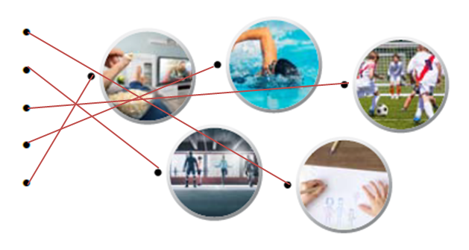
(2) 1. exercise 2. draw 3. soccer 4. watch
5. swim
(3) 1. never 2. always 3. usually 4. usually
5. sometimes
(4) 1. watch 2. plays 3. have/eat 4. read
5. wakes up 6. play

Unit 5 - Lesson B
(1) (Answers will vary)
(2) 1.1 2. 4 3. 3 4. 2 5. 5 6. 6 7. 7
(3) 1. What do you do in your free time?
2. Do you usually play video games?
3. Do you always wake up early?
4. Do you sometimes exercise?
5. What time do you usually go to bed?

Unit 5 - Lesson C
(1) listen to music, skateboard, chat, paint, go shopping
(2) 1. d 2. c 3. e 4. b 5. a
(3)
A: So Dan, do you usually exercise on the weekends? √
B: No, I never exercise on the weekend. But I exercise during the weekdays, in the afternoons. How about you? X
-> No, I never exercise on the weekend. But I exercise during the weekdays, early in the morning. How about you?
A: I always exercise at 11 a.m., after breakfast. X
-> I always exercise at 11:30 a.m., after breakfast.
B: What kind of exercise do you do? √
A: I sometimes swim and sometimes play tennis. X
-> I usually swim and sometimes skateboard.
B: OK. Do you do that every day? √
A: No, I’m usually tired, so I usually just listen to music and go to bed. X
-> No. I’m always tired, so I usually just play a video game and go to bed.

Unit 5 - Lesson D
(1) snowboard, hiking, baseball, photo, surf
(2) 1. skateboard, snowboard, basketball
2. surf, swim 3. baseball 4. photography
5. hiking
(3) /Ɵ/ : three, birthday, Thursday, thirty, Theo
/ð/ : the, mother, grandmother, father
(4) (Answers will vary)

Unit 5 - Lesson E
(1) 1. busy 2. passport 3. sad 4. fun
(2) 1. He usually goes to bed after dinner.
2. Before school, I never have breakfast.
3. We always play table tennis after school.
4. What do you usually do after lunch?
5. They sometimes go home together after class.
6. What do you always do before school?
(3) 1. busy 2. passport 3. fun 4. sad
(4) after, play, before, read

Unit 5 - Review
(1) (Answers will vary)
(2) Tim : always exercised in the morning and sometimes plays tennis after school
Gianna : never plays sports, usually stays at home and paints or reads books.
Benji : collects shoes, shops online and in stores to find shoes, also likes to play guitar.
(3) Q : What does your best friend do in his or her free time?
A : (Answers will vary)
(4) (Answers will vary)
(5) (Answers will vary)

Unit 6 - Lesson A
(1) glasses, beard, blonde, handsome, pretty, earrings
(2) 1. handsome 2. beard 3. pretty 4. blonde
5. glassed 5. earrings
(3) 1. Bastien’s Hair Salon
2. Antoine’s Accessories New styles!
3. The Gentlemen Factory
(4) (Answers will vary)

Unit 6 - Lesson B
(1) hat, sweater, jeans, jacket, pants, t-shirt
(2) (From left to right)
jacket, hat, pants, sweater, jeans, t-shirt
(Possible Answers)
glasses, shoes, skirt, beanie, etc.
(3) 1. F 2. F 3. T 4. T 5. T
(4) (Answers will vary)

Unit 6 - Lesson C
(1) (From left to right)
2, 3, 5, 1, 4
(2) (From left to right)
1, 4, 3, 2
(3) 1. a 2. c 3. a 4. c
(4) (Answers will vary)

Unit 6 - Lesson D
(1) 1. light hair, b 2. uncomfortable, c 3. straight hair, a
(2) (From left to right)
3, 2, 1, 5, 4
(3) 1. F 2. F 3. T 4. T 5. F
(4) (Answers will vary)

Unit 6 - Lesson E
(1) 3. beach 2. crowded 4. thief 1. steal
(2) 1. Where is your sister?
2. She is over there. The tall girl.
3. What is she wearing?
4. She is wearing a blue t-shirt and jeans.
5. Ok, yes I can see her. Wow, she is pretty.
(3)
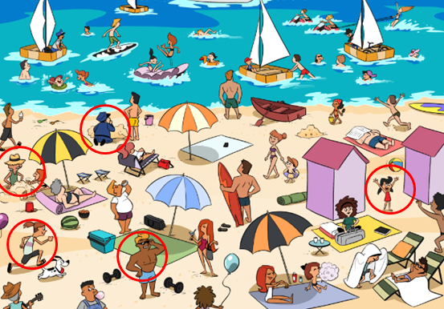
(4) (Answers will vary)

Unit 6 - Review
(1) 1. b 2. a 3. c
(2) (Possible Answers)
1. Q : What does your teacher look like?
A : He is a little fat and he has glasses.
2. Q : What are you wearing?
A : She is pretty and tall.
3. Q : What is your best friend wearing?
A : He has blonde hair and a long beard.
(3) It’s a kind of long white shirt. It is very cool and loose. It is very comfortable to wear in hot weather.
(4) (Answers will vary)
(5)

Review (Unit 5-6)
(1) 1. c 2. a 3. d 4. a 5. b 6. d 7. a
(2) 1. always 2. waiting 3. do 4. coat
5. don’t 6. hiking 7. exercise 8. I’m
9. curly
1. F 2. T 3. T 4. F
(3) 1. eat 2. am going 3. do, study 4. collects
5. is, working 6. Does, wear 7. has 8. is stealing
(4) 1. What is he look like? -> What does he look like?
2. A: Do you like sad movies? B: No, I’m not.
-> A: Do you like sad movies? B: No, I’m don’t.
3. Are you listen to music right now? -> Are you listening to music right now?
4. Her hair is long straight. -> Her hair is long and straight.
5. Stephen have a dark beard. -> Stephen has a dark beard.
6. We play after school video games. -> We play video games after school.
(5)
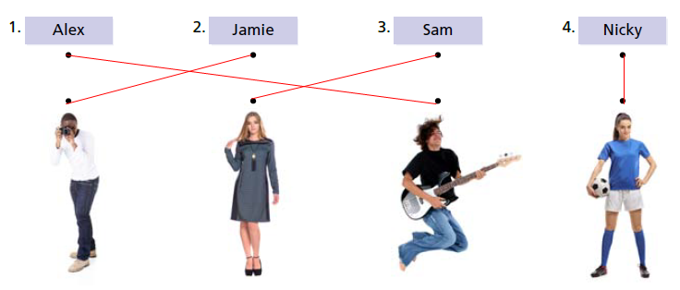
1. After school and on weekends
2. A (black) T-shirt and jeans
3. A new camera
4. Swim at the beach
5. In the morning before school
6. Teaches baseball to (little) kids

Unit 7 - Lesson A
(2) 1. e 2. a 3. b 4. c 5. d
(3) 1. I really like bread.
2. I do not like fish.
3. Do you like potatoes?
(4) 1. a 2. a 3. c 4. c 5. c
(5) (Answers will vary)

Unit 7 - Lesson B
(1) 1. b 2. b, c 3. b
(2) (Answers will vary)
(3) (Answers will vary)

Unit 7 - Lesson C
(1) 1. pizza 2. salad 3. slice 4. apple 5. glass 6. cup
(2) 1.
Sophia would like a salad. -> Sophia would like a pizza.
2. Mark would like a slice of pizza. -> Mark would like a salad.
3. Mark wants a cup of orange juice. -> Mark wants a glass of orange juice.
4. Sophia wants a glass of coffee. -> Sophia wants a cup of coffee.
(3) 1. c 2. a 3. b 4. c 5. c
(4) (Answers will vary)

Unit 7 - Lesson D
(1) 1. salt 2. rice 3. butter 4. sugar 5. water
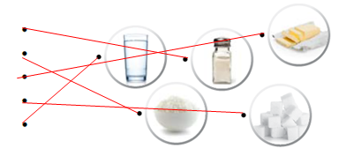

(2) 1. rice 2. butter 3. water 4. sugar 5. salt
(3) many 2. few 3. lot 4. some 5. little
(4) 1. I am bringing a few of food. -> I am bringing a lot of food; I have a little bananas and oranges.
-> I have many bananas and oranges; And I have many cake, too! -> And I have many cakes, too!
2. I am bringing a little pizzas to the picnic. -> I am bringing some pizzas to the picnic; I hope there is much juice at the picnic. -> I hope there is a lot of juice at the picnic.

Unit 7 - Lesson E
(1) fruit, fried chicken, cheese, cake, hamburgers, bread, fish
(2) 1. fried chicken 2. fruit 3. fish 4. cheese, bread 5. cake
(3) 1. How many hamburgers do you want?
2. How much fruit do you eat?
3. How many sodas do you drink in a day?
(4) 1. many, would 2. much, slice 3. much, a lot
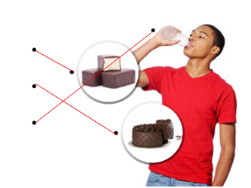

Unit 7 - Review
(1) (Answers will vary)
(2) 1. T 2. F 3. T
(3) (Answers will vary)
(4) (Answers will vary)
(5) (Answers will vary)

Unit 8 – Lesson A
(1) 1. c 2. a 3. b 4. c 5. c 6. a 7. c
(2) 1. We 2. trash 3. mopping 4. she 5. feeding 6. He 7. take out
(3) 1. I am changing the light bulb.
2. We are putting the food away.
3. They are washing the dishes.
4. Jen is dusting in the living room.
(4) 1. She is sweeping the floor.
2. They are mopping the floor.

Unit 8 – Lesson B
(1) (From left to right, top to bottom)
plant, weed, rake, grass, leaves
(2) 1. sweeping the floor
2. mopping the floor
3. planting flowers
4. raking the yard
(3) a. dirt b. burn c. girl d. work e. cut
(4) 1. pulling , weeds 2. plant, trees
3. sweeps, sand 4. raking, leaves
5. cuts, cake

Unit 8 – Lesson C
(1) (From left to right)
5, 6, 4, 2, 3, 1
(2) 1. can’t 2. can 3. can 4. can’t 5. can’t
6. can
(3) 1. are wearing nice clothes
2. is feeding a horse
3. am winning the game
4. is catching a ball

Unit 8 – Lesson D
(1) 1. b 2. c 3. a 4. c
(2) 1. sky 2. free time 3. indoor 4. stars
5. extra 6. water park 7. mountains 8. picking up
(3) 1. b 2. c 3. a 4. b
(4) 1. The mountain
2. Her brother
3. Spend time with her brother

Unit 8 – Lesson E
(1) 1. can’t, catch 2. can, horse 3. can, build 4. can’t, pull
(2) 1. is feeding 2. is taking out 3. are counting 4. are raking
(3) 1. b 2. c 3. b
(4) (Answers will vary)

Unit 8 - Review
(1) 1. moping 2. dusting 3. taking out
(2) 1. F 2. T 3. T
(3) 1. mountains 2. wearing 3. leaves
4. stars 5. sky 6. free time
(4) (Answers will vary)
(5) (Answers will vary)

Review (Unit 7-8)
(1) 1. stars 2. win 3. plant 4. oil 5. chocolate
6. different 7. mountains 8. glass
(2) 1. spare 2. like 3. can 4. can’t 5. much
6. soup 7. pick up 8. leaves 9. mop 10. feed
1. F 2. F 3. F
(3) 1. What is he doing?
2. What would you like?
3. Could I get a cup of coffee?
4. What is your least favorite thing to do?
(4) 1. much 2. many 3. many 4. much
5. much
(5) 1. Please buy some apple at the store. -> Please buy some apples at the store.
2. James can’t driving a car. -> James can’t drive a car.
3. Would you like some rices? -> Would you like some rice?
4. I’ll have a bowl chicken soup. -> I’ll have a bowl of chicken soup.
(6) 1- dusting, 3- mushroom, 5- fried chicken, 7- take out the trash, 8- pizza
1. 1. Working late
2. No, they can’t.
3. Pizza
4. Dusting (the living room)
5. An extra slice of pizza

Unit 9 – Lesson A
(From left to right, top to bottom)
1, 6, 8, 4, 2, 10, 7, 3, 9, 5
(2) 1. museum 2. supermarket 3. zoo 4. store
5. game
(3) 1. was 2. was, were 3. was, were 4. was
5. was 6. was, were
(4) 1. was 2. bank 3. were 4. game 5. was
6. supermarket 7. was 8. café

Unit 9 – Lesson B
(1) (From left to right)
3, 4, 7, 8, 2, 6, 5, 1
(2) 1. enjoyed 2. waited 3. looked
(3) 1. She stopped the car.
2. He waited for the bus.
3. He visited his family.
(4) 1. gem, /dʒ/ 2. magician, /dʒ/ 3. guitar, /g/
4. bag, /g/ 5. orange, /dʒ/ 6. giraffe, /dʒ/
7. golf, /g/ 8. gate, /g/

Unit 9 – Lesson C
(1) 1. do 2. take 3. have 4. go 5. come
6. give 7. feel 8. make 9. say 10. see
(2) 1. did 2. took 3. had 4. went 5. came
6. gave 7. felt 8. made 9. said 10. saw
(3) 1. went 2. took 3. made 4. felt 5. came
6. had
(4) 1. She went to Raincloud Coffee.
2. She went to Raincloud Coffee last weekend.
3. With a name like Raincloud, she thought it might rain.
4. The writer had a donut and coffee.

Unit 9 – Lesson D
(1) 1. d 2. a 3. c 4. b 5. e 6. f
(2) (Answers will vary)
(3) 1. b 2. a 3. c
(4) (Answers will vary)

Unit 9 – Lesson E
(1) (Answers will vary)
(2) (Answers will vary)
(3) (Answers will vary)

Unit 9 – Review
(1) 1. was, supermarket 2. were, zoo
(2) (Answers will vary)
(3) (top to bottom)
Sarah and Michelle, looked around the zoo and stayed at the café, zoo and café, last weekend
(4) (Answers will vary)
(5) (Answers will vary)

Unit 10 – Lesson A
(1) 1. rainy 2. cloudy 3. snowy 4. sunny
5. foggy 6. windy 7. dry 8. chilly
1. e 2. h 3. g 4. a 5. c 6. b 7. d 8. f
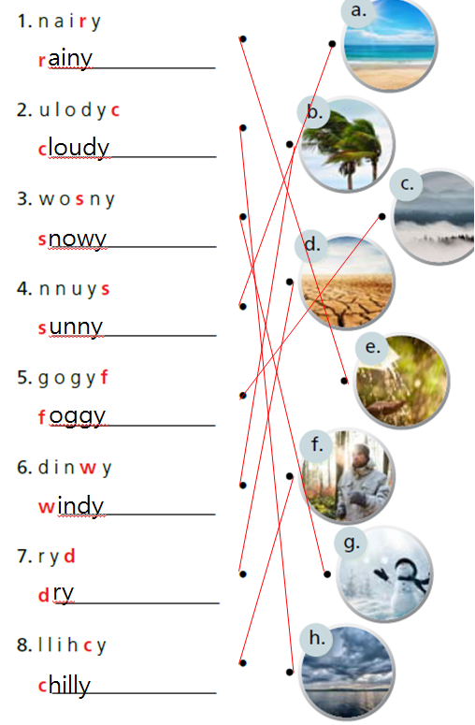
(2) 1. It’s very windy.
2. It’s really chilly.
3. It’s really nice and sunny.
(3) 1. I wear my sunglasses when it is sunny.
2. After it snows, we build a snowman.
3.I will go home before it rains.
(4) 1. T 2. F 3. F 4. T 5. c 6. b

Unit 10 – Lesson B
(1) (From left to right)
spring, summer, fall, winter
(2) (From left to right)
hiking, skiing, playing baseball, swimming
(3) (Answers will vary)
(4) (Answers will vary)

Unit 10 – Lesson C
(1) (From left to right)
5, 2, 3, 1, 4
(2) 2, 1, 3
(3) (Answers will vary)
(4) (Possible Answers)
1. She is going to bake a cake today.
2. They are going to travel in Hawaii next week.
3. He is going to play basketball tomorrow.
4. My father is going to build a house next year.
(5) 1. is not going to
2. am going to
3. is not going to
4. am going to

Unit 10 – Lesson D
(1) 1. fire 2. barbecue 3. field 4. party
5. badminton
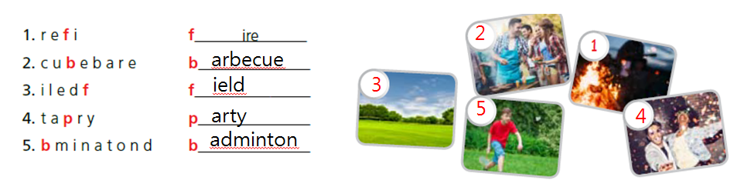
(2) 1. I am going to have a party at my house next Saturday on 7 p.m. -> I am going to have a party at my house next Saturday at 7 p.m.
2. I’m going to cooks pasta and chicken. -> I’m going to cook pasta and chicken.
3. After we eat, I’m go to play some music in my new guitar. -> After we eat, I’m going to play some music in my new guitar.
4. After we eat, I’m go to play some music in my new guitar. -> After we eat, I’m going to play some music on my new guitar.
5. See you in Saturday! -> See you on Saturday!
(3) (Answers will vary)
(4) 1. F 2. F 3. T 4.F
(5) (Answers will vary)

Unit 10 – Lesson E
(1) 1. scary 2. submarine 3. flashlight 4. deep
5. alien
(2) (Possible Answers)
1. On Sunday morning, it will be cloudy. On Sunday afternoon, it will be snowy and rainy.
2. On Monday morning, It will be snowy. On Monday afternoon, it will be sunny.
(3) (Answers will vary)
(4) (Answers will vary)

Unit 10 – Review
(1) It is going to be chilly.
(2) (Answers will vary)
(3) 1.-15℃ 2.20℃ 3.-7℃
(4) (Answers will vary)
(5) (Answers will vary)

Review (Unit 9-10)
(1) 1. d 2. c 3. b 4. a 5. c
6. a 7. d 8. b
(2) 1. summer 2. was 3. arrived 4. bank
5. waiting 6. She’s 7. excited 8. were
9. foggy 10. glad 11. chilly 12. temperature
13. Enjoy
(3) 1. How’s the weather outside?
2. I’m going to invite Michelle to the party.
3. What do you usually do in winter?
4. When it’s snowy, he wears boots.
5. What are they going to do tomorrow?
(4) 1. after 2. when 3. Before 4. When
(5) 1. The weather forecaster were wrong yesterday. -> The weather forecaster was wrong yesterday.
2. We going to visit our grandmother on Saturday. -> We’re going to visit our grandmother on Saturday.
3. Jamie maked a chocolate cake for my birthday. -> Jamie made a chocolate cake for my birthday.
4. When you are going to visit the museum? -> When are you going to visit the museum?
5. The teacher gived us a hard test last week. -> The teacher gave us a hard test last week.
6. (From left to right)
1, 3, 4, 2
1. She had a big party at her house.
2. He feels happy and excited.
3. She went to the beach with her friends.
4. He got really sick (in January). (He was in bed for ten days.)

