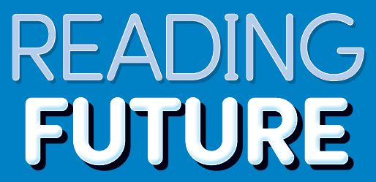 | Answer Key | 

READING FUTURE
DISCOVER 2 ANSWER
Student Book

Unit 1. Why Are There Days and Seasons?

p. 10
Warm-Up
(Answers will vary.)
I can see the sun.

New Words
1. a 2. b 3. d
4. c 5. f 6. e

p. 11
Vocabulary Skills
1. light 2. round

Reading Skills
1. a 2. a

p. 12
Reading Comprehension
1. a 2. c 3. b

Reading Skills
1. spins 2. night 3. seasons

p. 13
Vocabulary Review
1. seasons 2. day 3. round

Project
Step 2
A | B
hot, day | cold, night

Unit 2. The Shape of the Earth

p. 14
Warm-Up
(Answers will vary.)
The shape of the earth is round.

New Words
1. a 2. b 3. d
4. c 5. f 6. e

p. 15
Vocabulary Skills
1. earth 2. moon

Reading Skills
1. b 2. a

p. 16
Reading Comprehension
1. b 2. c 3. c

Reading Skills
1. must 2. tracked 3. proved

p. 17
Vocabulary Review
1. moon 2. thought 3. tracked

Project
Step 2
1. earth 2. Yes
3. cellphone 4. round
Unit 3. The Mystery of the Moon

p. 18
Warm-Up
(Answers will vary.)
I can see the moon and the stars.

New Words
1. b 2. a 3. c
4. d 5. f 6. e

p. 19
Vocabulary Skills
1. cheese 2. around

Reading Skills
1. b 2. b

p. 20
Reading Comprehension
1. a 2. c 3. a

Reading Skills
1. around 2. about 3. rock

p. 21
Vocabulary Review
1. wondered 2. cheese 3. questions

Project
1. rock 2. 1969
3. moves 4. smaller

Unit 4. The Earth’s Blanket

p. 22
Warm-Up
(Answers will vary)
Planets, stars, and rocks are moving through outer space.

New Words
1. a 2. b 3. d
4. c 5. e 6. f

p. 23
Vocabulary Skills
1. strong 2. toward

Reading Skills
1. b 2. a

p. 24
Reading Comprehension
1. c 2. a 3. b

Reading Skills
1. blanket 2. toward 3. sunshine

p. 25
Vocabulary Review
1. strong 2. worry 3. sunshine

Project
Step 2
1. strong 2. no
3. dangerous 4. shooting star
Unit 5. Art and Health

p. 28
Warm-Up
(Answers will vary.)
I might paint a picture of a rainbow if I was sad.

New Words
1. b 2. a 3. d
4. c 5. e 6. f

p. 29
Vocabulary Skills
1. brain 2. dream

Reading Skills
1. a 2. a

p. 30
Reading Comprehension
1. b 2. c 3. b

Reading Skills
1. brain 2. help 3. feelings

p. 31
Vocabulary Review
1. art 2. dreams 3. better

Project
1. fear 2. excitement
3. happiness 4. anger
Unit 6. Painting In the Air

p. 32
Warm-Up
(Answers will vary.)
Artists can use plants to create art.

New Words
1. a 2. b 3. d
4. c 5. e 6. f

p. 33
Vocabulary Skills
1. painting 2. air

Reading Skills
1. a 2. b

p. 34
Reading Comprehension
1. c 2. a 3. c

Reading Skills
1. create 2. headset 3. touch

p. 35
Vocabulary Review
1. Programs 2. painting 3. touch

Project
Step 2
1. computers 2. smell
3. can 4. can’t

Unit 7. Picasso’s Famous Painting

p. 36
Warm-Up
(Answers will vary.)
I like Picasso and Monet. I like their painting styles.

New Words
1. a 2. b 3. d
4. c 5. e 6. f

p. 37
Vocabulary Skills
1. different 2. exciting

Reading Skills
1. b 2. a

p. 38
Reading Comprehension
1. a 2. b 3. a

Reading Skills
1. Musicians 2. show 3. puzzles

p. 39
Vocabulary Review
1. famous 2. different 3. started

Project
(Answers will vary.)
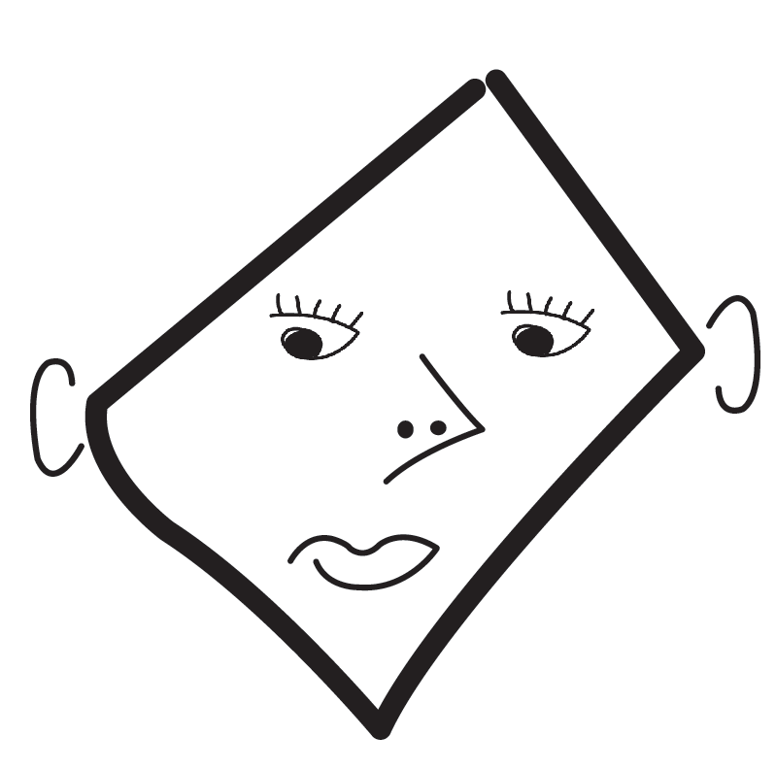
Unit 8. Points of Color

p. 40
Warm-Up
(Answers will vary.)
I like to create art using paint and canvas.

New Words
1. b 2. a 3. c
4. d 5. f 6. e

p. 41
Vocabulary Skills
1. pixels 2. artists

Reading Skills
1. a 2. a

p. 42
Reading Comprehension
1. b 2. c 3. a

Reading Skills
1. Pixels 2. dots 3. painting

p. 43
Vocabulary Review
1. screens 2. Artists 3. closer

Project
Step 1
(Answers will vary.)
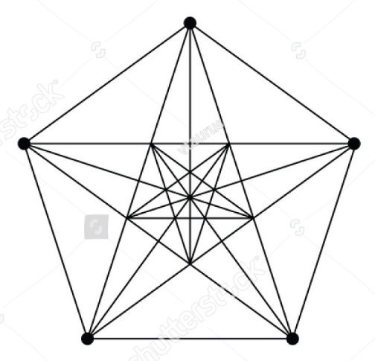
Unit 9. Put It in the Bank

p. 46
Warm-Up
(Answers will vary.)
I want to spend money on a new computer game.

New Words
1. a 2. b 3. d
4. c 5. e 6. f

p. 47
Vocabulary Skills
1. money 2. bank

Reading Skills
1. b 2. a

p. 48
Reading Comprehension
1. c 2. a 3. c

Reading Skills
1. Save 2. bank 3. expensive

p. 49
Vocabulary Review
1. enough 2. cheap 3. money

Project
Step 1
1. $1 2. $5 3. $1
Unit 10. Earning Money

p. 50
Warm-Up
(Answers will vary.)
I can take care of my younger brother to make money.

New Words
1. b 2. a 3. d
4. c 5. f 6. e

p. 51
Vocabulary Skills
1. clothes 2. job

Reading Skills
1. b 2. a

p. 52
Reading Comprehension
1. a 2. b 3. b

Reading Skills
1. job 2. neighbor 3. deliver

p. 53
Vocabulary Review
1. pays 2. job 3. newspapers

Project
(Answers will vary.)
Step 2
V | doing a job
 | paying for clothes
V | delivering newspapers
 | not helping clean your home
 | paying for food
V | walking a neighbor’s dog

Unit 11. Making Money

p. 54
Warm-Up
(Answers will vary.)
Money is made of metal and paper in my country.

New Words
1. b 2. a 3. c
4. d 5. e 6. f

p. 55
Vocabulary Skills
1. paper 2. hologram

Reading Skills
1. b 2. a

p. 56
Reading Comprehension
1. c 2. b 3. a

Reading Skills
1. fake 2. holograms 3. print

p. 57
Vocabulary Review
1. coins 2. details 3. holograms

Project
Step 2
1. art 2. details
3. holograms 4. hard
Unit 12. Penny Pincher

p. 58
Warm-Up
(Answers will vary.)
I enjoy spending money on buying chocolates.

New Words
1. a 2. b 3. d
4. c 5. e 6. f

p. 59
Vocabulary Skills
1. penny 2. dollars

Reading Skills
1. b 2. b

p. 60
Reading Comprehension
1. b 2. b 3. c

Reading Skills
1. spend 2. dollars 3. at once

p. 61
Vocabulary Review
1. penny 2. sound 3. snack

Project
(Answers will vary.)
Step 1
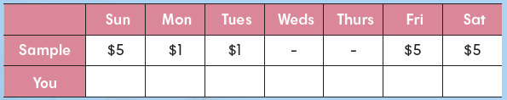
$1 $3 $1 $1 $2 $2 $2

Step 2
I spent $12 in the past week.

Unit 13. Music in a Bottle

p. 64
Warm-Up
(Answers will vary.)
I can use my voice to make music.

New Words
1. b 2. a 3. d
4. c 5. e 6. f

p. 65
Vocabulary Skills
1. bottles 2. lower

Reading Skills
1. a 2. a

p. 66
Reading Comprehension
1. a 2. a 3. b

Reading Skills
1. note 2. lower 3. song

p. 67
Vocabulary Review
1. song 2. bottle 3. amounts

Project
Step 1 a Step 2 c
Step 3 d Step 4 e
Unit 14. Eat Your Instruments

p. 68
Warm-Up
(Answers will vary.)
An instrument made out of wood is a clarinet. An instrument made of metal is a tuba.

New Words
1. b 2. a 3. d
4. c 5. f 6. e

p. 69
Vocabulary Skills
1. group 2. vegetables

Reading Skills
1. b 2. a

p. 70
Reading Comprehension
1. c 2. b 3. c

Reading Skills
1. drum 2. concert 3. onion

p. 71
Vocabulary Review
1. group 2. instruments 3. concert

Project
Step 2
1. piano 2. drum 3. guitar
Unit 15. Mouth Music

p. 72
Warm-Up
(Answers will vary.)
I can sing with my mouth.

New Words
1. a 2. b 3. d
4. c 5. e 6. f

p. 73
Vocabulary Skills
1. mouth 2. popular

Reading Skills
1. b 2. b

p. 74
Reading Comprehension
1. b 2. a 3. a

Reading Skills
1. musical 2. part 3. mouths

p. 75
Vocabulary Review
1. whistle 2. popular 3. rap

Project
Step 2
Classical Music | Mouth Music
guitar | mouth
piano | beatbox
drum | whistle
Unit 16. Telling Stories with Music

p. 76
Warm-Up
(Answers will vary.)
I like performances where the actors sing and dance.

New Words
1. a 2. b 3. c
4. d 5. e 6. f

p. 77
Vocabulary Skills
1. farm 2. wizard

Reading Skills
1. b 2. a

p. 78
Reading Comprehension
1. b 2. c 3. a

Reading Skills
1. Characters 2. Everyone 3. Wizard

p. 79
Vocabulary Review
1. musical 2. Everyone 3. farm

Project
Step 2
1. music 2. new
3. talk 4. story

READING FUTURE
DISCOVER 2 ANSWER KEY
Workbook

Unit 1. Why Are There Days and Seasons?

p. 4
Vocabulary Check
Across
2. season
5. earth
Down
1. day
2. spin
3. night
4. year

Sentence Check
1. This is why we have seasons.
2. We face away from the sun at night.
3. This takes a year.

p. 5
Comprehension Check
A.
1. Bottom; This shows four seasons.
2. Bottom; The earth spins around the sun.
3. Top; When we see this, we are facing the sun.

B.
1. F 2. F 3. T

Summary
1. earth 2. day
3. night 4. sun
5. year 6. seasons

Unit 2. The Shape of the Earth

p. 6
Vocabulary Check
Across
3. true
4. prove
5. track
Down
1. later
2. must
6. round

Sentence Check
1. People thought the earth really was flat.
2. Pythagoras looked at the moon.
3. Aristotle tracked the stars.

p. 7
Comprehension Check
A.
1. Top; It’s hard to see the shape of the earth.
2. Top; People thought that the earth was flat.
3. Bottom: Aristotle tracked the stars.

B.
1. F 2. F 3. T

Summary
1. true 2. round
3. must 4. prove
5. Later 6. tracked

Unit 3. The Mystery of the Moon

p. 8
Vocabulary Check
Across
2. wonder
4. about
6. question
Down
1. rock
3. example
5. land

Sentence Check
1. We still have questions about the moon.
2. The moon moves around the earth.
3. In 1969, people landed on the moon.

p. 9
Comprehension Check
A.
1. Bottom; In the past, people guessed the moon was made of cheese.
2. Top; The moon is about 384,400 km away from earth.
3. Bottom; We still have questions about the moon.

B.
1. F 2. F 3. T

Summary
1. wondered 2. example
3. questions 4. landed
5. about 6. rock

Unit 4. The Earth’s Blanket

p. 10
Vocabulary Check
Across
3. sunshine
4. worry
5. huge
Down
1. blanket
2. danger
3. space

Sentence Check
1. The sun's light is very strong.
2. The atmosphere is the air around the earth.
3. The atmosphere is like a blanket.

p. 11
Comprehension Check
A.
1. Top; Space is cold, and it has no air.
2. Bottom; Don’t worry because the earth has an atmosphere.
3. Top; “Shooting stars” are rocks burning in the atmosphere.

B.
1. T 2. T 3. F

Summary
1. danger 2. huge
3. space 4. blanket
5. sunlight 6. worry

Unit 5. Art and Health

p. 12
Vocabulary Check
Across
3. feeling
4. draw
6. sure
Down
1. relax
2. discuss
5. healthy

Sentence Check
1. How do you stay healthy?
2. Making art is good for you.
3. Art can help you feel better.

p. 13
Comprehension Check
A.
1. Bottom; Making art is good for you.
2. Top; Art helps people relax.
3. Top; People sometimes have bad dreams.

B.
1. T 2. T 3. F

Summary
1. dreams 2. art
3. understand 4. ask
5. discuss 6. better

Unit 6. Painting in the Air

p. 14
Vocabulary Check
Across
1. touch
5. create
6. through
Down
2. own
3. headset
4. program

Sentence Check
1. Artists can paint in 3D.
2. They see their art through a headset.
3. They can even touch it.

p. 15
Comprehension Check
A.
1. Top; Programs help artists create art with computers.
2. Bottom; Artists use a headset to see their art.
3. Top; People can see the art with their own computer.

B.
1. T 2. T 3. F

Summary
1. create 2. programs
3. air 4. through
5. touch 6. own

Unit 7. Picasso’s Famous Painting

p. 16
Vocabulary Check
Across
2. strange
3. start
4. puzzle
Down
1. famous
2. style
3. show

Sentence Check
1. Picasso changed the art world.
2. Their bodies look like puzzles.
3. Other artists started painting this way.

p. 17
Comprehension Check
A.
1. Bottom; Picasso is famous for his art style.
2. Top; The Three Musicians shows three men.
3. Top; Picasso’s style was new and exciting.

B.
1. F 2. T 3. T

Summary
1. styles 2. strange
3. famous 4. show
5. puzzles 6. started

Unit 8. Points of Color

p. 18
Vocabulary Check
Across
3. dot
5. close
6. painting
Down
1. idea
2. screen
4. look at

Sentence Check
1. Pixels are small dots of colored light.
2. Georges Seurat made paintings with dots.
3. Look at his paintings from far away.

p. 19
Comprehension Check
A.
1. Bottom; We see pixels on computer screens.
2. Top; Using dots to make pictures is an old idea.
3. Top; You will see a beautiful picture if you look from far away.

B.
1. T 2. F 3. T

Summary
1. paintings 2. look at
3. closer 4. dots
5. idea 6. screens

Unit 9. Put It in the Bank

p. 20
Vocabulary Check
Across
3. cheap
4. want
5. enough
6. save
Down
1. expensive
2. a while

Sentence Check
1. Is there something you want to buy?
2. It's safe to have a little money at home.
3. Put the money in a bank.

p. 21
Comprehension Check
A.
1. Bottom; You can buy something when you have enough money.
2. Bottom; It takes a while to save enough money for something expensive.
3. Top; A lot of money is safe in a bank.

B.
1. F 2. T 3. T

Summary
1. cheap 2. expensive
3. save 4. a while
5. enough 6. want

Unit 10. Earning Money

p. 22
Vocabulary Check
Across
2. deliver
4. honest
5. newspaper
Down
1. neighbor
3. earn
6. pay

Sentence Check
1. What's the best way to make money?
2. Most people earn money by doing a job.
3. Even children can find a job.

p. 23
Comprehension Check
A.
1. Bottom; Money pays for a place to live.
2. Top; The only honest way to get money is to earn it.
3. Top; Children can walk a neighbor’s dog.

B.
1. T 2. F 3. F

Summary
1. pay 2. honest
3. earn 4. neighbor
5. deliver 6. newspaper

Unit 11. Making Money

p. 24
Vocabulary Check
Across
3. valuable
4. coin
6. detail
Down
1. government
2. fake
5. print

Sentence Check
1. The coins were made of gold and silver.
2. Today, money is made of paper, too.
3. Some money has holograms.

p. 25
Comprehension Check
A.
1. Bottom; Long ago, money was coins.
2. Top; Art with many details is hard to print.
3. Top; Holograms are hard to make.

B.
1. T 2. F 3. F

Summary
1. valuable 2. Coins
3. printed 4. Governments
5. fake 6. details

Unit 12. Penny Pincher

p. 26
Vocabulary Check
Across
2. snack
4. spend
5. every
Down
1. cost
3. at once
4. sound

Sentence Check
1. "Penny pinchers" count every penny.
2. Do you buy a snack every day?
3. Don't eat them all at once!

p. 27
Comprehension Check
A.
1. Top; “Penny pinchers” save their pennies.
2. Top; Saving money doesn’t sound fun.
3. Top; If you buy a snack every day, you may be spending too much.

B.
1. T 2. F 3. F

Summary
1. snack 2. every
3. sound 4. spend
5. at once 6. cost

Unit 13. Music in a Bottle

p. 28
Vocabulary Check
Across
3. amount
4. each
5. song
Down
1. blow
2. note
3. across

Sentence Check
1. Glass bottles can make music.
2. A song is made from many notes.
3. Each bottle has a different amount of air.

p. 29
Comprehension Check
A.
1. Bottom; Blow across the bottle to make a note.
2. Top; To play a song, you need many bottles.
3. Top; Bottles with more air make lower notes.

B.
1. F 2. T 3. T

Summary
1. song 2. blow
3. across 4. note
5. each 6. amount

Unit 14. Eat Your Instruments

p. 30
Vocabulary Check
Across
2. drum
5. onion
6. instrument
Down
1. guitar
2. concert
4. piano

Sentence Check
1. Do you like the piano?
2. They make music with vegetables.
3. Then they have a vegetable concert.

p. 31
Comprehension Check
A.
1. Bottom; A group in Austria makes special music.
2. Top; They cut the vegetables into instruments.
3. Top; The group works hard to make them sound good.

B.
1. F 2. T 3. T

Summary
1. concert 2. guitars
3. piano 4. drum
5. instruments 6. onion

Unit 15. Mouth Music

p. 32
Vocabulary Check
Across
4. also
5. part
6. whistle
Down
1. beat
2. musical
4. rap

Sentence Check
1. There are many ways to make music.
2. Today, beatboxing is still very popular.
3. It's a big part of hip-hop music.

p. 33
Comprehension Check
A.
1. Bottom; You can use your mouth to make music.
2. Bottom; Beatboxing became popular in the 1980s.
3. Top; In beatboxing, people use their mouths to make sounds.

B.
1. F 2. T 3. F

Summary
1. whistling 2. also
3. musical 4. part
5. beat 6. rap

Unit 16. Telling Stories with Music

p. 34
Vocabulary Check
Across
2. musical
5. witch
6. everyone
Down
1. play
3. character
4. hero

Sentence Check
1. Musicals became popular in the 1940s.
2. Oklahoma! is about life on a farm.
3. It's a love story.

p. 35
Comprehension Check
A.
1. Bottom; Characters talk and sing in musicals.
2. Bottom; Wicked tells the story of the Wizard of Oz.
3. Top; In Wicked, the witch is the hero.

B.
1. F 2. F 3. T

Summary
1. Musicals 2. plays
3. Characters 4. witch
5. hero 6. everyone

