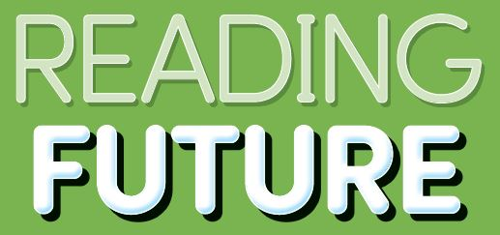 | Answer Key | 

READING FUTURE
DREAM 1 ANSWER
Student Book

Unit 1. Meet the Meerkats

p. 10
Warm-Up
(Answers will vary.)
They live in groups to help each other stay safe or find food.

p. 11
Vocabulary Skills
1. small 2. brown

Reading Skills
1. No 2. Yes

p. 12
Reading Comprehension
1. b 2. a 3. c

Reading Skills
1. cute 2. groups 3. help

p. 13
Vocabulary
1. group 2. cute 3. brown

Project
(Answers will vary.)
When I’m with my family, I can cook.
My family helps me do my homework.
What is your favorite thing to do in a group?
My favorite thing to do in a group is to cook.

Unit 2. Winter Sleep

p. 14
Warm-Up
(Answers will vary.)
During the winter, I wear warm clothes and play in the snow.

p. 15
Vocabulary Skills
1. fat 2. thin

Reading Skills
1. Yes 2. No

p. 16
Reading Comprehension
1. b 2. c 3. b

Reading Skills
1. summer(fall) 2. fall(winter) 3. winter

p. 17
Vocabulary
1. winter 2. thin 3. wake up

Project
(Answers will vary.)
In winter, I wear sweaters.
In winter, I like to go skiing for fun.
I eat sweet potatoes in winter.
What’s your favorite part of winter?
My favorite part of winter is playing in the snow.

Unit 3. Octopus Hide and Seek

p. 18
Warm-Up
(Answers will vary)
Some animals have special patterns or can change their colors.

p. 19
Vocabulary Skills
1. octopus 2. hide

Reading Skills
1. No 2. Yes

p. 20
Reading Comprehension
1. b 2. c 3. a

Reading Skills
1. change 2. bottom 3. Nothing

p. 21
Vocabulary
1. color 2. hide 3. change

Project
(Answers will vary.)
A polar bear hides in the snow because it is white.
A lion hides in the dry grass because it is brown.
A snake hides in the leaves because it is green.
What color would help an animal hide in the dark?
Black would help an animal hide in the dark.

Unit 4. Cool Dad

p. 22
Warm-Up
(Answers will vary)
They keep their babies safe and give them food.

p. 23
Vocabulary Skills
1. feet 2. warm

Reading Skills
1. Yes 2. Yes

p. 24
Reading Comprehension
1. a 2. c 3. b

Reading Skills
1. lays 2. feet 3. months

p. 25
Vocabulary
1. together 2. feet 3. tired

Project
(Answers will vary.)
When I’m sad, my parents give me a hug.
When I’m bored, my parents play a game with me.
When I’m hungry, my parents give me food.
When I’m sad, my parents order food.
Unit 5. Healthy Hands

p. 28
Warm-Up
(Answers will vary.)
I wash my hands before eating.

p. 29
Vocabulary Skills
1. rinse 2. water

Reading Skills
1. No 2. Yes

p. 30
Reading Comprehension
1. c 2. a 3. b

Reading Skills
1. hands 2. Wash 3. bathroom

p. 31
Vocabulary
1. bathroom 2. sick 3. rinse

Project
(Answers will vary.)
1. b 2. a 3. d
4. c
Unit 6. Ouch! Cavities

p. 32
Warm-Up
(Answers will vary.)
I brush my teeth 3 times a day.

p. 33
Vocabulary Skills
1. healthy 2. dentist

Reading Skills
1. No 2. Yes

p. 34
Reading Comprehension
1. a 2. b 3. a

Reading Skills
1. Cavities 2. sugar 3. Brush

p. 35
Vocabulary
1. cavity 2. dentist 3. brush

Project
DOs | DON’Ts
1 | 2
3 | 5
4

Unit 7. Feeling Sleepy?

p. 36
Warm-Up
(Answers will vary.)
I like to sleep in my bedroom.

p. 37
Vocabulary Skills
1. sleep 2. bird

Reading Skills
1. No 2. Yes

p. 38
Reading Comprehension
1. b 2. c 3. b

Reading Skills
1. brains 2. upset 3. think

p. 39
Vocabulary
1. dream 2. upset 3. sleep

Project
Less than 8 hours | More than 8 hours
3, 5, 6 | 1, 2, 4

Unit 8. Eat Healthy Colors

p. 40
Warm-Up
(Answers will vary.)
I eat apples, carrots, and onions.

p. 41
Vocabulary Skills
1. grow 2. color

Reading Skills
1. Yes 2. No

p. 42
Reading Comprehension
1. b 2. a 3. c

Reading Skills
1. vegetables 2. strong 3. rainbow

p. 43
Vocabulary
1. grow 2. taste 3. sweet

Project
(Answers will vary.)

Unit 9. Origami

p. 46
Warm-Up
(Answers will vary.)
It is made from paper.

p. 47
Vocabulary Skills
1. fold 2. shape

Reading Skills
1. Yes 2. Yes

p. 48
Reading Comprehension
1. a 2. b 3. c

Reading Skills
1. paper 2. fold 3. bird

p. 49
Vocabulary
1. paper 2. thin 3. shape

Project
(Answers will vary.)
I can make a paper plane.

Unit 10. Cartoon Animals

p. 50
Warm-Up
(Answers will vary.)
I like Spiderman.

p. 51
Vocabulary Skills
1. artist 2. face

Reading Skills
1. Yes 2. No

p. 52
Reading Comprehension
1. a 2. c 3. b

Reading Skills
1. computer 2. study 3. cartoon

p. 53
Vocabulary
1. walk 2. learn 3. artist

Project
(Answers will vary.)
It is a penguin.
Its name is Robo.
It likes to dance.

Unit 11. Colors

p. 54
Warm-Up
(Answers will vary.)
I can see red, orange, yellow, and blue.

p. 55
Vocabulary Skills
1. color 2. angry

Reading Skills
1. Yes 2. No

p. 56
Reading Comprehension
1. c 2. c 3. b

Reading Skills
1. purple 2. red 3. green

p. 57
Vocabulary
1. angry 2. feel 3. yellow

Project
(Answers will vary.)
Name | Favorite Color
Sunny | red
Sam | yellow
Laura | red
Lisa | pink
Tom | green
(Sample)
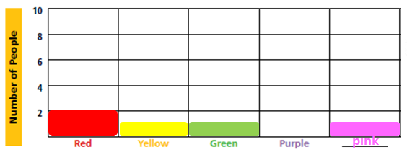
Unit 12. How Art Helps Us

p. 58
Warm-Up
(Answers will vary.)
This art makes me feel quiet.

p. 59
Vocabulary Skills
1. paint 2. blue

Reading Skills
1. Yes 2. Yes

p. 60
Reading Comprehension
1. a 2. c 3. a

Reading Skills
1. teaches 2. tell 3. happy

p. 61
Vocabulary
1. blue 2. tell 3. teach

Project
(Answers will vary.)
What do you draw?
I draw a bunch of flowers.
What colors do you use?
I use red, yellow, blue, and green.
How may this card make your friend feel?
She may feel happy.

Unit 13. Different Kinds of Transportation

p. 64
Warm-Up
(Answers will vary.)
I go from place to place by subway or bus.

p. 65
Vocabulary Skills
1. train 2. pull

Reading Skills
1. No 2. Yes

p. 66
Reading Comprehension
1. c 2. b 3. a

Reading Skills
1. sleds 2. cars 3. Boats

p. 67
Vocabulary
1. sled 2. boat 3. train

Project
(Answers will vary.)
Step 1
Which would you use to move on water?
I would use a boat.
Where do you want to go?
I want to go to an island.
Step 2
Which do you take with a group of people?
I take them with a bus.
Who do you go with?
I go with my parents.
Unit 14. Traffic Signs

p. 68
Warm-Up
(Answers will vary.)
First, cars should stop at corners. Second, you should wear seat belts in a car.

p. 69
Vocabulary Skills
1. share 2. animals

Reading Skills
1. Yes 2. No

p. 70
Reading Comprehension
1. a 2. c 3. b

Reading Skills
1. Traffic 2. signs 3. slow

p. 71
Vocabulary
1. road 2. stop 3. share

Project
(Answers will vary.)
Step 1
Sign 1: I think it means children are crossing the road, so drivers should be careful about them.
Sign 2: It means danger.
Step 2
(Answers will vary.)
Unit 15. Right or Left?

p. 72
Warm-Up
(Answers will vary.)
I walk on my right side.

p. 73
Vocabulary Skills
1. road 2. car

Reading Skills
1. No 2. Yes

p. 74
Reading Comprehension
1. a 2. c 3. c

Reading Skills
1. right 2. Drivers 3. left

p. 75
Vocabulary
1. driver 2. right 3. car

Project
(Answers will vary.)
Step 1
Look at this car. What side of the street should it drive on?
It should drive on the right side.
Why?
Because drivers sit on the left side.

Step 2
(Answers will vary.)
Unit 16. Roundabouts

p. 76
Warm-Up
(Answers will vary.)
I see cars make turns at an intersection.

p. 77
Vocabulary Skills
1. people 2. walk

Reading Skills
1. No 2. Yes

p. 78
Reading Comprehension
1. b 2. c 3. a

Reading Skills
1. turn 2. see 3. around

p. 79
Vocabulary
1. walk 2. turn 3. circle

Project


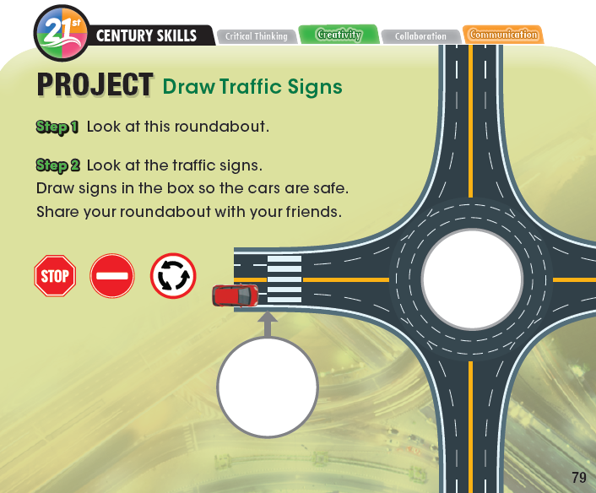
READING FUTURE
DREAM 1 ANSWER KEY
Workbook

Unit 1. Meet the Meerkats

p. 4
Vocabulary Check
A.
Across
2. care
5. cute
6. live
Down
1. group
3. safe
4. help

B.
1. group 2. cute
3. safe 4. small

p. 5
Comprehension Check
A.
1. Top; Meerkats live in groups.
2. Bottom; Meerkats have brown fur.
3. Top: Meerkats help each other care for babies.

B.
1. F 2. F 3. T

Summary
1. cute 2. live
3. groups 4. help
5. safe 6. care

Unit 2. Winter Sleep

p. 6
Vocabulary Check
A.
Across
4. wake up
5. winter
6. hungry
Down
1. summer
2. fall
3. spring

B.
1. summer 2. hungry
3. spring 4. fat

p. 7
Comprehension Check
A.
1. Bottom; Winters are hard and cold.
2. Top; Bears sleep all winter.
3. Bottom: In spring, bears are thin.

B.
1. F 2. T 3. T

Summary
1. wake up 2. spring
3. hungry 4. summer
5. fall 6. winter

Unit 3. Octopus Hide and Seek

p. 8
Vocabulary Check
A.
Across
4. bottom
5. dinner
6. well
Down
1. nothing
2. color
3. change

B.
1. octopus 2. change
3. bottom 4. color

p. 9
Comprehension Check
A.
1. Top; This animal can change color.
2. Bottom; The octopus hides.
3. Top; Fish do not see the octopus.

B.
1. T 2. F 3. T

Summary
1. octopus 2. well
3. change 4. color
5. bottom 6. Nothing

Unit 4. Cool Dad

p. 10
Vocabulary Check
A.
Across
3. work
5. ice
6. together
Down
1. month
2. rest
4. tired

B.
1. month 2. together
3. warm 4. rest

p. 11
Comprehension Check
A.
1. Bottom; Mom and dad work together.
2. Top; The ice is cold.
3. Top; Dad puts the egg on his feet.

B.
1. T 2. T 3. F

Summary
1. ice 2. work
3. together 4. tired
5. rest 6. months

Unit 5. Healthy Hands

p. 12
Vocabulary Check
A.
Across
1. wash
3. sick
4. bathroom
Down
2. germ
3. soap
5. hand

B.
1. sick 2. soap
3. water 4. hand

p. 13
Comprehension Check
A.
1. Bottom; Wash your hands.
2. Top; Wash your hands before you eat.
3. Top; Rinse your hands with water.

B.
1. T 2. T 3. F

Summary
1. Wash 2. hands
3. germs 4. sick
5. soap 6. bathroom

Unit 6. Ouch! Cavities

p. 14
Vocabulary Check
A.
Across
2. brush
3. cavity
5. floss
6. hurt
Down
1. sugar
4. tooth

B.
1. sugar 2. floss
3. brush 4. healthy

p. 15
Comprehension Check
A.
1. Bottom; He flosses his teeth.
2. Bottom; He brushes his teeth.
3. Bottom; Cavities hurt your teeth.

B.
1. F 2. F 3. T

Summary
1. teeth 2. eat
3. cavities 4. Brush
5. Floss 6. sugar

Unit 7. Feeling Sleepy?

p. 16
Vocabulary Check
A.
Across
2. upset
5. brain
6. memory
Down
1. hour
3. think
4. dream

B.
1. upset 2. dream
3. bird 4. brain

p. 17
Comprehension Check
A.
1. Top; Sleep at least 10 hours a night.
2. Top; Dogs need sleep.
3. Bottom; Our brains make memories.

B.
1. F 2. T 3. T

Summary
1. upset 2. brains
3. memories 4. dreams
5. think 6. hours

Unit 8. Eat Healthy Colors

p. 18
Vocabulary Check
A.
Across
2. salad
5. vegetable
6. sweet
Down
1. taste
3. strong
4. dessert

B.
1. sweet 2. taste
3. color 4. salad

p. 19
Comprehension Check
A.
1. Bottom; Fruits and vegetables are healthy foods.
2. Bottom; You can make a salad.
3. Top; Eat many different colors.

B.
1. T 2. F 3. T

Summary
1. vegetables 2. strong
3. salad 4. taste
5. dessert 6. colors

Unit 9. Origami

p. 20
Vocabulary Check
A.
Across
2. thin
3. bear
5. paper
Down
1. flower
3. bird
4. cat

B.
1. flower 2. paper
3. shape 4. fold

p. 21
Comprehension Check
A.
1. Bottom; When we fold paper, we make origami.
2. Top; We use square paper to make origami.
3. Bottom; People can make many kinds of stars.

B.
1. F 2. F 3. T

Summary
1. paper 2. thin
3. flower 4. bear
5. cat 6. bird

Unit 10. Cartoon Animals

p. 22
Vocabulary Check
A.
Across
1. pencil
4. eye
6. animal
Down
2. computer
3. learn
5. walk

B.
1. learn 2. animal
3. pencil 4. face

p. 23
Comprehension Check
A.
1. Top; Some artists use a computer.
2. Bottom; Artists look at a real animal.
3. Top; Artists watch an animal move.

B.
1. F 2. T 3. F

Summary
1. pencil 2. computer
3. animal 4. eyes
5. learn 6. walk

Unit 11. Colors

p. 24
Vocabulary Check
A.
Across
3. green
5. red
6. blue
Down
1. happy
2. yellow
4. feel

B.
1. green 2. happy
3. blue 4. color

p. 25
Comprehension Check
A.
1. Top; Yellow is a happy color.
2. Top; Our eyes see many colors.
3. Top; Color changes how we feel.

B.
1. F 2. T 3. F

Summary
1. see 2. green
3. red 4. yellow
5. blue 6. colors

Unit 12. How Art Helps Us

p. 26
Vocabulary Check
A.
Across
2. sometimes
3. tell
4. mad
Down
1. art
2. smile
3. teach

B.
1. smile 2. sometimes
3. paint 4. teach

p. 27
Comprehension Check
A.
1. Top; Art helps us learn about people from long ago.
2. Top; A happy picture makes us smile.
3. Top; Art helps us tell others how we feel.

B.
1. T 2. F 3. T

Summary
1. feels 2. helps
3. happy 4. tell
5. teaches 6. Try

Unit 13. Different Kinds of Transportation

p. 28
Vocabulary Check
A.
Across
4. place
5. drive
6. car
Down
1. boat
2. sled
3. taxi

B.
1. drive 2. sled
3. place 4. pull

p. 29
Comprehension Check
A.
1. Top; Dogs can pull this.
2. Bottom; Many people can ride this.
3. Top; People move from place to place.

B.
1. T 2. T 3. F

Summary
1. places 2. drive
3. taxis 4. sleds
5. water 6. boats

Unit 14. Traffic Signs

p. 30
Vocabulary Check
A.
Across
1. stop
3. corner
5. traffic
Down
1. slow
3. road
4. signs

B.
1. road 2. corner
3. animals 4. traffic

p. 31
Comprehension Check
A.
1. Top; This is a traffic sign.
2. Top; This traffic sign tells cars how fast to go.
3. Bottom; Cars have to stop at corners.

B.
1. T 2. F 3. F

Summary
1. roads 2. Traffic
3. signs 4. slow
5. stop 6. corners

Unit 15. Right or Left?

p. 32
Vocabulary Check
A.
Across
3. right
5. country
6. side
Down
1. driver
2. left
4. true

B.
1. driver 2. country
3. road 4. left

p. 33
Comprehension Check
A.
1. Top; Most cars drive on the right.
2. Bottom; Most drivers sit on the left.
3. Bottom; People drive on different sides in different countries.

B.
1. T 2. T 3. F

Summary
1. countries 2. sides
3. right 4. drivers
5. left 6. true

Unit 16. Roundabouts

p. 34
Vocabulary Check
A.
Across
3. moving
4. safely
6. turn
Down
1. look
2. circle
5. around

B.
1. turn 2. people
3. move 4. around

p. 35
Comprehension Check
A.
1. Top; This is a roundabout.
2. Top; Cars turn in roundabouts.
3. Bottom; Cars keep moving in roundabouts.

B.
1. T 2. F 3. T

Summary
1. turn 2. around
3. circle 4. moving
5. look 6. safely

