Reading Starter 1 / New Edition
Book 1 Unit 1-5
A. Fill in the blanks with the correct word.
1. I think he feels ________.
a. say | b. yesterday | c. lonely | d. pretty
2. My big brother and big sister ________ to lie on the beach.
a. prefer | b. squirrel | c. winner | d. terrible
3. I had long _________ hair.
a. ask | b. blonde | c. both | d. coconut
4. The ________ got $25.
a. winner | b. come | c. minute | d. short
5. He asks the animals, “Can you ____________?"
a. rabbit | b. cookie | c. hairdresser | d. come back

B. Match the related words.

1. coconut |  | a. animal
2. contest |  | b. tree
3. snake |  | c. winner
4. forest |  | d. milk
5. swim |  | e. ocean
C. Choose True or False.
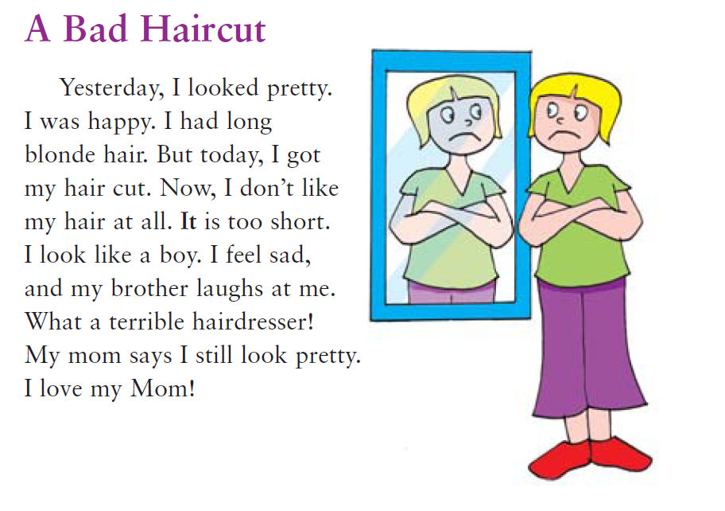
1. I have blonde hair. | True / False
2. My brother laughs at me after I get my hair cut. | True / False
3. My mom says I don’t look pretty. | True / False
4. Yesterday, I had long blonde hair. | True / False
5. I don’t love my mom. | True / False

Reading Starter 1 / New Edition
Book 1 Unit 6-10
A. Fill in the blank with the correct word.
1. Whales live in oceans all around the _____________.
a. town | b. world | c. province | d. country
2. ________________, the students use a fork and knife to eat their food.
a. Sale | b. Green | c. Morning | d. Sometimes
3. The raccoon likes to play in a ____________.
a. river | b. ocean | c. field | d. city
4. They will ____________ at the zoo at 10:00.
a. attack | b. buy | c. arrive | d. bring
5. Puppies are very cute and ____________.
a. friendly | b. run | c. love | d. fastest

B. Fill in the blanks with the words below.
loud | calls | holiday | trip | scared
1. Whales make ___________ sounds.
2. No ____________ in the morning or on Sunday, please.
3. Bayview School is taking a _________ to the zoo.
4. This Wednesday is a _____________.
5. His friends are too _____________ to help him.

C. Read and write sentences to fill in the schedule.
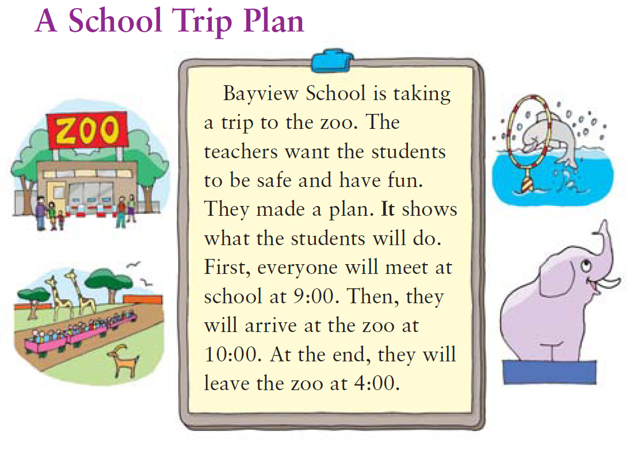

TIME | WHAT WE WILL DO
9:00
10:00
4:00

Reading Starter 1 / New Edition
Book 1 Unit 11-15
A. Fill in the blank with the correct word.
1. Tina then moved to a beautiful ____________.
a. palace | b. egg | c. field | d. ocean
2. The ____________ talked to the students about their school trip tomorrow.
a. soccer player | b. friend | c. | d. principal
3. George Washington was ____________ in 1732.
a. born | b. eaten | c. sung | d. run
4. The monkeys went back ____________ the cage.
a. on | b. inside | c. out | d. above
5. He has won more than 60 ________________.
a. miles | b. tournament | c. festivals | d. plays

B. Match the related words.

1. win |  | a. principal
2. sport |  | b. tournament
3. magic |  | c. golf
4. born |  | d. trick
5. school |  | e. baby

C. Circle True or False.
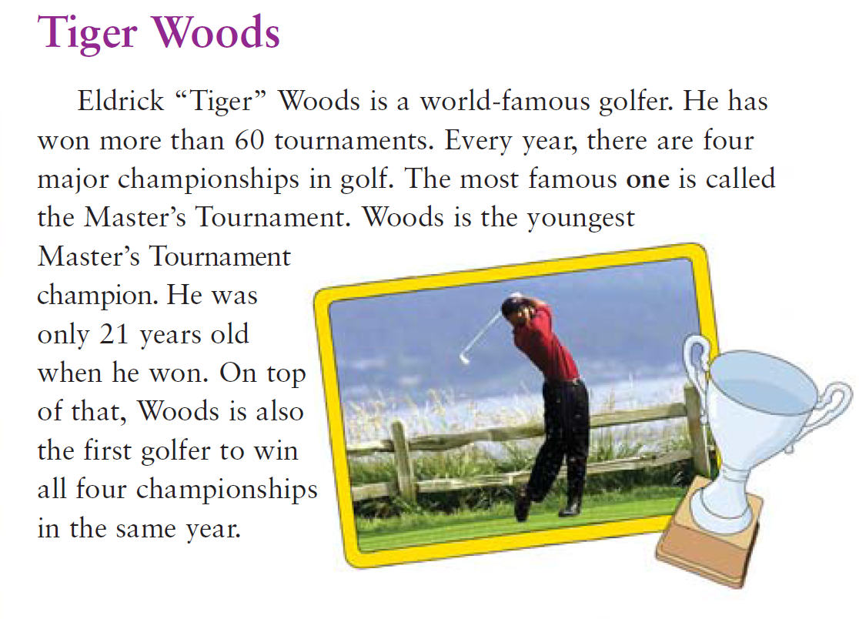

1. Eldrick Tiger Woods is the most famous golfer in the world. | True / False
2. He has not won any tournaments. | True / False
3. Wood is the oldest Master’s Tournament champion. | True / False
4. The most famous tournament is called the Master’s Tournament. | True / False
5. Woods is the first golfer to win all championships in the same year. | True / False

Reading Starter 1 / New Edition
Book 1 Unit 16-20
A. Fill in the blanks with the correct word.
spread | popular | tail | same | treat
1. As the result, many students liked the ____________ animal.
2. She is becoming ___________ as a singer.
3. Sarah gives her dog a _____________.
4. When my pet meets people, she wags her ____________.
5. First, ____________ peanut butter on one slice of bread.

B. Connect the parts of the sentences.
1. The teacher asked them |  | a. to take care of animals.
2. When the dog meets people, |  | b. tease her big sister.
3. Spread peanut butter |  | c. she wags her tail.
4. Olivia likesto  5. It would be fun |  | d. on one slice of bread.  e. which animal was their favorite

C. Circle True or False.

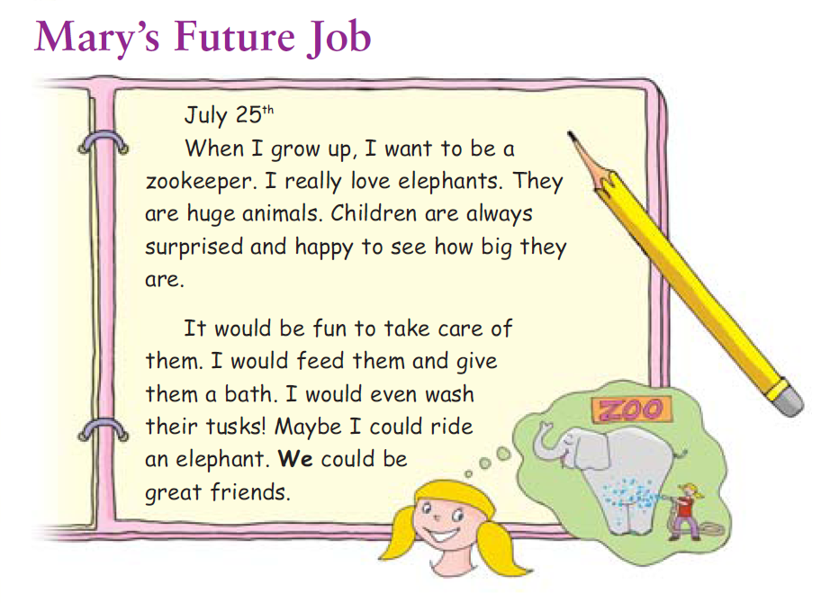

1. Mary doesn’t love elephants. | True / False
2. Mary and elephants could be great friends. | True / False
3. Mary wants to be an owner of elephants. | True / False
4. Mary wants to work in the zoo. | True / False
5. Children are happy to see how small elephants are. | True / False

Reading Starter 1 / New Edition
Review Test

Book1 Unit 1-5
A.
1.c
2.a
3.b
4.a
5.d

B.
1. b
2. c
3. a
4. d
5. e

C.
1. True
2. True
3. False
4. True
5. False

Book1 Unit 6-10
A.
1. b
2. d
3. c
4. c
5. a

B.
1. loud
2. calls
3. trip
4. holiday
5. scared

C.
9:00- Everyone will meet at school
10:00- We will arrive at the zoo
4:00- We will leave the zoo.

Book1 Unit 11-15
A.
1. a
2. d
3. a
4. b
5. b

B.
1- b
2- c
3- d
4- e
5- a

C.
1. T
2. F
3. F
4. T
5. T

Book1 Unit 16-20
A.
1. same
2. popular
3. treat
4. tail
5. spread

B.
1- e
2- c
3- d
4- b
5- a

C.
1. F
2. T
3. F
4. T
5. F

