Reading Success 6 Midterm Test
Units 1-20
A. Fill in the blank with the correct word from the box.
shred | intended | survey | false teeth | tutor
scrub | frightened | disobedient | lawyer | sag

- The taxi driver _______________ me because he was driving recklessly.
- We took a(n) _______________ to find out how many students like the school lunches.
- Do you need a(n) _______________? I think the police think you are guilty.
- My dog is _______________; he never does what I ask him to.
- You should _______________ documents that contain personal information if you don’t need them.
- I need to get an English _______________ because I am not doing well in class.
- The little boy had to _______________ hard to get all of the dirt off of him in the shower.
- Your skin will start to wrinkle and _______________ as you age.
- My grandmother can’t chew tough food because she has _______________.
- I _______________ to pay her back, but I was robbed.
B. Match the word to its definition.
1. streamlined | a. to have the same idea or opinion as someone else
2. extract | b. to fall into many pieces
3. eliminate | c. to remove from another substance
4. agree | d. a disagreement
5. argument | e. to make a story or other writings into a book
6. publish | f. to stop; to get rid of
7. annoy | g. having a smooth shape
8. crumble | h. to bother; to make someone uncomfortable
9. predict | i. a small pool of water on the ground
10. puddle | j. to guess what will happen in the future
Read the passage. Rewrite the statement to make it correct.
The staff of the Kennedy School Newsletter asked students at our school to take a survey. In the survey, we asked, “What is your dream job?” We asked a total of 367 students at our school. Here are the results of our survey.
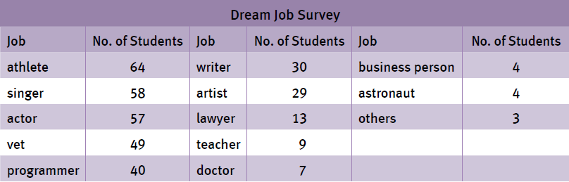
Most of the students at our school want to be professional athletes in the future! 64 people hope to be sports stars in the future. This includes 32 future soccer players, 12 baseball players, 10 basketball players, 7 tennis players, and 3 hockey players.
Lots of students at our school also want to be movie stars or singers. Fifty-eight students said they wanted to become singers, and 57 said they wanted to act in movies. We hope your dreams come true! Just remember your friends from school when you become superstars.
Other popular future careers include veterinarians (49), computer programmers (40), writers (30), and artists (29). To our surprise, very few students at our school want to be doctors (7), lawyers (13), or business people (4). The teachers at our school may be disappointed to know that only 9 students hope to teach in the future. Sorry, teachers!
You can see the rest of the results from our survey in the chart. And for those students who did not get to answer our survey, please stop by our office. We want to hear from you, too! We will add your answers to our survey results and publish the final results in the school yearbook.
Thanks for helping us make this interesting survey so successful!
1. More students want to be baseball players than soccer players. ________________

2. All the students that want to be actors want to act in movies. ________________

3. Fewer students want to be teachers than business people. ________________

4. Students cannot answer the survey if they haven’t yet. ________________

5. The results will be included in the newspaper. ________________

D. Read the passage. Answer the questions.
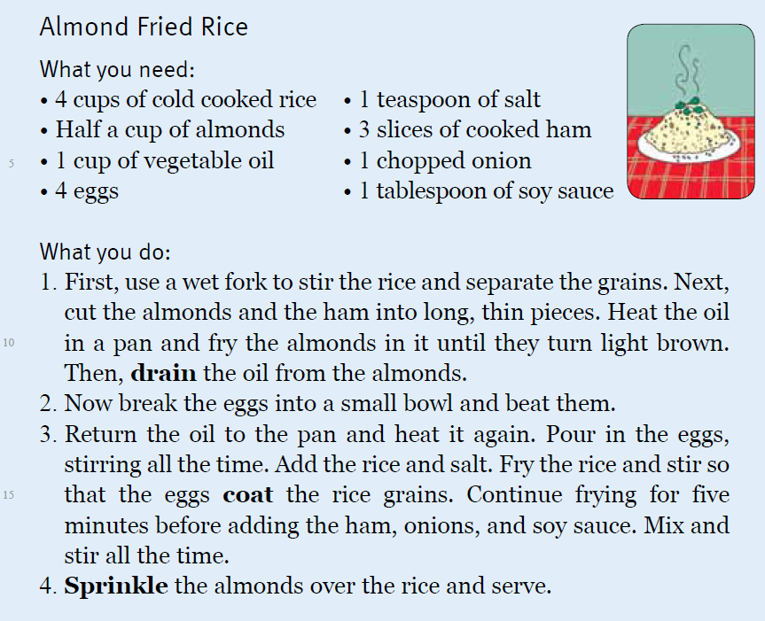
- What kind of meat is needed to make the rice?
________________________________________________________
- When should you cook the rice? Why?
________________________________________________________
- What do you add the rice to?
________________________________________________________
- When do you add the almonds?
________________________________________________________
- What vegetable(s) is/are used in this recipe?
________________________________________________________

Reading Success 6 Midterm Test

A.
1. frightened
2. survey
3. lawyer
4. disobedient
5. shred
6. tutor
7. scrub
8. sag
9. false teeth
10. intended

B.
1. g
2. c
3. f
4. a
5. d
6. e
7. h
8. b
9. j
10. i
C.
- More students want to be baseball players than soccer players. (Fewer)
- All the students that want to be actors want to act in movies. (Almost all / Most)
- Fewer students want to be teachers than business people. (More)
- Students cannot answer the survey if they haven’t yet. (can still)
- The results will be included in the newspaper. (school yearbook)

D.
- Ham is needed to make the rice.
- You should cook the rice before you are ready to make the fried rice so that it can have time to cool.
- Add the rice to the pan with the eggs.
- Add the almonds at the end.

- Onions are used in this recipe.

