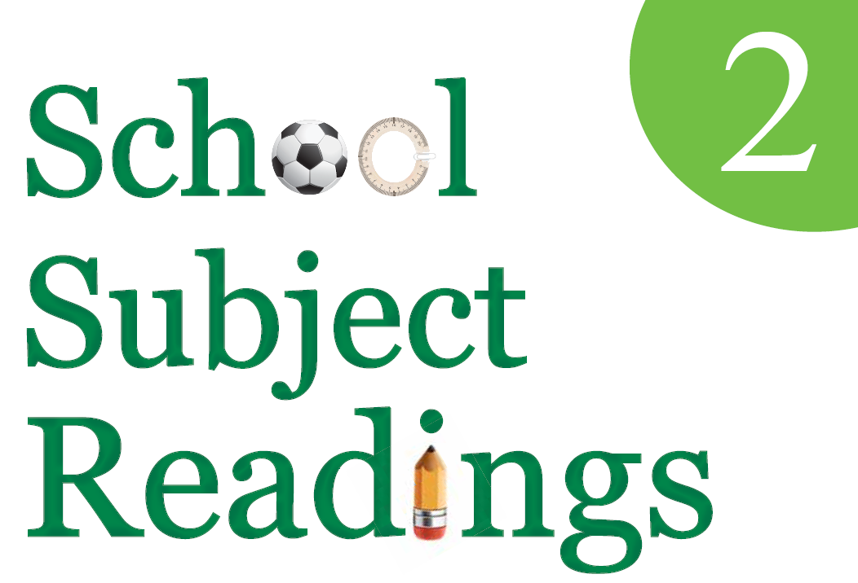 | Transcripts | 

Unit 1 Tim’s First Day
Today is Tim’s fi rst day of school. Tim is sad to go to school. He is sad to say goodbye to his mom and dad. He is sad to say goodbye to all of his games, but Tim has a plan!
Tim hears a knock on his bedroom door. Tim’s mom says, “Wake up! It’s time for school.” Tim says, “I feel sick! My head is hot. My hands are cold and sweaty. I cannot go to school!”
Tim’s mom says, “Cool your head. Dry your hands. You are going to school.” She tells Tim to get ready for school. Tim’s plan did not work. He is not happy.

Unit 2 The Poor Children
My class sells cookies. Then we use the cookie money to buy things for other children. These children are very poor kids in our city.
When you are poor, you have no money or very little money. Some poor children have no family. Some poor children cannot pay for a doctor when they are sick. Poor children do not have fancy homes. They cannot buy clothes or toys. They don’t have warm clothes for winter.
Children in my class help these poor kids. We buy clothes and toys. We give these nice presents to the poor children. We feel great when we help others.

Unit 3 The World of Robots
Many people think robots are big. They see big robots in movies. Big robots work for people. There are small robots, too. Sometimes they are toys for children. These robots are fun for children.
There are also robot trucks. Many children play with them. They control the trucks with a remote. The remote can drive the truck. The truck moves back and forth. The truck can make turns. The truck can move very fast. Sometimes children have robot truck fights. Children can have robot truck races, too.
Robot toys are lots of fun!

Unit 4 Life in the Mountains
My family is camping. We are high up in the mountains. At night, the sky is very dark, but I can see every star! When we sleep, we hear crickets. Sometimes we can hear other animals. They howl at the moon. Do they see us? They scare me.
Every day, it is very sunny. There are many bugs. That bothers me. It also bothers my sister. They get in her hair.
The river has clean water. We drink it. We fish in it. We swim in it. Tomorrow we’ll ride a raft down the river. That will be fun. I love camping.

Unit 5 The History of Soccer
Soccer is a three-thousand-year-old sport. Long ago, people in Japan played a kicking game with balls. Their game was similar to soccer that is played today. Later, the Romans also played a game like soccer.
People first played real soccer in England. In the beginning, only rich people and students played soccer in England. Soon, poor people played soccer, too. Then English sailors learned soccer.
They taught soccer to people in other countries. Today, many people play soccer. Soccer has many names. The English call it “football.” Mexicans call it “fútbol.” Can you say “soccer” in another language?

Unit 6 A Night in the Toy Store
Dante joined a contest. The winner gets to spend a night at the Toys4You store. The winner and his or her family sleep in the store. Dante is the winner of the contest!
Now Dante is in the Toys4You store. First, he races every toy car in the store. Next, he and his brother play with the action figures. Dante’s favorite is Iron Man. Dante’s brother likes The Hulk. They fight big battles with their action heroes.
The store has a big swing set with three slides. It also has an ice cream stand. Dante is having chocolate ice cream for dinner. His brother is having strawberry ice cream.
Unit 7 Martine’s Allowance
I do many chores around the house. It makes my mom happy. She gives me a nice allowance. My favorite chore is washing the car. My least favorite chore is walking my big dog, Buster. Buster gives me trouble. He runs away very fast!
Today, I walked Buster to the park. He saw a cat and ran after it. Then I ran after Buster. There was a puddle in the park. Buster pulled me into the puddle. I got mud all over my shoes. My mom was mad.
Now I have a new chore. I have to wash the mud off my shoes. I need a bigger allowance, or I need a new dog.

Unit 8 Every Day is My Birthday
Anika’s birthday is today. She is having a birthday party in her class. She gets presents and cake from the class. Metsa is jealous. She wants presents and cake, too. So Metsa says to the teacher, “Today is my birthday.”
“Really?” asks the teacher.
“Yes!” says Metsa. “I am not lying!”
There is no cake, but the teacher gives Metsa a paper crown. The class says, “Happy birthday, Metsa!” However, they have no presents for her. The teacher says, “Sorry, Metsa. I didn’t know it was your birthday.” Metsa is happy. She likes her crown. She wants every day to be her birthday!

Unit 9 My Pet Snake
My father cuts the lawn on Sundays. I help my father. We make big piles of grass. It is very hot. I go into the house and drink water. Then I go back outside.
What do I find outside? A cute little snake! He is hiding under the grass piles. He wants to rest in a cool spot.
I read a book about snakes. The world’s longest snake is almost ten meters long! It is a python. Pythons live in hot places. They can be pets, too.
My snake is very small. He is now my pet. His name is Shorty. I like him a lot!

Unit 10 Winning a Million Dollars
Katie’s mother won a million dollars! The store sells lottery tickets. One winner gets a million dollars! Katie’s mother buys one ticket. And guess what? She is the winner!
Now Katie’s mother is rich. Katie wants new toys and new clothes. Katie wants a big house. She wants to travel around the world. However, Katie’s mother has a plan. It is not exciting.
She puts all the money in the bank. It is for Katie’s future. Katie’s mother is right. Katie knows it, but how about just one new toy?

Unit 11 A Trip to Belize
Dear Chris,
Guess where I am! I’m in Belize. Belize is a small country next to the ocean. I’m here with my parents. My grandfather lives here. We came to visit him.
I didn’t want to come. I wanted to stay home. My parents said, “You have to come. We need a change.” I wanted to play with my friends in Wisconsin. They are fun. My grandfather isn’t fun. He doesn’t speak English. We cannot understand each other.
In Belize, it is warm and sunny. There are many palm trees. Their leaves are green. Also, the food here is very tasty. But I’m sad because I miss my friends. I want to go home and see them!
Your friend,
Paul

Unit 12 Thor and Odin
Long ago, Viking people believed in many gods. One god was Thor. Thor was the god of thunder. He made rain and storms. His father’s name was Odin. He was the king of the gods. The Viking people said, “Odin is very wise. He is the father of all the gods.”
Today, many people still know Thor and Odin’s names. They are in popular movies. They even have their own days! The word “Wednesday” comes from the god Odin. The word “Thursday” comes from the god Thor. Wednesday is Odin’s day. Thursday is Thor’s day.
Unit 13 African Music
African music uses many drums. Drums sound the best with African songs! African music also uses the “thumb piano.” Many Africans like the thumb piano very much.
A thumb piano is very small, so you have to be gentle with it. You can see a hole in it. There are many keys on the thumb piano. You can make music when you tap the keys. Some of its keys are long, and some are short. All thumb pianos sound like little bells. African music is very special! It sounds great!

Unit 14 A Day off from School
Joseph never misses a day of school. He doesn’t want to miss class. He wants the blue ribbon given to students who don’t miss class.
Joseph’s father is in the army. He doesn’t live with Joseph. He lives far away. Today, he is coming home, and he wants to have fun with Joseph.
Joseph knows today is important. He has not seen his father in many months. Joseph does not go to school. Joseph and his father ride a train into the city. Then they tour around the city. They eat at Lookout Lunch.
They have so much fun. Joseph cannot get a blue ribbon, but he is very happy today!

Unit 15 Tony Goes Caving
Tony and his mother are on a trip. They are going to a cave. “Be careful!” says Tony’s mom. Tony wears a helmet. His mother wears a helmet, too. They walk into the cave. Soon they cannot walk any further. The cave is very low. Tony is scared. The cave is very dark.
“Everything is OK,” says Tony’s mother. She helps Tony walk forward, but Tony doesn’t want to go forward. “Mom, let’s go back!” says Tony. They go back through the cave. They get out. Suddenly, Tony sees the sky. Tony is very happy!

Unit 16 The Teddy Bear
Many children like teddy bears. Do you know how they got their names? Long ago, Theodore Roosevelt was the president of the United States. Mr. Roosevelt liked the forest. He liked animals. One day, Mr. Roosevelt was in a forest. He saw a bear. It was a baby bear. Some people said, “Kill the bear!” Mr. Roosevelt would not kill the bear.
Morris Michtom heard about Mr. Roosevelt’s story. He made a doll of the baby bear. He wanted to remember this story. He called the doll a “teddy bear.” “Teddy” is a nickname for Theodore. Today, many people have teddy bears, but most people don’t know the story of their name or where they came from.

