School Subject Reading1 Review Test
Book 1 Unit 1-5
A. Fill in the blanks with the correct word.
1. ______________ are not nice to others.
a. Teachers b. Bullies c. Cages d. Cubs
2. Our _______________ gave us too much homework yesterday.
a. bully b. cub c. teacher d. shoes
3. My mom _______________ at me when I don’t clean my room.
a. yells b. misses c. fights d. shakes
4. I didn’t go to school today because I was _______________.
a. grown-up b. famous c. warm d. sick
5. I _______________ my family when I am at camp.
a. shake b. travel c. miss d. fight

B. Label the pictures.
world | bully | shop | shoes | leaves | treasure
- ______________ |  |  | - 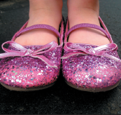 ______________
- 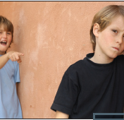 ______________ |  |  | - 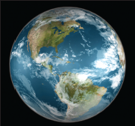 ______________
- ______________ |  |  | - 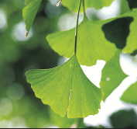 ______________
C. Choose the best answer.
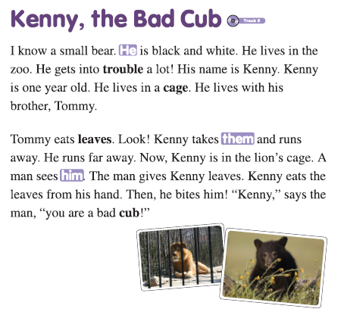
1. Kenny is a bear. | True / False
2. Tommy and Kenny live together. | True / False
3. Tommy never bites. | True / False
4. Tommy can get in the lion’s cage. | True / False
5. Tommy takes Kenny’s leaves. | True / False

School Subject Reading1 Review Test
Book 1 Unit 6-10
A. Fill in the blanks with the correct word.
1. My dog leaves ________ on my bed when he sleeps on it.
a. pillows | b. blankets | c. fur | d. pajamas
2. I like to eat sandwiches for ________.
a. lunch | b. soup | c. restaurant | d. plate
3. I ________ my rubber ball, but I couldn’t find it.
a. found | b. looked for | c. turned | d. lost
4. It’s ________ outside, so wear a jacket.
a. cool | b. warm | c. hot | d. bright
5. I put on my ________ before bed.
a. blankets | b. blankets | c. pillows | d. pajamas

B. Label the pictures.
rubber balls | highway | couch | racing | water slide | haircut
- 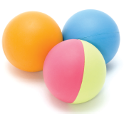 ______________ |  |  | - 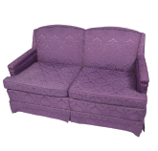______________
- 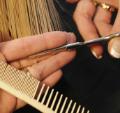 ______________ |  |  | - 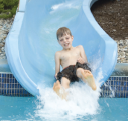 ______________
- 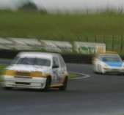 ______________ |  |  | - 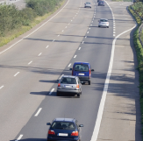 ______________

C. Circle True or False.
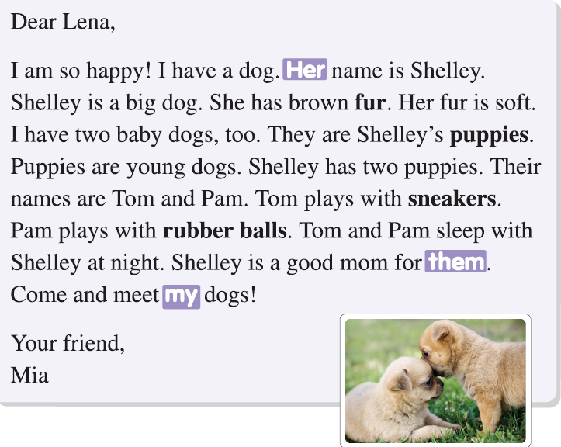

1. Shelley has a big dog. | True / False
2. She has soft fur. | True / False
3. The puppies like to play. | True / False
4. Lena has three dogs. | True / False
5. Sneakers are Tom’s favorite toys. | True / False

School Subject Reading1 Review Test
Book 1 Unit 11-15
A. Fill in the blanks with the correct word.
1. Cows like to eat ____________.
a. seagulls | b. skin | c. grass | d. trees
2. I like to build sandcastles on the ____________.
a. lake | b. street | c. grass | d. beach
3. I broke my arm and had to wear a ____________.
a. cast | b. shovel | c. cane | d. shirt
4. The ____________ took me quickly to the hospital.
a. ambulance | b. street | c. highway | d. train
5. Be careful with the knife because it is ____________.
a. dull | b. sharp | c. bright | d. cool

B. Label the pictures.
siren | street | grab | mess | cane | seagull
- 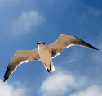 _____________ |  |  | - 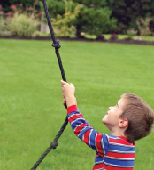 _____________
- ______________ |  |  | - 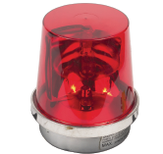______________
- 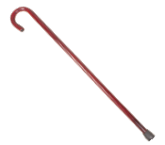______________ |  |  | - _____________

C. Circle True or False.

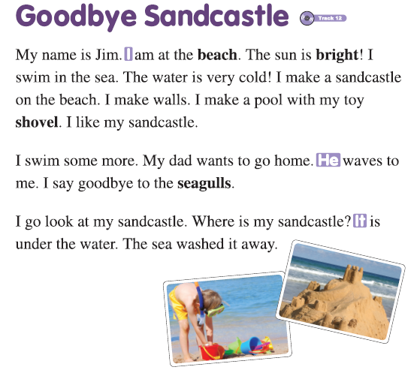

1. Jim is near the sea. | True / False
2. Jim swims in the cold water. | True / False
3. The sandcastle doesn’t have walls. | True / False
4. The seagulls wave to Jim. | True / False
5. The sandcastle was washed away. | True / False

School Subject Reading1 Review Test
Book 1 Unit 16-20
A. Fill in the blanks with the correct word.
1. Elisa’s older sister wears ____________ on her face.
a. cheeks | b. makeup | c. light | d. medicine
2. We live on the ____________ Earth.
a. rock | b. hill | c. planet | d. floor
3. The fruit salad is very ____________.
a. tasty | b. wrong | c. bright | d. sharp
4. Will you ____________ for me at the bus stop?
a. grow | b. wait | c. grab | d. fall
5. My ____________ is red after being in the sun too long.
a. cast | b. hair | c. clothes | d. skin

B. Label the pictures.
light | rock | pills | monster | cheeks | hills
- 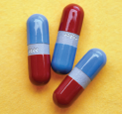 ______________ |  |  | - 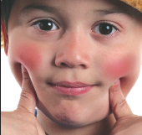 ______________
- 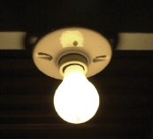 ______________ |  |  | - 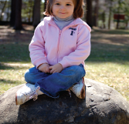 ______________
- 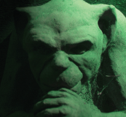 ______________ |  |  | - _____________

C. Circle True or False.

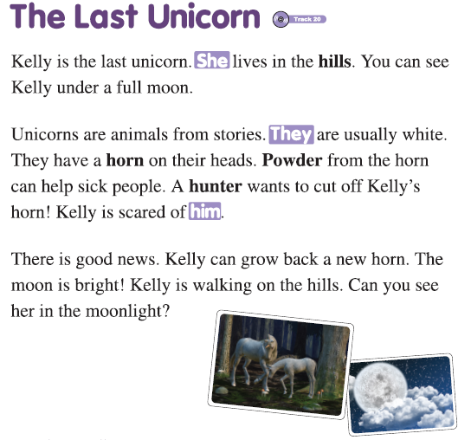

1. Kelly can be seen under a full moon. | True / False
2. Kelly has horns on her head. | True / False
3. Kelly is white. | True / False
4. Another unicorn wants to cut off her horn. | True / False
5. The unicorn’s fur helps people. | True / False

School Subject Reading1 Review Test

Book 1 Unit 1-5
A.
1. b
2. c
3. a
4. d
5. c

B
1. shop
2. shoes
3. bully
4. world
5. treasure
6. leaves

C.
1. True
2. True
3. False
4. True
5. False

Book 1 Unit 6-10
A.
1. c
2. a
3. b
4. a
5. d

B.
1. rubber balls
2. couch
3. haircut
4. water slide
5. racing
6. highway

C.
1. False
2. True
3. True
4. False
5. True

Book 1 Unit 11-15
A.
1. c
2. d
3. a
4. a
5. b

B.
1. seagull
2. grab
3. street
4. siren
5. cane
6. mess

C.
1. True
2. True
3. False
4. False
5. True

Book 1 Unit 16-20
A.
1. b
2. c
3. a
4. b
5. d

B.
1. pills
2. cheeks
3. light
4. rock
5. monster
6. hill

C.
1. True
2. False
3. True
4. False
5. False

