School Subject Readings 1
Second Edition
Suggested Lesson Plan

Introduction:
- The teacher greets students; reviews previous units with related questions during attendance check. Questions should be related to vocabulary and content from previous lessons’ passages.
- The teacher writes two words (one related to the title of the passage, and one related to the content area) on the board and asks students to brainstorm as many words as possible that are related to both words. Students can work in pairs.
- Homework check: The teacher circulates around the room to ensure homework is complete.

Review:
- Vocabulary quiz from previous unit.
- If students have struggled with quizzes, then give quizzes from previous units again.

Pre-Reading:
(Pages 1-2)

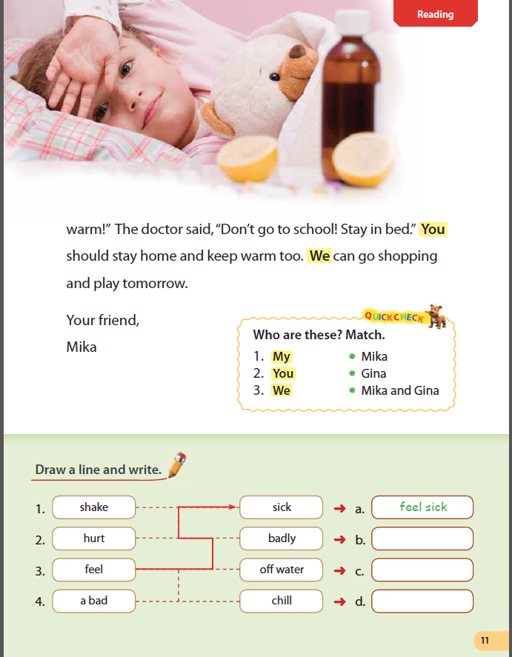
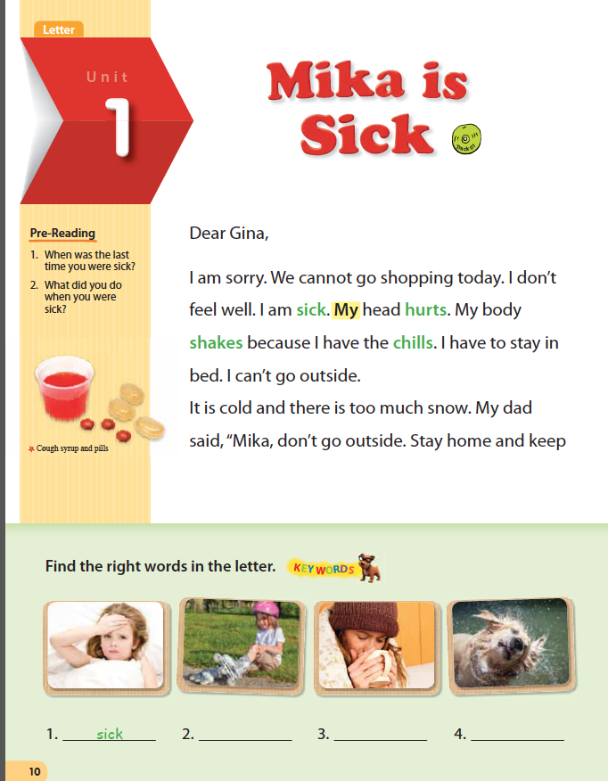
Pre-Reading
Step 1:
Option 1)
- The teacher shows students the picture(s) from the second page of the unit. The teacher covers the picture(s) and gives students thirty seconds to call out as many words as they can think of to describe the picture(s). If students call out words that are not descriptive, the teacher does not write them on the board.

Option 2)
- The teacher asks students to create a background story about the picture(s) from the first two pages of the unit.

Step 2:
- The teacher has students open their books and look at the Pre-Reading section. The teacher directs students to the questions and asks them one at a time.
- The teacher encourages students to write new words and ideas in the space next to the questions.

Key Words

-Before reading: Have students cover the passage with a piece of paper. Students look at the pictures and guess the key words. The teacher writes guesses on the board.
-After reading: Complete the activity as a class. For each picture, the teacher elicits the correct word and either circles it on the board or adds it.

Reading:
(Pages 1-2 cont.)
Passage

- The teacher plays the audio CD and has students track the words and circle words in the passage they do not know. The teacher introduces the meanings of the words.
- The teacher asks simple comprehension questions that relate directly to the text. Questions should relate to the reading skill introduced on the last page of the lesson.

Quick Check

This is an ideal homework activity as it ensures students will re-read the main passage.
- Assign for homework and write the answers on the board for students to self-correct during the next class.

Draw a line and write.

-The teacher draws students’ attention to the sample answer (e.g., feel sick). Encourage students to form complete sentences using the key word and collocation.
-In pairs, students match the other key words with their collocations. Teacher circulates to monitor and help.
-Check answers as a class.
Optional activities:
-Each student chooses one collocation and writes a complete sentence using it. Share sentences with the class.
-In pairs, students choose three additional words from the reading and write fill-in-the blank sentences for them. Each pair reads (or writes on the board) their sentences, and other students guess which words go in the blanks.

Optional Activities

1) The teacher has students create dramatic readings based on the content.
2) The teacher asks students to create two questions each about the passage and then to take turns asking their questions to the class.
3) Have students put slashes in the text where they feel they would naturally pause to breathe or for emphasis. Then have students read aloud and adjust their slashes.

Ex. These days, / Bill always cleans up. This kind of activity will help students become more aware of their pronunciation and intonation when reading aloud.

(Page 3)
Reading Comprehension A

- The teacher introduces the first activity by having students close their books and first asking the questions orally, with students giving their own answers.
- The teacher asks students to open their books and has them answer the questions independently while walking around the room and checking to ensure students understand the questions.
- The teacher writes the answers on the board for students to self-correct their work. The teacher then asks students how they knew the answers to questions or why think they got some answers wrong.

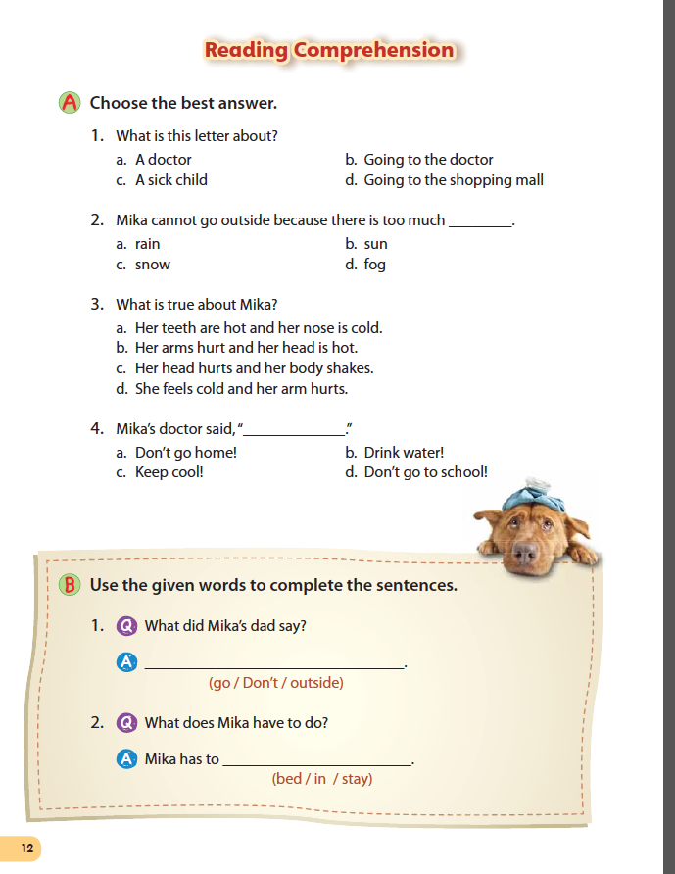
Reading Comprehension B

-Either independently or in pairs, students unscramble the key expressions to complete the sentences, while the teacher circulates to monitor and help.
-The teacher elicits the correct answers from students and writes them on the board so that students can self-correct.
-In pairs, students practice asking and answering the questions.

(Page 4)
Reading Skill Practice

- The teacher introduces the reading skill with a simple example.
Ex. Cause and effect I have an ice cream cone. It is a hot day. I do not eat the ice cream cone quickly. What happens?
- The teacher then has students work individually or in pairs to complete the activity. Encourage students to come up with their own answers before referring to the answer choices.
- The teacher has students read the main passage again, underlining the parts of the passage that are related to the mapping activity.

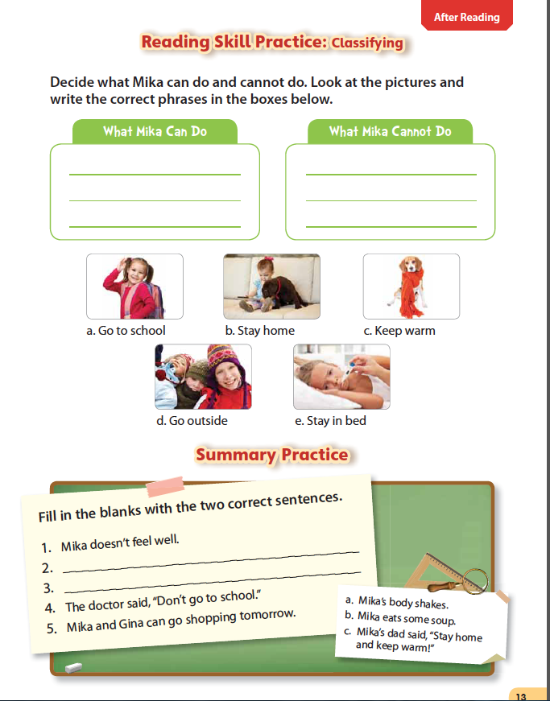

Summary Practice

- The teacher first has students write their own passage summaries. Teachers should always remind students that their summary must have a clear beginning, middle, and ending, just like the passage.
- The teacher then has students complete the summary practice activity and check the answers as a class.

Closure:

Homework

The teacher assigns homework. Homework can be unfinished student book activities, independent writing following the model passages from the book, or workbook activities.

Final Activity Ideas

1) The teacher says a word from the passage; students say a sentence with the word.
2) The teacher spells words incorrectly on the board; students correct the spellings and then make sentences with the words.

